Conversion of Organosolv and Kraft lignins into value-added compounds assisted by an acidic deep eutectic solvent

Filipe H. B. Sosa1,2, Ana Bjelić3, João A. P. Coutinho1, Mariana C. Costa2, Blaž Likozar3 Edita Jasiukaitytė-Grojzdek3, Miha Grilc3, Andre M. da Costa Lopes1,4*

1CICECO, Department of Chemistry, University of Aveiro, Campus Universitário de Santiago, Aveiro, Portugal.
2School of Chemical Engineering (FEQ), University of Campinas (UNICAMP), Campinas, Brazil.
3Department of Catalysis and Chemical Reaction Engineering, National Institute of Chemistry, Hajdrihova 19, 1000 Ljubljana, Slovenia
4CECOLAB - Collaborative Laboratory Towards Circular Economy, R. Nossa Senhora da Conceição, 3405-155 Oliveira do Hospital, Portugal

*corresponding author: andremcl@ua.pt

Abstract

- In this study, an acidic deep eutectic solvent (DES) was used as benign solvent to valorise

- technical lignins by breaking down their structure into value-added aromatic compounds.

- The action of an acidic DES composed of cholinium chloride ([Ch]Cl) and oxalic acid

- (Oxa), at molar ratio 1:1, towards depolymerisation of Kraft and Organosolv lignins (KL

- and OL) was studied at mild conditions (80 °C, for 1 to 6 h). Furthermore, the addition of

- hydrogen peroxide (H₂O₂) or sulfuric acid (H₂SO₄) as co-catalysts was also performed.

- The obtained data showed maximum yields between 26.1 wt% and 27.8 wt% of lignin

- depolymerisation products after KL and OL breakdown. Moreover, the profile of

- depolymerisation products was distinct between examined lignins as well as between

- acidic ([Ch]Cl:Oxa and [Ch]Cl:Oxa/H₂SO₄) and acidic oxidative treatments

- ([Ch]Cl:Oxa/H₂O₂). The acidic treatments of KL favoured the formation of syringol and

- acetosyringone, while vanillic and syringic acids were the main products in the acidic

- treatments of OL. On the other hand, the presence of H₂O₂ in DES revealed the ability to

- promote electrophilic substitutions of chloride from [Ch]Cl in the aromatic ring of lignin

- monomers. After depolymerisation, the regenerated lignin samples presented a different

- molecular weight, while FT-IR data showed structural changes, including esterification

- with oxalic acid and formation of phenolic groups as consequence of aryl ether bond

- breakdown. The insights gained in this study provide a better understanding on lignin

- depolymerisation mechanisms with DES (in presence and absence of co-catalysts) and

- envisage process integration through the production of lignin monomers (and oligomers)

- combined with functionalisation of regenerated lignin.

23

- Keywords. Lignin, deep eutectic solvents, depolymerisation, acidolysis, oxidation,

- value-added aromatic compounds.

- Introduction

- Lignin is one of the three major macromolecular components of plant biomass, besides

- cellulose and hemicelulloses, and is the second most abundant resource in nature after

- cellulose.1 It exhibits structural and protective functions in plants against external biotic

- attacks and its content can reach 15 to 40 % of plant dry weight. Lignin is a randomly

- branched macromolecule constituted by three phenylpropanoid units, namely guaiacyl

- (G), syringyl (S) and p-hydroxyphenyl (H), linked by different types of C-O (e.g. β-O-4

- and α-O-4) and C-C (e.g. β-β, β-1 and β-5) covalent bonds.2,3 Therefore, this

- macromolecule represents a valuable source of aromatics and stands as one of the most

- important candidates to replace fossil-based feedstocks in the production of commodities,

- such as fuels, chemicals and materials within the scope of the biorefinery concept.4,5

- Currently, most of the available lignin is produced as by-product of cellulose pulp and

- 2G bioethanol industrial activities, while its current fate is to serve as fuel in boilers to

- produce energy into the grid.6 Bearing in mind all the potentialities of this aromatic carbon

- source, this is a low value chain strategy that must be upgraded. However, the

- heterogeneous and complex structure of lignin as well as its low reactivity restrict the

- development of applications towards novel materials and value-added chemicals.7,8 A

- possible solution relies on the effective depolymerisation of this macromolecule into its

- monomeric constituents providing an opportunity to generate new products and also to

- overcome scientific and technological barriers upon lignin valorisation.

- Nevertheless, the development of efficient lignin depolymerisation processes has been

- a massive challenge. The intricate structure of lignin, allied with highly stable C-C

- chemical bonds, hinders the depolymerisation that requires high energy input to promote

- effective linkage disruption. Amongst those chemical bonds, β-O-4 aryl ether are the most

- representative linkages in lignin structure (about 60%),6 thus their cleavage has been

- intensively approached.9 However, simultaneous breakdown of C-C bonds is of utmost

- importance specially when targeting the production of low molecular weight aromatic

- compounds, such as lignin monomers and oligomers, which may disclose a high market

- value in the future.4

- In literature, heterogeneous10,11 and homogeneous4,12 catalysis have been reported as

- technologies capable of disrupting lignin chemical bonds (C-C and C-O) towards the

- production of aromatic chemicals. 4,10,13 The heterogeneous catalysis of lignin typically

- involves the application of metal catalysts, but they exhibit some disadvantages. Catalysts

- containing noble metals (palladium, platinum, ruthenium14) have disclosed high

- efficiency, but their high cost is a drawback, while cheap metal-based catalysts possessing

- zinc or copper are less efficient and their surface is quite often saturated with lignin

- fragments, preventing their appropriate reuse.15 On the other hand, the homogeneous

- catalysis of lignin stands as an alternative by overcoming some of the disadvantages of

- heterogeneous conversion. However, it often relies on the application of strong mineral

- acids or alkaline solutions, posing undesired technical issues, especially in downstream

- processing.16 A more sustainable solution may lie in the use of green tools, such as green

- solvents or green catalysts, to overcome these environmental and health limitations.

- In this regard, ionic liquids (ILs) stand as an attractive class of green solvents.17,18

- Since the initial report on their ability to dissolve cellulose,19 several studies have been

- describing the application of acidic ILs towards biomass fractionation, while some of

- them have shown their capacity for lignin depolymerisation.20–22 For instance, Cox et al.23

- demonstrated the depolymerisation of lignin using 1-H-3-methylimidazolium chloride

- under the temperature range of 110-150°C. In another study, Jia et al.24 reported the

- hydrolysis of β-O-4 bonds in two lignin model compounds using the same IL with a yield

- greater than 70% at 150°C. Furthermore, SO₃H-based ILs applied in water:methanol

- mixtures up to 1:1 molar ratio demonstrated a high conversion yield of dealkaline lignin

- into aromatic monomers (95-97%) at temperature range of 110-170°C.22 Although some

- of these technologies demonstrated ILs as suitable solvents/catalysts for lignin

- depolymerisation, the availability and high cost of ILs have been limiting their application

- in depolymerisation reactions of large amounts of lignin.25 Therefore, other green

- alternatives have been investigated.

- Recently, deep eutectic solvents (DES) have been studied and applied as green

- solvents in several applications.26 Introduced by Abbott et al.,27 DES is a mixture of at

- least one hydrogen bond donor (HBD) and one hydrogen bond acceptor (HBA) capable

- of establishing strong hydrogen bonds and form an eutectic solution with inherent

- negative deviation to the melting temperature of the ideal mixture.27,28 This depression in

- the melting temperature allows a large number of DES to be liquid at room temperature

- enabling their use as solvents. In addition, DES possess other favourable characteristics,

- including low vapor pressure, easy preparation and tailored physicochemical properties

- (acidity, basicity, polarity, among others).29

- These features drew the attention to apply DES in lignin dissolution30 and biomass

- delignification.31,32 Several studies have been reporting acidic DESs, such as those

- formed by the combination of cholinium chloride ([Ch]Cl) as HBA and carboxylic acids,

- including oxalic acid (Oxa), formic acid (For) and lactic acid (Lac) as HBD, as efficient

- solvents for the extraction and dissolution of lignin from biomass.33–35 A small group of

- works have stressed out small changes to lignin structure after its delignification with

- DES,36 while others have proven the ability of DES to disrupt lignin chemical bonds,35

- specially β-O-4 ether bonds.37 These apparent contradictory observations result mostly

- from the acidity of the HBD as well as the mild vs severe conditions applied in biomass

- delignification. Notwithstanding these differences, a close inspection on the

- delignification mechanisms and performance of acidic DES was investigated.38,39

- Alvarez-Vasco et al. reported that the cleavage of β-O-4 bond in a lignin model compound

- (guaiacylglycerol-β-guaiacyl) by [Ch]Cl:Lac is similar to lignin acidolysis catalysed by

- hydrochloric acid.38 In another work, da Costa Lopes et al.40 demonstrated that [Ch]Cl:p-

- toluenesulfonic acid (pTSA) and its bromide equivalent ([Ch]Br:pTSA) are able to cleave

- efficiently β-O-4 bonds of another lignin model compound (1-phenyl-2-phenoxyethanol).

- Through DFT calculations, the authors revealed a nucleophilic role of the halide anion

- (chloride or bromide) that substitutes the hydroxyl group neighbouring the β-O-4 ether

- linkage, forming a halide intermediate that energetically favours the cleavage.40 On the

- other hand, Hong et al.39 evaluated the structural changes of alkali lignin after its

- treatment with [Ch]Cl:Oxa and [Ch]Cl:Lac. In both cases, the cleavage of ether bonds

- was preceded by the following steps: i) removal of the C_{α} alcohol and the formation of

- highly reactive benzylic carbocations in the lignin side chains; ii) oxidation of the C_{α}

- position and acylation of the C_{γ} position.39

- Bearing all this in mind, the application of DES as both solvent and catalyst may

- provide a new and sustainable process for lignin depolymerisation, besides biomass

- delignification. However, there are still few studies that explore the performance of DES

- to depolymerise lignin in its monomeric and oligomeric fragments.39,41 The present study

- aims at giving an initial contribution to understand the mechanisms behind this process.

- [Ch]Cl:Oxa (1:1 molar ratio), which previously showed an improved performance on

- lignin cleavage in contrast to other acidic DES,37 was chosen as representative medium

- to dissolve and depolymerise two technical lignins, namely Kraft and Organosolv, under

- moderate conditions (80 °C, 1-6 h). In addition, sulfuric acid (H₂SO₄) and hydrogen

- peroxide (H₂O₂) were used as co-catalysts to address different mechanistic possibilities

- in the disruption of lignin chemical linkages. Moreover, a brief demonstration on the

- physicochemical modifications of remaining lignin solid fraction induced by these

- systems were also addressed by GPC, FT-IR and elemental analysis.

Materials and Methods

- Chemicals. Kraft Lignin (KL) isolated from Eucalyptus urograndis was directly

- supplied by Suzano Papel & Celulose (Brazil). KL was precipitated from the industrial

- black liquor by employing carbon dioxide. On the other hand, Organosolv Lignin (OL)

- was directly supplied by Fraunhofer (Germany). OL was extracted from beech wood with

- 50 % (v/v) ethanol solution and sulphuric acid as a catalyst. The HSQC NMR spectra of

- both lignins and corresponding 13C-1H assignments are shown in Figure S1 and Table S1,

- respectively. Cholinium chloride ([Ch]Cl, 98.0 wt% purity) was purchased from Acros

- Organics (New Jersey, US). Oxalic acid (Oxa, 99.5% purity), tetrahydrofuran (THF, 99

- wt% purity and methyl benzoate (99 wt% purity) were purchased from Merck (Darmstadt,

- Germany). Both hydrogen peroxide (H₂O₂, 30 % v/v) and methyl isobutyl ketone (MIBK,

- 98.5 wt% purity) were purchased from Riedel-de Haën - Honeywell (Charlotte, US),

- while sulfuric acid (H₂SO₄, 96 wt% purity) was supplied by Fisher Chemical (New Jersey,

- US).

DES Preparation

- The binary mixture of [Ch]Cl and Oxa at molar ratio 1:1 was sealed in glass vials,

- heated in oil bath at 60 °C and kept at constant magnetic stirring until a transparent liquid

- (approximately 2 hours) was formed. The prepared DES was cooled down to room

- temperature and water content was measured by Metrohm 831 Karl-Fischer coulometer.

- Water content in DES was corrected to 5 wt% afterwards to uniform every batch.

Lignin depolymerisation assays

- The methodology of lignin depolymerisation and post-processing steps are briefly

- described in Figure 1. KL or OL (300 mg) was added to [Ch]Cl:Oxa (1:1) (6.0 g) in 250

- mL glass flasks from 6 Plus Reaction Station™ carousel (Radleys, United Kingdom),

- which allows parallel reactions at the same temperature and agitation. The mixture was

- heated up to 80 °C and reaction was left for 1, 3 and 6 h under constant agitation (200

- rpm) provided by the magnetic bar stirrer. Both technical lignins were treated with three

- distinct systems: i) DES; ii) DES with catalytic amount of H₂SO₄ (1 wt%); and iii) DES

- with catalytic amount of H₂O₂ (2 wt%).

- 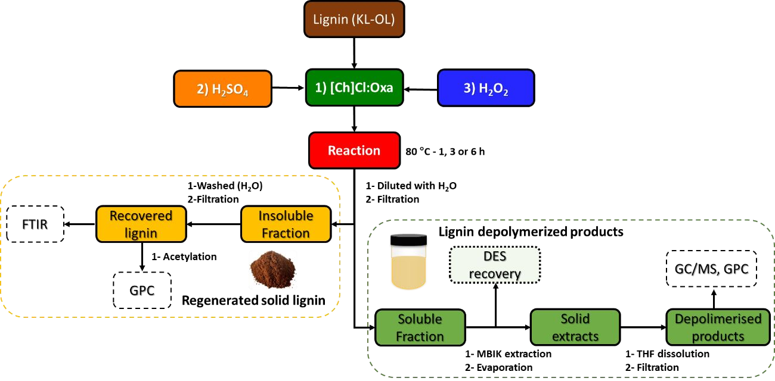
- Figure 1. The flowchart of lignin treatment and post-processing analysis performed in

- this work.

- After reaction, the glass flasks were placed in ice bath (5 °C) and 20 mL of water was

- added to the mixture enabling lignin precipitation. The precipitated lignin was separated

- by vacuum filtration, washed with water (3 x 10 mL), and finally freeze dried before its

- gravimetric quantification. The lignin recovery yields were determined by the equation

- 1. The liquid phase containing lignin depolymerised products was collected and stored in

- a fridge before analysis. The obtained yields of lignin depolymerisation product were

- calculated by closing the mass balance of the initial lignin as disclosed by the equation 2.

𝑚_{𝐿𝑖𝑔}𝑟𝑒𝑐 ∙ (1 ― 𝐴𝑠ℎ_{𝐿𝑖𝑔}𝑟𝑒𝑐)
𝑚𝐿𝑖𝑔
)

𝑙𝑖𝑔𝑛𝑖𝑛 𝑟𝑒𝑐𝑜𝑣𝑒𝑟𝑦 𝑦𝑖𝑒𝑙𝑑 (𝑤𝑡%) =
𝑖𝑛𝑖𝑡
- (1 ― 𝐴𝑠ℎ
  - 100 (1)
𝐿𝑖𝑔𝑖𝑛𝑖𝑡

𝑚_{𝐿𝑖𝑔}𝑖𝑛𝑖𝑡 .(1 ― 𝐴𝑠ℎ_{𝐿𝑖𝑔}𝑖𝑛𝑖𝑡) ― 𝑚_{𝐿𝑖𝑔}𝑟𝑒𝑐 ∙ (1 ― 𝐴𝑠ℎ_{𝐿𝑖𝑔}𝑟𝑒𝑐)
)

𝑃𝑟𝑜𝑑𝑢𝑐𝑡 𝑦𝑖𝑒𝑙𝑑 (𝑤𝑡%) =
𝑚𝐿𝑖𝑔𝑖𝑛𝑖𝑡
.(1 ― 𝐴𝑠ℎ
  - 100 (2)
𝐿𝑖𝑔𝑖𝑛𝑖𝑡

- where 𝑚_{𝐿𝑖𝑔}𝑟𝑒𝑐 is the total amount of recovered lignin (g), 𝑚_{𝐿𝑖𝑔}𝑖𝑛𝑖𝑡 is the initial amount
- of lignin (g), 𝐴𝑠ℎ_{𝐿𝑖𝑔}𝑟𝑒𝑐 is the ash content in recovered lignin, and 𝐴𝑠ℎ_{𝐿𝑖𝑔}𝑖𝑛𝑖𝑡 is the ash content

- in initial lignin.

Extraction of lignin depolymerisation products from DES.

- The collected liquid phase (≈20 mL) was subjected to a liquid/liquid extraction with

- MIBK (10 mL) to separate the lignin depolymerisation products from DES.6,42 The MIBK

- phase enriched with those compounds was then separated from DES phase. This

- liquid/liquid extraction step was repeated twice and MIBK phases were collected in the

- same flask and further evaporated in a centrifugal vacuum concentrator (MiVac, US). The

- samples were dissolved in 5 mL THF followed by filtration to remove any trace of [Ch]Cl

- (insoluble in THF). Subsequently, THF was evaporated in centrifugal vacuum

- concentrator. The resulting solid extracts were re-dissolved in THF to obtain a known

- concentration (20.0 mg·L-1) for GC-MS analysis.

Lignin acetylation.

- The regenerated lignin samples (section 2.3) were acetylated with pyridine and acetic

- anhydride (2:1) v/v mixture at 50 °C. After 8 hours of reaction, the pH of the solutions

- was adjusted to approximately 3.0 with a HCl (0.1 N) solution and left at room

- temperature for 12 h with continuous stirring (approximately 200 rpm) to avoid lignin

- agglomeration. The obtained suspensions were centrifuged for 10 min at 4500 rpm and

- the resulting acetylated lignin was exhaustively washed with distilled water (5 x 10 mL)

- and freeze-dried. The acetylated lignin samples were analysed by GPC.

Characterisation of lignin depolymerisation products and remaining lignin solid

- fractions

- Gas chromatography/mass spectrometry (GC/MS) analysis

- The identification and semi-quantification of lignin depolymerisation products was

- carried out using a gas chromatograph/mass spectrometer Shimadzu QP2010 Ultra,

- equipped with an AOC‐20i autosampler and high‐performance quadrupole mass filter.

- The separation of reaction products was carried out in a DB‐5 ms column (30 m length,

- 0.25 mm i.d. and 0.25 μm film thickness) using helium as the carrier gas (40 cm s−1). The

- chromatographic conditions were as follows: isothermal at 80 °C for 5 min, ramped from

- 80 to 250 °C (8 °C min−1), ramped from 250 to 300 °C (4 °C min−1) and then isothermal

- at 300 °C for 5 min; injector temperature of 320 °C; and split ratio equal to 1:10. The MS

- was operated in the electron impact mode with an electron impact energy of 70 eV and

- data was collected at a rate of 1 scan s−1 over a range of m/z 50–1000. The ion source was

- kept at 200 °C and the interface temperature at 300 °C.

- Identification of compounds was performed by comparing chromatographic peaks

- retention times and their mass spectra with the equipment mass spectral library (NIST14s

- MS Library Database or WILEY229 MS Library Database). The m/z value of the

- molecular ion together with the fragmentation was used to figure out the structure of the

- compound. A semi-quantitative analysis was carried out by considering the ratio between

- the peak area of compound and the peak area of the internal standard as shown by the

- equation 3:

% 𝑅𝑒𝑙𝑎𝑡𝑖𝑣𝑒 𝑃𝑒𝑎𝑘 𝐴𝑟𝑒𝑎_{𝑖} =

𝐴_{𝑖}
∑𝑛𝐴 ·100 (3)

𝑖 𝑖

- where 𝐴_{𝑖} is the peak area of compound “i”, and “n” is the number of compounds.

- Gel Permeation Chromatography (GPC) analysis

- GPC analyses of acetylated lignin samples and depolymerisation products were

- performed on a gel permeation chromatographic system (HP — AGILENT system)

- equipped with a UV detector (set at 280 nm). Analyses were carried out at ambient

- temperature using THF as eluent at a flow rate of 1 mL·min-1. Aliquots (100 µL) of

- acetylated lignin dissolved in THF (1.5 mg·mL-1) were injected into PLgel 3 µm MIXED

- E 7.5 x 300 mm. The column specifications allow for the separation of molecular masses

- up to 3.0 x 104 g·mol-1. The GPC system was calibrated with polystyrene standards (Mw

231 = 162, 672, 890, 2280, 4840, 5180, 9630, 25500, 61400, 127000 g·mol-1). Moreover,

- guaiacylglycerol-β-guaiacyl ether (>99 % purity, TCI Chemicals, Belgium), known as β-

- O-4 linkage-lignin model compound (Mw 320 g·mol-1) was used to construct the

- calibration curve aiming to increase the accuracy of the measured values in the low

- molecular weight region. The chromatographic data were processed with the PSS

- (Polymer Standards Service) WinGPC Unity software.

- Fourier Transform InfraRed (FT-IR) analysis

- The FT-IR spectra of lignin samples (not acetylated) were recorded on a PerkinElmer

- Spectrum BX spectrometer equipped with a horizontal Golden Gate ATR cell and a

- diamond crystal. A total of 32 scans were made for each sample with a resolution of 4

- cm-1 in a wave range between 4000 cm-1 and 400 cm-1.

- Elemental Analysis

- The elemental analysis of lignin samples was conducted with a TruSpec series 630-

- 200-200 elemental analyser (Michigan, US). The combustion furnace temperature and

- the afterburner temperature were maintained at 1075 °C and 850 °C, respectively. The

- oxygen content was determined by the difference.

Experimental and analytical error analyses

- All the experiments were performed in duplicate and the obtained results were

- expressed as means with associated standard deviation errors (u). The applied temperature

- in the reactions demonstrated a u(T)=1 °C. All the mass determinations were performed

- with a given u(m)=0.1 mg.

Results

Characterisation of lignin depolymerisation products

- Kraft and Organosolv lignins (KL and OL) were treated with three distinct solvent

- systems: i) [Ch]Cl:Oxa; ii) [Ch]Cl:Oxa/H₂SO₄; and iii) [Ch]Cl:Oxa/H₂O₂. Their ability

- for lignin depolymerisation at 80 ºC was evaluated over time (1, 3 and 6 h) and the

- obtained depolymerisation product yields are depicted in Figure 2.

- At first sight, depolymerisation product yields were all higher than 6.0 wt%,

- suggesting that the studied systems were able to convert at least a small portion of the

- initial lignin. Furthermore, reactions of OL and KL with both [Ch]Cl:Oxa and

- [Ch]Cl:Oxa/H₂SO₄ revealed an increase of the depolymerisation product yield from 1 to

- 3 h, but a sharply decrease at 6 h was verified. Maximum yields between 26.1 wt% and

- 27.8 wt% of lignin depolymerisation products were obtained in the reaction of both KL

- and OL with these DES systems at 3 h. However, an exception to this trend was observed

- for DES comprising a catalytic amount of H₂O₂, which exhibited a different behaviour in

- the depolymerisation of both KL and OL in contrast to other DES systems. For KL

- treatment with [Ch]Cl:Oxa/H₂O₂, a maximum depolymerisation product yield (20.4 wt%)

- was detected at 1 h, while it decreased continuously over time up to one half after 6 h. On

- the other hand, no relevant changes in yields (between 12.6 and 15.3 wt%) during OL

- treatment with [Ch]Cl:Oxa/H₂O₂ were observed.

- 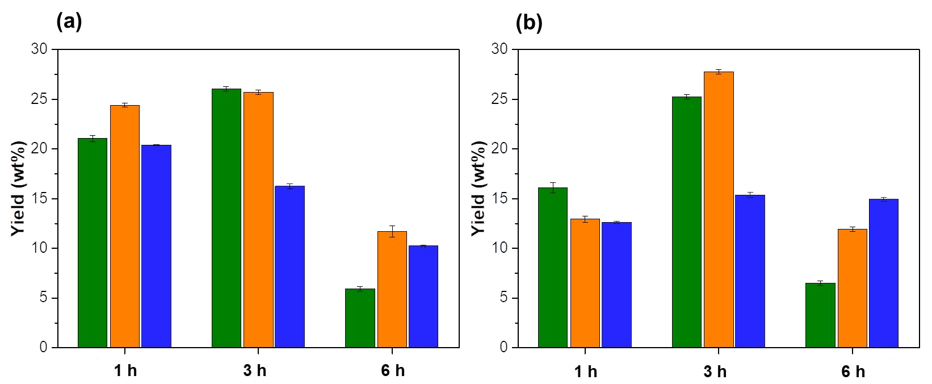
- Figure 2. Yields of lignin depolymerisation products in the liquid phase after a) KL and

- (b) OL treatment with [Ch]Cl:Oxa (■), [Ch]Cl:Oxa/H₂SO₄ (■) and [Ch]Cl:Oxa/H₂O₂ (■)

277 at 80 °C.

278

- Afterwards, lignin depolymerisation products were tentatively identified by GC/MS.

- Initially, 60 compounds were labelled, but among these, the 30 most representative

- compounds were selected (Table 1) to compare the catalytic behaviour of the examined

- DES systems. The obtained products were identified as aromatic monomers derived from

- syringyl (S) and guaiacyl (G) units containing alcohols, ketones, aldehydes and

- carboxylic acids as functional groups attached to the aromatic ring or to the carbon chain

- at α, β and γ positions of those units. Due to the nature of KL (E. grandis wood) and OL

- (beech wood), which are mostly comprised by S and G units,43,44 compounds derived

- from hydroxyphenyl (H) units were not identified in this work. Furthermore, the

- chromatograms of depolymerisation extracts from KL and OL showed the same peaks,

- although with different relative abundances (Figure S2 in SI).

- Table 1. Main compounds identified by GC-MS (chemical structures are represented in

- Table S2 in SI).

Entry | Compounds | MW (Da) | Ret. Time (min)
1 | guaiacol | 124.14 | 7.380
IS* | methyl benzoate | 136.15 | 7.645
2 | 1-(3,4,5-trihydroxyphenyl)propanone | 182.17 | 10.818
3 | 3-(3,4,5-trihydroxyphenyl)propanal | 182.17 | 11.430
4 | 5-chloroguaiacol | 158.01 | 11.609
5 | 4-ethyl-guaiacol | 152.19 | 11.663
6 | 2-methoxy-4-vinylphenol | 150.22 | 11.903
7 | 3-methoxycatechol | 140.05 | 11.285
8 | syringol | 154.16 | 13.062
9 | vanillin | 152.15 | 14.011
10 | 1-chloro-5-methoxybenzene-3,4-diol | 174.01 | 14.358
11 | acetovanillone | 166.17 | 15.485
12 | 3,4-dihydroxy-5-methoxyacetophenone | 182.17 | 16.027
13 | guaiacylacetone | 182.17 | 16.130
14 | vanillic acid | 168.14 | 16.690
15 | 4-allyl-2,6-dimethoxyphenol | 194.23 | 17.037
16 | 2-chloro-3,5-dimethoxybenzene-1,4-diol | 204.02 | 17.680
17 | homovanillic acid | 182.17 | 17.760
18 | 2,5-dimethoxy-1,4-benzenediol | 170.16 | 18.002
19 | syringaldehyde | 182.17 | 18.072

  - 3,5-dichloro-2,6-dimethoxyphenol 221.99 18.370
  - 3-(4-hydroxy-3-methoxyphenyl)-2-oxopropanoic acid 210.05 18.640
  - 3,4,5-trichloro-2-methoxyphenol 225.94 18.655
  - 2-(4-hydroxy-3,5-dimethoxyphenyl)acetaldehyde 196.20 19.050
  - acetosyringone 196.19 19.137
  - 2,6-dichloro-3,5-dimethoxybenzenediol 239.50 19.685
  - 5-chlorovanillic acid 202.17 19.792
27 syringic acid 198.17 20.150
- 1-(6-chloro-4-hydroxy-3,5-dimethoxyphenyl)ethanone 230.30 20.323
- 1-(4-hydroxy-3,5-dimethoxyphenyl)propanedione 224.25 20.373
- 2-chloro-4-hydroxy-3,5-dimethoxybenzoic acid 232.01 22.275
- *Internal Standard

- The composition of lignin depolymerisation extracts was performed by semi-

- quantitative analysis. Figure 3 depicts the relative abundances of the identified 30

- compounds after treatment of both KL (3a) and OL (3b) with the three examined DES

- systems at 80 ºC for 3 h. The obtained data showed once more a distinct behaviour

- between both [Ch]Cl:Oxa and [Ch]Cl:Oxa/H₂SO₄ when compared with

- [Ch]Cl:Oxa/H₂O₂ in the formation of lignin depolymerisation products. For the first two

- systems, lignin monomers, including 2-(3,4-dihydroxy-5-methoxyphenyl)acetaldehyde

- (3), syringol (8) and acetosyringone (24), were detected in higher amount than other

- compounds in KL depolymerisation. In fact, syringol reached approximately 25 % of all

- identified compounds in KL depolymerisation with neat DES and in presence of H₂SO₄.

- However, when looking to the depolymerisation products achieved with

- [Ch]Cl:Oxa/H₂O₂, compound (3) stood as the most abundant monomer resultant from the

- KL treatment (≃ 10%). On the other hand, by changing the lignin sample to OL, besides

- compound (3) the formation of vanillic (14) and syringic (27) acids were favoured in the

- three DES systems. Furthermore, it should be also highlighted that the presence of H₂O₂

- promotes the formation of distinct chlorinated species, including (10), (16), (25), (28) and

- (30), which were not produced in its absence. The corresponding data obtained for the

- lignin treatments with all DES systems at 1 and 6 h are presented in SI (Figures S3 and

- S4, respectively).

- 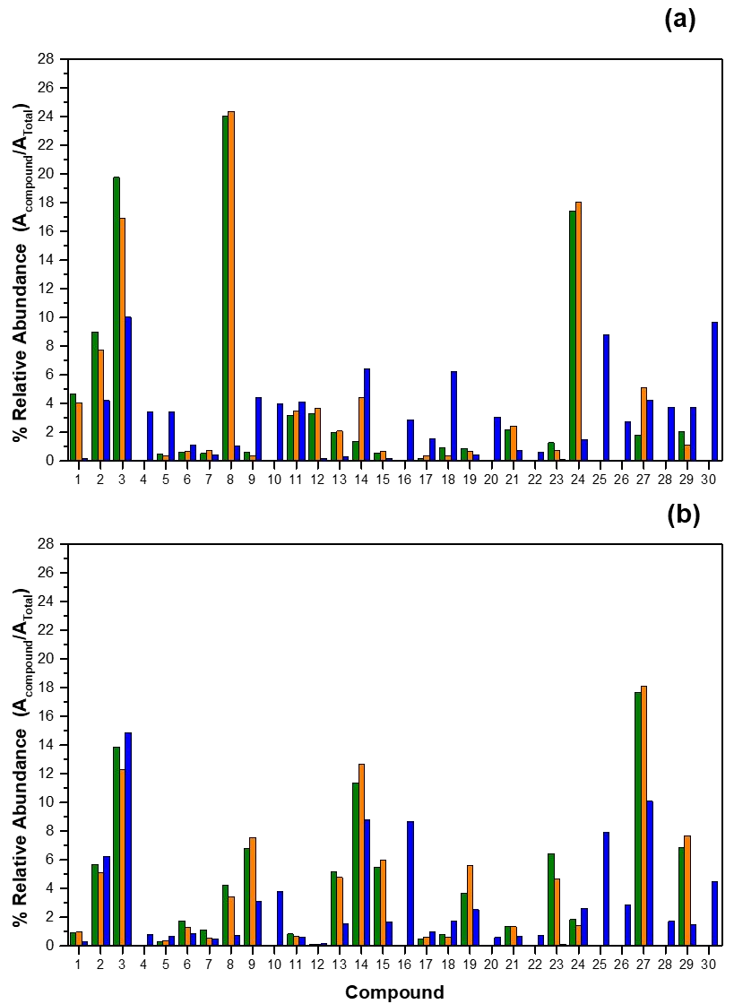

- Figure 3. Relative abundance (%) of lignin depolymerisation products from (a) KL and

- (b) OL depolymerisation at 80 °C for 3 hours with [Ch]Cl:Oxa (■), [Ch]Cl:Oxa/H₂SO₄

317 (■) and [Ch]Cl:Oxa/H₂O₂ (■).

318

- As aforementioned, the GC/MS data allowed the identification of several monomeric

- compounds with maximum molecular weight (MW) between 124 of 232 Da (Table 1).

- However, the existence of oligomeric products is highly probable after depolymerisation

- with examined DES systems. Therefore, to evaluate the MW distribution of

- depolymerised lignin extracts during time, acetylated samples were analysed by GPC. As

- an example, chromatograms of KL depolymerisation products obtained with the three

- DES systems at 1 h and 6 h are presented in Figure 4 (results for OL are shown in Figure

- S5 in SI).

- On the left of Figure 4, the MW fraction below 240 Da is highlighted in grey,

- corresponding to lignin monomers that were detectable by the GC/MS method. It is

- possible to identify 4 main peaks with maximum at 90, 118, 160 and 170 Da, the last two

- being the most intense. Amongst the 30 compounds identified by GC-MS, around 21 have

- a molecular mass between 140 and 190 Da, which may comprise the GPC peaks at 160

- and 170 Da. Surprisingly, the peaks at 90 and 118 Da are very pronounced in the KL

- depolymerisation fraction obtained with DES/H₂O₂. They may comprise low molecular

- weight aromatic compounds that were not identified by the GC/MS method used in this

- work (e.g. toluene and benzene, which are eluted simultaneously with the solvent). On

- the other hand, oligomers with wide distributed MWs can be observed on the right of

- Figure 4, representing a substantial fraction in each depolymerisation extract. These

- oligomeric fragments were also not identified by the GC/MS. The GPC data revealed that

- a higher quantity of oligomers seems to be produced by neat DES and DES/H₂SO₄. On

- the contrary, the oxidative environment promoted by H₂O₂ favoured the formation of low

- molecular weight compounds to the detriment of lignin oligomers.

- 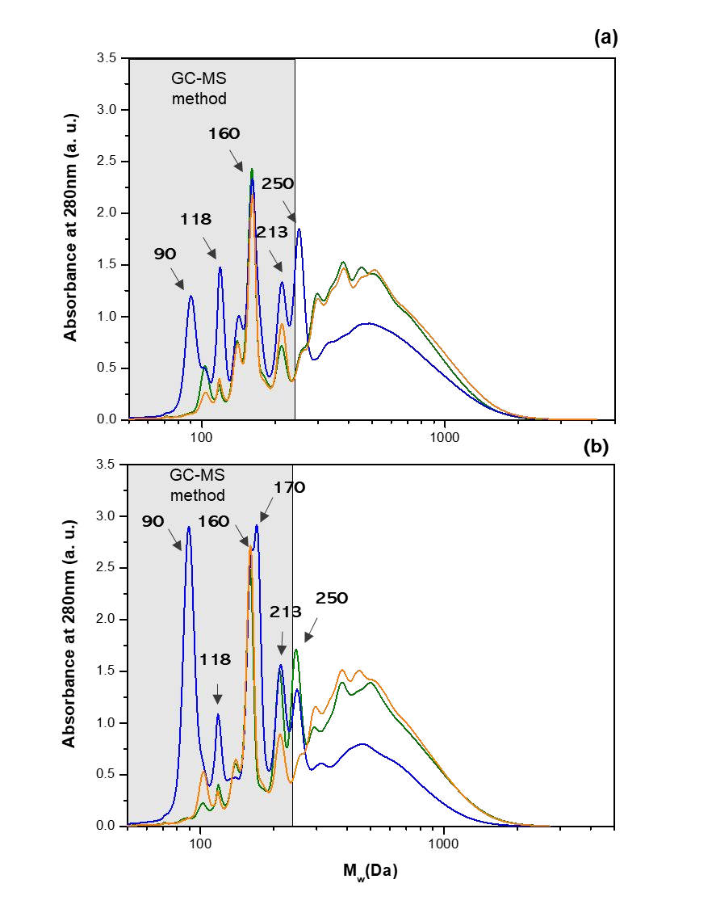
- Figure 4. GPC analysis of lignin depolymerisation products from KL treatment at 80 °C

- during (a) 1 h and (b) 6 h with [Ch]Cl:Oxa (■), [Ch]Cl:Oxa/H₂SO₄ (■) and

345 [Ch]Cl:Oxa/H₂O₂ (■).

346

Lignin depolymerisation over time

- The formation and consumption of depolymerisation products was tracked over time

- to understand the mechanisms behind lignin depolymerisation assisted by the three

- examined DES systems. The kinetics of 15 relevant aromatic compounds, previously

- identified by GC/MS, were represented as relative peak area of each compound to the

- internal standard (methyl benzoate). The data obtained from KL depolymerisation with

- the three DES systems between 1 and 6 h is presented as a model in Figure 5.

- At first sight, treatments at 3 h disclosed the highest formation of aromatic monomers,

- which correlates well with the depolymerisation yields presented in Figure 1. Once more,

- this is an indication that the reaction time directly affects lignin depolymerisation.

- Furthermore, the kinetic profile of the 15 compounds are similar between treatments with

- [Ch]Cl:Oxa (Figure S6 in SI) and [Ch]Cl:Oxa/H₂SO₄ (Figure 5a), but noticeably different

- in lignin depolymerisation mediated by [Ch]Cl:Oxa/H₂O₂ (Figure 5b).

- The KL depolymerisation under acidic conditions ([Ch]Cl:Oxa/H₂SO₄) revealed that

- a major fraction of monomeric compounds, including guaiacol (1), syringol (8),

- acetovanillone (11), vanillic acid (14), a demethylated ketone (2) and a demethylated

- aldehyde (3) presented a remarkable formation from 1 to 3 h, but was followed by their

- drastic consumption up to 6 h. Although a similar trend was observed for acetosyringone

- (24), its consumption rate was moderate. On the other hand, syringic acid (27) presented

- a maximum yield at 1 h and was followed by a decreasing trend over time. On the

- opposite, vanillin (9) and syringaldehyde (19) relative peak areas increased during time,

- although their representation in depolymerisation extract is very low.

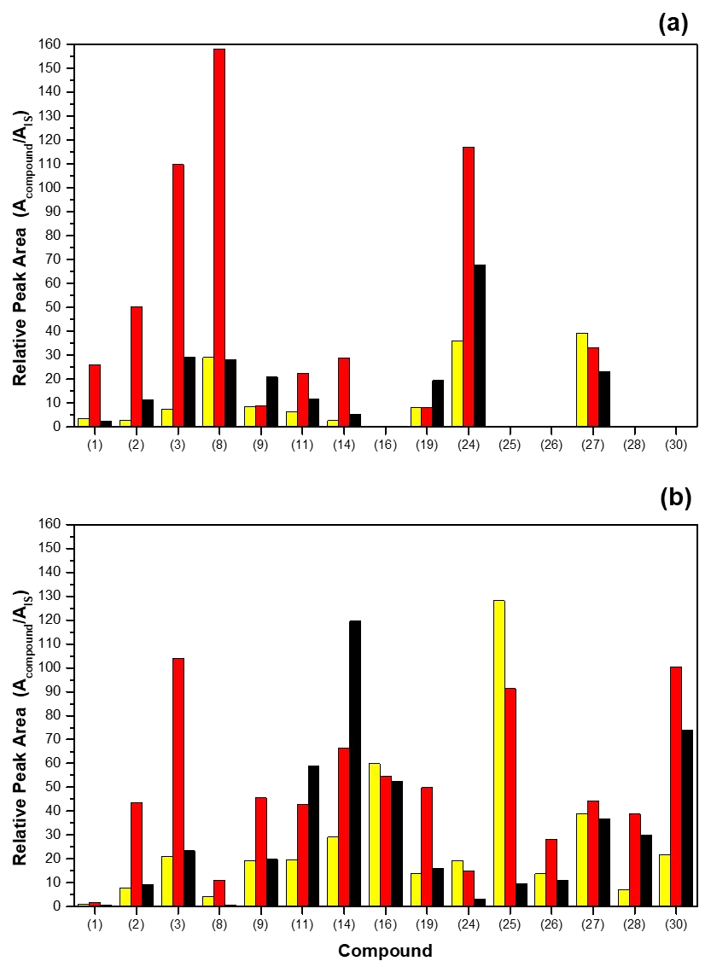
- Figure 5. Relative peak area of identified compounds after KL depolymerisation at 80 °C

- for 1 h (■),3 h (■) and 6 h (■) with (a) [Ch]Cl:Oxa/H₂SO₄ and (b) [Ch]Cl:Oxa/H₂O₂.

- Considering that all these compounds are expected to participate in

- repolymerisation/condensation reactions in prolonged times leading to their

- consumption,45 it seems that produced monomeric alcohols (1 and 8), demethylated

- compounds (2 and 3) and vanillic acid are more prone to those type of reactions. On the

- other hand, syringic acid, vanillin and syringaldehyde are less reactive and more stable

- during lignin treatment in presence of [Ch]Cl:Oxa/H₂SO₄ (or [Ch]Cl:Oxa, Figure S6 in

- SI).

- The kinetics of OL depolymerisation with the three DES systems were also studied

- and obtained results are depicted in Figure 6. Similar to KL depolymerisation, treatments

- of OL at 3 h revealed the highest formation of aromatic monomers. However, the kinetic

- profiles of OL depolymerisation revealed differences from those achieved with KL.

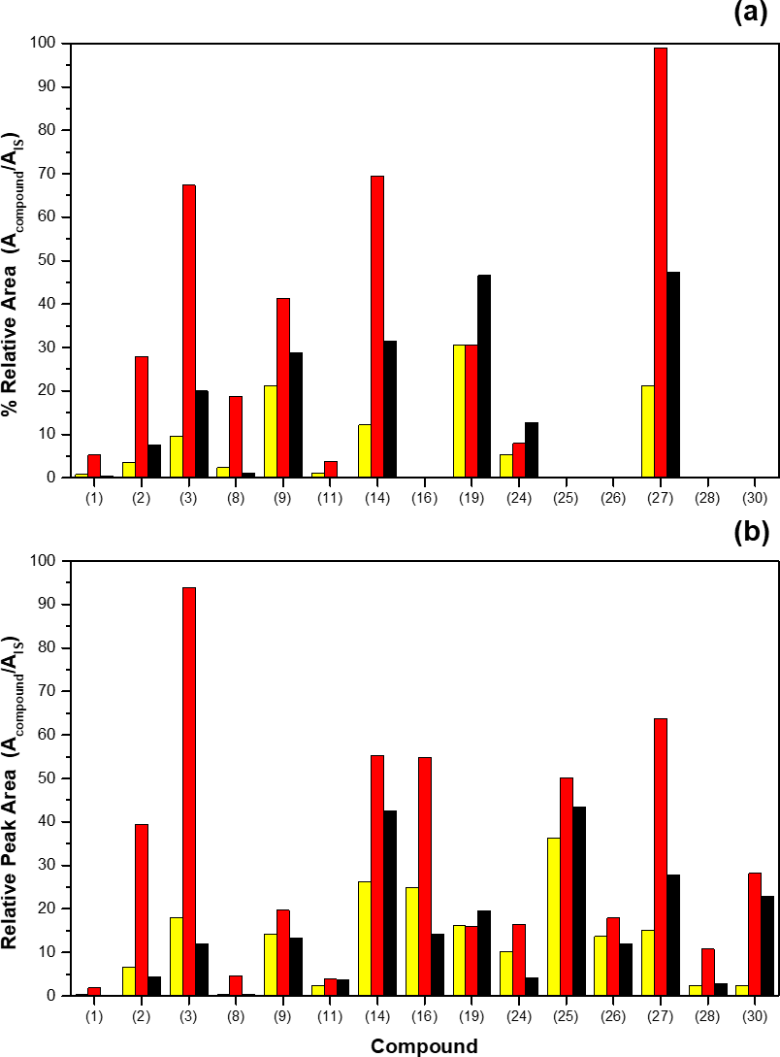

- Figure 6. Relative peak area of identified compounds after OL depolymerisation at 80 °C

- for 1 h (■),3 h (■) and 6 h (■) with (a) [Ch]Cl:Oxa/H₂SO₄ and (b) [Ch]Cl:Oxa/H₂O₂.

- Depolymerisation of OL under acidic conditions ([Ch]Cl:Oxa/H₂SO₄) revealed that

- most monomeric compounds, including 3-(3,4,5-trihydroxyphenyl)propanal (3), vanillin

- (9), vanillic acid (14), syringic acid (27) showed an extensive production up to 3 h, but a

- drastic decrease was observed for longer times. Unlike KL depolymerisation, the

- formation of syringic acid (27) and vanillic acid (14) were favoured to the detriment of

- syringol (8) and guaiacol (1) in both [Ch]Cl:Oxa and [Ch]Cl:Oxa/H₂SO₄. This is an

- evidence that lignin nature, which is dependent on its biomass origin and delignification

- process, exhibits a significant impact on the final composition of depolymerisation

- products. Furthermore, the corresponding precursors, syringaldehyde (9) and vanillin

- (19), were found in higher amount in OL depolymerised fraction than in the case of KL

- depolymerisation.

- Regarding the OL depolymerisation with [Ch]Cl:Oxa/H₂O₂, vanillic acid (14) was

- again a major product after 6 h of reaction, while consumption of compound (25) was not

- as fast as that observed for KL. The strong oxidative medium provided by H₂O₂ allowed

- the substitution at different positions of the aromatic chloride ring, resulting in the same

- chlorinated compounds ((16), (25), (26), (28) and (30)) as highlighted above.

Structural characterisation of the recovered lignin.

- The impact of the depolymerisation reactions mediated by the studied systems on the

- remaining solid lignin was also evaluated. The lignin molecular weight distribution was

- first evaluated by GPC and the obtained results, including average molecular weight

- (Mw), number average molecular weight (Mn) and polydispersity index (PDI), are

- presented in Figure 7 and Table S3.

- The Mw values of both KL and OL were 2500 and 3300 g·mol-1, while the

- polydispersity indexes (PDI) were determined to 2.1 and 2.2, respectively (Table 2). After

- depolymerisation with studied DES systems, recovered lignin samples at 1 h and 6 h of

- treatment disclosed reduced Mw and Mn values in contrast to initial KL and OL,

- confirming depolymerisation mediated by all systems. Although the highest yields of

- lignin depolymerisation was observed at 3 h treatment (Figures 2, 5 and 6), the

- corresponding recovered lignins presented the highest Mw and Mn values (Figure 7). This

- means that albeit lignin monomers are extensively produced at 3 h, simultaneous side

- reactions between remaining lignin fragments are favoured at cleavage sites enabling the

- formation of higher molecular weight lignin macromolecules.46 In turn, this high

- molecular weight fraction influences the average Mw and Mn values (Figure 7). The

- increase of lignin Mw and Mn values at 3 h is more pronounced in the presence of H₂O₂.

- The oxidative nature of this catalyst induces the formation of reactive OH radical and

- radical lignin sites, increasing the rate of side reactions.47 After 6 h of treatment, Mw and

- Mn values decreased, which is associated not only to the gradual degradation of the

- formed fragments through cleavage of the remaining ether bonds, but also to the

- repolymerisation of lignin monomers into insoluble low molecular weight fragments.

- This explains the decreasing yield of lignin depolymerisation products after 6 h of

- treatment as stated above (Figure 2). Moreover, at this stage, the side reactions between

- lignin fragments might be suppressed, due to the peroxide radical neutralisation over time,

- favouring the reduction of both Mw and Mn values.

4500

4000

3500
Molecular Weight (g.mol⁻¹)

3000

2500

2000

1500
(a) (b)
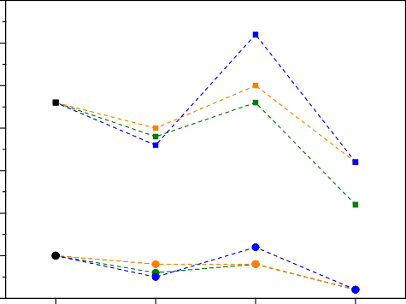
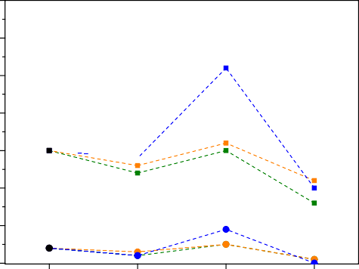4500

4000

3500
Molecular Weight (g.mol⁻¹)

3000

2500

2000

1500

1000

KL 1 h 3 h 6 h
1000

OL 1 h 3 h 6 h

- Figure 7. Molecular weight average (Mw - ■) and molecular number average (Mn - ●)

- of technical lignins and corresponding recovered lignin samples after treatment with

- [Ch]Cl:Oxa (Mw - ■; Mn - ●), [Ch]Cl:Oxa/H₂SO₄ (Mw - ■; Mn - ●) and

- [Ch]Cl:Oxa/H₂O₂ (Mw - ■; Mn - ●) at 80 °C during time. a) KL; b) OL

- In addition, FT-IR analyses of recovered lignin samples were performed to address

- possible chemical modifications induced by DES systems during depolymerisation

- process. All infrared spectra showed lignin fingerprint with typical vibrational bands as

- reported in literature.48–52 The list of all lignin vibrational bands and corresponding

- assignments are presented in SI (Table S4). Figure 8 shows magnified FT-IR spectra of

- KL, OL and corresponding recovered lignins (2000-600 cm-1). The most relevant were

- observed in the region 1800-750 cm-1 with remarkable high intensities at 1109, 1211,

- 1368, 1456, 1514, 1590 and 1736 cm-1. However, significant changes in the absorbance

- of specific bands were detected after depolymerisation with DES systems.

- One of the most prominent differences was the substantial increase of the vibrational

- band at 1736 cm-1 over time in all systems and both lignins. This vibration corresponds

- to the elongation of C=O chemical linkage, specifically associated to ester groups, which

- means that esterification was promoted between lignin hydroxyl groups and oxalic acid

- from DES. This phenomenon was already mentioned in a previous work.37 Moreover, this

- esterification was more evident in DES with catalysts than neat DES, suggesting that both

- H₂SO₄ and H₂O₂ might boost this parallel reaction. These results also reveal that

- depolymerisation product yields might be higher than those shown in Figure 1. The

- esterification of oxalic acid in lignin structure directly increases the recovery yield of

- regenerated lignin affecting the calculations of depolymerisation product yield (equation

- 2, section 2.3).

- 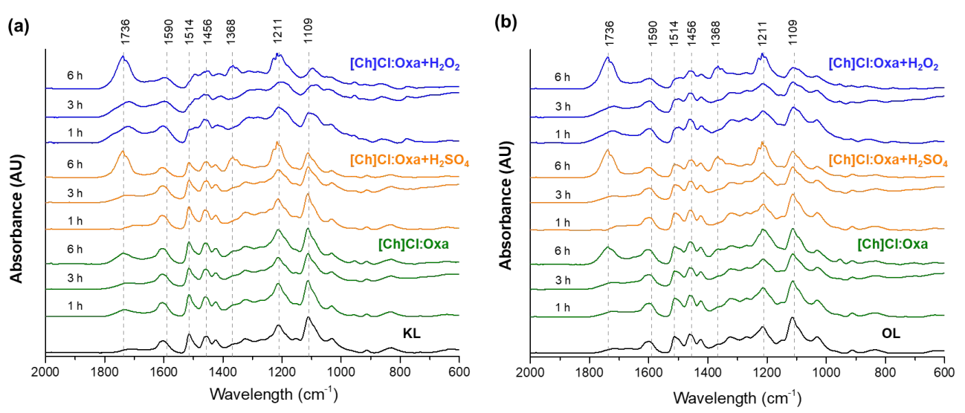
- Figure 8. Magnified FT-IR spectra of technical lignins and corresponding recovered

- lignin samples after treatment with [Ch]Cl:Oxa (■), [Ch]Cl:Oxa/H₂SO₄ (■) and

- [Ch]Cl:Oxa/H₂O₂ (■) at 80 °C during time.

- On the other hand, the vibrational band at 1109 cm-1 decreased sharply during lignin

- treatments, while an opposite behaviour was observed for the vibrational band at 1368

- cm-1. The last represents the C-OH vibrations of phenolic hydroxyl groups,53,54 which

- increased during time as consequence of the direct cleavage of aryl ether bonds (e.g. β-

- O-4 and α-O-4), represented by the first one (C-O vibration in ether bonds).55,56 Once

- more, these chemical changes were more pronounced when using [Ch]Cl:Oxa/H₂SO₄ and

- [Ch]Cl:Oxa/H₂O₂.

- Another important change to be highlighted from these data is the conservation or

- deformation of the aromatic structure of lignin directly represented by the aromatic

- skeletal vibrations, namely 1456, 1514, and 1590 cm-1, after treatments. As observed in

- Figure 8, treatments of both lignins with [Ch]Cl:Oxa did not affect these bands, but those

- with [Ch]Cl:Oxa/H₂SO₄ (6 h) and [Ch]Cl:Oxa/H₂O₂ (1, 3 and 6 h) altered significantly

- their shape and absorbance. This is more pronounced for treatments with H₂O₂,

- suggesting that aromatic skeletal structure of lignin is highly disrupted or substantially

- changed under oxidative conditions. This behaviour is in agreement with the results

- reported by Wan et al.57 The authors verified that after acidic oxidative treatment of lignin

- (phosphonic acid and hydrogen peroxide) HO+ or HO radical was produced, being

- responsible for an extensive ring-opening on the aromatic substructure. Furthermore,

- aromatic ring substitution by chloride atoms may also be favoured in similar way as

- chlorinated compounds were formed during depolymerisation in presence of H₂O₂.

- The results obtained from the elemental analysis (Table S5) of depolymerised lignins

- showed an impact of depolymerisation on carbon, hydrogen, nitrogen and sulfur contents

- in recovered lignins. This impact is mostly pronounced in acidic oxidative medium

- ([Ch]Cl:Oxa/H₂O₂), in which the carbon and sulfur content decreased almost 1.2- and

- 3.2-fold, respectively. In this case, the substitution of chloride atoms in the aromatic ring

- structure may lead to such drastic decrease of carbon content.

- Discussion

- Overall, the present work demonstrated that acidic DES such as [Ch]Cl:Oxa can act as

- both solvent and catalyst to simultaneously allow partial lignin depolymerisation into

- desired monomeric and oligomeric compounds and partial lignin modification into a

- functionalised material. In the chemical point of view, no substantial difference between

- the performances of neat DES or DES with catalytic amount of H₂SO₄ was observed,

- while on the opposite using H₂O₂ as catalyst provided severe side reactions that changed

- both depolymerisation product profile and the remaining lignin structure.

- The inherent acidity of oxalic acid (pka ≃ 1.5) per se was sufficient to give [Ch]Cl:Oxa

- the ability to promote lignin depolymerisation for all studied system.39,58 However,

- additional catalytic amount of a strong acid like H₂SO₄ (pka ≃ -3.0) slightly favoured the

- disruption of lignin chemical bonds, specially β-O-4 bond cleavage,59,60 increasing the

- depolymerisation efficiency. The maximum yield of 27.8 wt% is at the same level of

- lignin depolymerisation with DES reported in literature. Hong et al.39 observed that the

- process of alkaline lignin treatment with [Ch]Cl:Lac or [Ch]Cl:Oxa at 80-120 °C for 6 h

- resulted in depolymerisation yields ranging from 25 to 56 % of the initial lignin.39

- Furthermore, for treatments with [Ch]Cl:Oxa and [Ch]Cl:Oxa/H₂SO₄, a decrease of

- lignin depolymerisation product yield at 6 h can be explained by the existence of

- condensation and repolymerisation reactions between formed products.6,39 This enables

- the formation of insoluble products and subsequently increases the yield of regenerated

- lignin. These undesired reactions, which are favoured at long treatments, are also one of

- the major limitations in several lignin depolymerisation processes.61,62 The condensation

- and repolymerisation reactions during time was more evident in KL treatment with

- [Ch]Cl:Oxa/H₂O₂.

- The identification of depolymerised products by GC/MS plainly shows that the

- composition of lignin depolymerisation extract is highly dependent on lignin nature.

- Although 2D HSQC NMR of both KL from E. grandis wood and OL from beech wood

- did not reveal significant structural differences (Figure S1 in SI), distinct lignin

- monomers were produced under similar treatment conditions (DES system, temperature,

- and time). This might be associated to the sulfur content in KL (approximately 2 wt%),

- that will influence the reactivity in contact with DES and subsequently its

- depolymerisation.63,64 Furthermore, treating KL under acidic conditions ([Ch]Cl:Oxa and

- [Ch]Cl:Oxa/H₂SO₄) enables a selective formation of syringol (8), which means that

- propyl side chains of S type units present in KL are favourably cleaved apart from the

- aromatic ring. On the contrary, this cleavage seems to not be favoured when OL is the

- feedstock, since syringic acid (27) is formed in higher content than syringol (8) under the

- same acidic conditions. On the other hand, the acidic oxidative medium

- ([Ch]Cl:Oxa/H₂O₂) favoured the formation of vanillic acid (14) from KL, probably as a

- result of the strong oxidation of G type units, like acetovanillone (11) and vanillin (9),

- mediated by H₂O₂.65 Similar observation was found for OL treatment under same

- oxidative conditions, in which syringic and vanillic acids were two of the most produced

- monomers. Moreover, chlorinated aromatic compounds were detected in higher amount

- in presence of H₂O₂, resulting from the electrophilic substitution of chloride anion in the

- aromatic ring.

- Lignin depolymerisation in acidic DES has been tackled over the last few years, where

- several authors have used lignin model compounds to mimic and to understand the

- mechanisms acting in real lignin samples.38,40,66,67 For instance, Alvarez-Vasco et al.38

- used guaiacylglycerol-β-guaiacil ether (GG) as lignin model compound to evaluate the

- ability of [Ch]Cl:Lac to cleave its β-O-4 ether bond. The authors found that GG was

- completely converted into guaiacol and a Hibbert ketone in almost stoichiometric

- proportion. The proposed mechanism was similar to the acidolysis mechanism of lignin

- catalysed by hydrochloric acid.59 Bearing this in mind and looking to products of KL and

- OL depolymerisation with both [Ch]Cl:Oxa and [Ch]Cl:Oxa/H₂SO₄, it is possible to

- propose a plausible reaction pathway for this acidic lignin depolymerisation. The reaction

- starts through an attack of acidic protons from Oxa and/or H₂SO₄ to the α-hydroxyl group

- surrounding the β-O-4 linkage, generating a carbocation through the release of a

- molecular unit of H₂O.68–70 The elimination reaction between α positive charge and β-H

- results in an enol ether intermediate and simultaneous regeneration of the proton. This

- intermediate energetically favours the cleavage of the ether bond enabling the formation

- of S or G type Hibbert ketones (compounds (21) and (29)) and simultaneous liberation of

- an aromatic alcohol, guaiacol (1) or syringol (8).68–70 From those very unstable Hibbert

- ketones, all other identified compounds are formed through distinct reactions (e.g.

- dehydration, oxidation, acylation, demethoxylation, etc.) and their stability is dependent

- on the chemical environment offered by DES media. Although this mechanism finds well

- the KL depolymerisation, the low formation of guaiacol and syringol during OL

- treatments with both [Ch]Cl:Oxa and [Ch]Cl:Oxa/H₂SO₄ suggests that other kind of

- depolymerisation mechanism is favoured in OL.

- As mentioned above, both KL and OL depolymerisation with [Ch]Cl:Oxa/H₂O₂

- provided a distinct profile of monomeric aromatic compounds, with the formation of

- chlorinated compounds. The oxidative action of H₂O₂ in presence of [Ch]Cl:Oxa led to a

- wide extent of several types of chlorinated substitutions at the aromatic ring of lignin

- monomers. Syringol (8), one of the most produced monomers in acidic depolymerisation,

- and its precursor (18) were substituted in different positions of the aromatic ring by

- chloride (compounds (16), (20) and (25)). In fact, compounds (16) and (25), single and

- double substituted with chloride (at positions 2 and 6), respectively, represented the major

- monomer compounds of the KL depolymerisation extract at 1 h. During treatment, the

- amount of those compounds decreased. As consequence of these chlorinated

- substitutions, guaiacol and syringol were barely formed in [Ch]Cl:Oxa/H₂O₂ medium.

- Moreover, chlorination of other G and S type monomers, including vanillic acid (14),

- acetosyringone (24) and syringic acid (27) into compounds (26), (28) and (30), was also

- observed. Their formation had a maximum at 3 h, while further consumption up to 6 h

- was observed, which means that lignin monomer substitution with chloride do not prevent

- further condensation and repolymerisation reactions. Surprisingly, the chlorination of

- acetovanillone (11) and vanillic acid (14) was not favoured. For instance, the amount of

- chlorinated vanillic acid (26) was much lower than its chlorinated counterparts, while

- vanillic acid stands as one of the major compounds in both lignin depolymerisation

- extracts at 6 h.

- Therefore, lignin depolymerisation given by [Ch]Cl:Oxa/H₂O₂, not only provides an

- acid-based catalysis of lignin into different lignin monomers, but also enables their

- chlorination. The oxidation power of H₂O₂ gives chloride an electrophilic behaviour to

- substitute the aromatic ring in different positions.71,72 Since chlorinated aromatic

- compounds are highly toxic, their production from lignin depolymerisation in presence

- of [Ch]Cl:Oxa/H₂O₂ might be seen as a disadvantage. Although there was a wide market

- for these kind of compounds in the past, to be used as pesticides, herbicides and

- desinfectants,73,74 their poor biodegradation poses some environmental concerns.75

- Therefore, their substitution by other more environmentally friendly compounds have

- been pursued lately.76,77 Therefore, the use of [Ch]Cl-based DES (or other DES composed

- of halide salts) in combination with H₂O₂ is not recommended for lignin depolymerisation

- technologies.

- Apart from the depolymerised product fraction, the remaining lignin suffered

- physicochemical modifications that are relevant for further valorisation.

- The data of lignin molecular weight distribution highlights the performance of

- [Ch]Cl:Oxa without additional catalyst, since recovered lignin samples from treatments

- at 6 h using this system presented the lowest values of Mw and PDI. The PDI value was

- even lower than that of initial KL and OL, an indication that such recovered lignin

- exhibits a narrow dispersity of molecular weights,34 probably as consequence of less

- severe and more selective depolymerisation. On the other hand, the more acidic (H₂SO₄)

- and oxidative (H₂O₂) DES systems provided severe and wider depolymerisation of lignin

- fragments leading to higher PDI values (Table S3).

- Furthermore, an increase of COOH (oxalic esterification) and phenolic OH sites 602 (cleavage of aryl ether bonds) in remaining lignin structures was unveiled, which 603 enhances the reactivity potential of these lignin samples for several applications, 604 including grafting reactions with high density polyethylene (HDPE)78 as well as the 605 preparation of functionalised lignin nanoparticles for new bio-based composites.79 It 606 should be emphasised that although the esterification reaction between DES and lignin 607 during depolymerisation leads to slight DES consumption, these results show that 608 recovered lignins can be considered as functionalised materials. Moreover, the sulfur 609 content in KL was substantially reduced with depolymerisation, which is also beneficial, 610 since sulfur content is one the major deterrents of Kraft lignin valorisation.
611 Therefore, an integration of depolymerisation and functionalisation of lignin with DES 612 is herein presented as an alternative process to increase cost efficiency in the production 613 of value-added compounds and new bio-based composites and materials from technical 614 lignins. Yet, future work regarding the fine-tune and optimization of this process should 615 be carried out.
616

617 Conclusion

618 This work demonstrated the potential of an acidic DES ([Ch]Cl:Oxa at molar ratio 1:1) 619 in presence or absence of co-catalysts (H₂SO₄ and H₂O₂) towards the depolymerisation 620 of Kraft and Organosolv lignins at mild conditions (80 ºC). At least a quarter of the initial 621 lignin can be converted into monomers and oligomers in 3 h, while longer times favoured 622 condensation and repolymerisation reactions decreasing the yield of depolymerisation 623 products. Furthermore, the final product content is dependent on lignin nature as well as 624 on the chemical environment provided by DES systems, namely acidic ([Ch]Cl:Oxa and 625 [Ch]Cl:Oxa/H₂SO₄) or acidic oxidative treatments ([Ch]Cl:Oxa/H₂O₂). For instance, the

626 acidic treatments of Kraft lignin favoured the formation of syringol and acetosyringone, 627 while vanillic and syringic acids were the main products in the acidic treatments of 628 Organosolv lignin. On the other hand, the presence of H₂O₂ in DES revealed an opposite 629 behaviour by inducing electrophilic substitutions of chloride from [Ch]Cl in the aromatic 630 ring of produced lignin monomers from both lignin types. Bearing in mind the toxicity of 631 these chlorinated compounds, it seems prudent to avoid the use of H₂O₂ as an additive in 632 lignin depolymerisation with [Ch]Cl-based DES or other DES composed of halide salts. 633 Moreover, the regenerated lignin samples after depolymerisation reveal different 634 characteristics in contrast to their precedent technical lignins. Different molecular weight 635 and significant chemical changes, including esterification with oxalic acid and increase 636 of phenolic group content as consequent of aryl ether bond cleavage, were observed. 637 Overall, the data herein presented is a first step to accomplish a sustainable lignin 638 valorisation using DES.
639

640 Conflicts of interest

641 There are no conflicts to declare.

642

643 Acknowledgments

644 This work was financed in part by the Coordenação de Aperfeiçoamento de Pessoal 645 de Nível Superior - Brasil (CAPES) - Finance Code 001, FAPESP [2014/21252-0], CNPq 646 [169459/2017-9, 200627/2018-0, 310272/2017-3, 140723/2016-1, 169743/2018-7],
647 Banco Santander S. A., PROCAD (88887.200617/2018-00),

648 CAPES/PRINT(88881.310551/2018-01) and FAEPEX/UNICAMP and partially

649 developed within the scope of the project CICECO-Aveiro Institute of Materials, FCT

650 Ref. UIDB/50011/2020 & UIDP/50011/2020, financed by national funds through the

651 FCT/MCTES. Authors would like to thank COST Action CA17128 for financing the 652 STSM of Filipe H. Sosa enabling collaboration with National Institute of Chemistry in 653 Ljubljana. Slovenian Research Agency (ARRS) through Programme P2–0152 and the 654 research project J2-2492 is also greatly acknowledged. André M. da Costa Lopes thanks 655 his research contract funded by Fundação para a Ciência e Tecnologia (FCT) and project 656 CENTRO-04-3559-FSE-000095 - Centro Portugal Regional Operational Programme 657 (Centro2020), under the PORTUGAL 2020 Partnership Agreement, through the 658 European Regional Development Fund (ERDF).
659

660 Abbreviations

661 DES, deep eutectic solvent; HBA, hydrogen bond acceptor; HBD, hydrogen bond donor; 662 [Ch]Cl, cholinium chloride; KL, Kraft Lignin; OL, Organosolv Lignin; Oxa, oxalic acid, 663 LA, lactic acid; pTsa, p-toluenesulfonic acid; DFT, Density functional theory.
664

665 Author Contributions

666 Filipe H. B. Sosa: Conceptualisation, Methodology, Investigation, Data Curation Writing 667 - Original Draft, Visualisation; Ana Bjelić: Investigation; João A. P. Coutinho: Writing 668 - Review & Editing, Supervision; Mariana C. Costa: Writing - Review & Editing, 669 Supervision, Funding acquisition; Blaž Likozar: Writing - Review & Editing; Edita 670 Jasiukaitytė-Grojzdek: Conceptualisation, Methodology, Data Curation, Writing - 671 Review & Editing; Miha Grilc: Conceptualisation, Writing - Review & Editing, 672 Supervision, Funding acquisition; André M. da Costa Lopes: Conceptualisation, 673 Methodology, Data Curation, Writing - Review & Editing, Supervision, Funding 674 acquisition.
675

676 References

677 1 A. Berlin and M. Balakshin, in Bioenergy Research: Advances and Applications, 678 eds. V. K. Gupta, M. G. Tuohy, C. P. Kubicek, J. Saddler and F. Xu, Elsevier, 679 Amsterdam, 2014, pp. 315–336.
680 2 S. Imman, P. Khongchamnan, W. Wanmolee, N. Laosiripojana, T. Kreetachat, C.

681 Sakulthaew, C. Chokejaroenrat and N. Suriyachai, RSC Adv., 2021, 11, 26773–

682 26784.

683 3 E. Adler, Nature, 1977, 11, 169–218.

684 4 S. Gillet, M. Aguedo, L. Petitjean, A. R. C. Morais, A. M. Da Costa Lopes, R. M.

685 Łukasik and P. T. Anastas, Green Chem., 2017, 19, 4200–4233.

686 5 Q. Qiao, J. Shi and Q. Shao, Phys. Chem. Chem. Phys., 2021, 23, 25699–25705. 687 6 J. Zakzeski, P. C. A. Bruijnincx, A. L. Jongerius and B. M. Weckhuysen, Chem. 688 Rev., 2010, 110, 3552–3599.
689 7 A. J. Ragauskas, G. T. Beckham, M. J. Biddy, R. Chandra, F. Chen, M. F. Davis, 690 B. H. Davison, R. A. Dixon, P. Gilna, M. Keller, P. Langan, A. K. Naskar, J. N. 691 Saddler, T. J. Tschaplinski, G. A. Tuskan and C. E. Wyman, Science (80-. )., 2014, 692 344, 1246843.
693 8 C. Heitner, D. Dimmel and J. Schmidt, Lignin and lignans: advances in chemistry,

694 CRC press, 2016.

695 9 C. Chio, M. Sain and W. Qin, Renew. Sustain. Energy Rev., 2019, 107, 232–249.

696 10 M. Wang, L. H. Li, J. M. Lu, H. J. Li, X. C. Zhang, H. F. Liu, N. C. Luo and F.

697 Wang, Green Chem., 2017, 19, 702–706.

698 11 D. M. Miles-Barrett, A. R. Neal, C. Hand, J. R. D. Montgomery, I. Panovic, O. S. 699 Ojo, C. S. Lancefield, D. B. Cordes, A. M. Z. Slawin, T. Lebl and N. J. Westwood, 700 Org. Biomol. Chem., 2016, 14, 10023–10030.

701 12 C. Li, X. Zhao, A. Wang, G. W. Huber and T. Zhang, Chem. Rev., 2015, 115,

702 11559–11624.

703 13 S. Mukundan, L. Atanda and J. Beltramini, Sustain. Energy Fuels, 2019, 3, 1317–

704 1328.

705 14 R. Ma, M. Guo and X. Zhang, Catal. Today, 2018, 302, 50–60.

706 15 C. Xu, R. A. D. Arancon, J. Labidi and R. Luque, Chem. Soc. Rev., 2014, 43, 7485–

707 7500.

708 16 J. R. Gasson, D. Forchheim, T. Sutter, U. Hornung, A. Kruse and T. Barth, Ind.

709 Eng. Chem. Res., 2012, 51, 10595–10606.

710 17 T. Welton, Biophys. Rev., 2018, 10, 691–706.

711 18 C. J. Clarke, W.-C. Tu, O. Levers, A. Bröhl and J. P. Hallett, Chem. Rev., 2018,

712 118, 747–800.

713 19 R. P. Swatloski, S. K. Spear, J. D. Holbrey and R. D. Rogers, J. Am. Chem. Soc.,

714 2002, 124, 4974–4975.

715 20 A. P. Carneiro, O. Rodríguez and E. A. Macedo, Bioresour. Technol., 2017, 227,

716 188–196.

717 21 E. Reichert, R. Wintringer, D. A. Volmer and R. Hempelmann, Phys. Chem. Chem.

718 Phys., 2012, 14, 5214–5221.

719 22 US9550710B2, 2014.

720 23 B. J. Cox and J. G. Ekerdt, Bioresour. Technol., 2012, 118, 584–588.

721 24 S. Jia, B. J. Cox, X. Guo, Z. C. Zhang and J. G. Ekerdt, ChemSusChem, 2010, 3,

722 1078–1084.

723 25 S. P. F. Costa, A. M. O. Azevedo, P. C. A. G. Pinto and M. L. M. F. S. Saraiva,

724 ChemSusChem, 2017, 10, 2321–2347.

725 26 B. B. Hansen, S. Spittle, B. Chen, D. Poe, Y. Zhang, J. M. Klein, A. Horton, L.

726 Adhikari, T. Zelovich, B. W. Doherty, B. Gurkan, E. J. Maginn, A. Ragauskas, M. 727 Dadmun, T. A. Zawodzinski, G. A. Baker, M. E. Tuckerman, R. F. Savinell and J. 728 R. Sangoro, Chem. Rev., 2021, 121, 1232–1285.
729 27 A. P. Abbott, D. Boothby, G. Capper, D. L. Davies and R. K. Rasheed, J. Am.

730 Chem. Soc., 2004, 126, 9142–9147.

731 28 M. A. R. Martins, S. P. Pinho and J. A. P. Coutinho, J. Solution Chem., 2019, 48,

732 962–982.

733 29 X. Tang, M. Zuo, Z. Li, H. Liu, C. Xiong, X. Zeng, Y. Sun, L. Hu, S. Liu, T. Lei

734 and L. Lin, ChemSusChem, 2017, 10, 2696–2706.

735 30 F. H. B. Sosa, R. M. Dias, A. M. d. C. Lopes, J. A. P. Coutinho and M. C. da Costa,

736 Sustain., , DOI:10.3390/SU12083358.

737 31 M. Chen, Q. Sun, Y. Wang, Z. Yang, Q. Wang, Y. Cao and J. Wang, J. Biobased

738 Mater. Bioenergy, 2019, 13, 317–328.

- 32 B. Soares, A. M. da Costa Lopes, A. J. D. Silvestre, P. C. Rodrigues Pinto, C. S.

- R. Freire and J. A. P. Coutinho, Ind. Crops Prod., 2021, 160, 113128.

- 33 J. G. Lynam, N. Kumar and M. J. Wong, Bioresour. Technol., 2017, 238, 684–689.

- 34 Z. Chen and C. Wan, Bioresour. Technol., 2018, 250, 532–537.

- 35 Y. Song, R. P. Chandra, X. Zhang, T. Tan and J. N. Saddler, Sustain. Energy Fuels,

744 2019, 3, 1329–1337.

745 36 S. Hong, X.-J. Shen, Z. Xue, Z. Sun and T.-Q. Yuan, Green Chem., 2020, 22,

746 7219–7232.

- 37 F. H. B. Sosa, D. O. Abranches, A. M. Da Costa Lopes, J. A. P. Coutinho and M.

- C. Da Costa, ACS Sustain. Chem. Eng., 2020, 8, 18577–18589.

- 38 C. Alvarez-Vasco, R. Ma, M. Quintero, M. Guo, S. Geleynse, K. K. Ramasamy,

- M. Wolcott and X. Zhang, Green Chem., 2016, 18, 5133–5141.

- 39 S. Hong, X. J. Shen, B. Pang, Z. Xue, X. F. Cao, J. L. Wen, Z. H. Sun, S. S. Lam,

752 T. Q. Yuan and R. C. Sun, Green Chem., 2020, 22, 1851–1858.

753 40 A. M. Da Costa Lopes, J. R. B. Gomes, J. A. P. Coutinho and A. J. D. Silvestre,

754 Green Chem., 2020, 22, 2474–2487.

755 41 P. D. Muley, J. K. Mobley, X. Tong, B. Novak, J. Stevens, D. Moldovan, J. Shi

756 and D. Boldor, Energy Convers. Manag., 2019, 196, 1080–1088.

757 42 D. Di Marino, V. Aniko, A. Stocco, S. Kriescher and M. Wessling, Green Chem.,

758 2017, 19, 4778–4784.

759 43 C. Fernández-Costas, S. Gouveia, M. A. Sanromán and D. Moldes, Biomass and

760 Bioenergy, 2014, 63, 156–166.

761 44 A. Trubetskaya, H. Lange, B. Wittgens, A. Brunsvik, C. Crestini, U. Rova, P.

762 Christakopoulos, J. J. Leahy and L. Matsakas, Processes, 2020, 8, 1–21.

763 45 S. Nanayakkara, A. F. Patti and K. Saito, Green Chem., 2014, 16, 1897–1903. 764 46 E. Jasiukaityte-Grojzdek, M. Kunaver and C. Crestini, J. Wood Chem. Technol., 765 2012, 32, 342–360.
766 47 H. Wang, M. Tucker and Y. Ji, J. Appl. Chem., 2013, 2013, 1–9.

767 48 N. Cachet, S. Camy, B. Benjelloun-Mlayah, J. S. Condoret and M. Delmas, Ind.

768 Crops Prod., 2014, 58, 287–297.

769 49 P. H. G. Cademartori, P. S. B. dos Santos, L. Serrano, J. Labidi and D. A. Gatto,

770 Ind. Crops Prod., 2013, 45, 360–366.

771 50 A. García, X. Erdocia, M. González Alriols and J. Labidi, Chem. Eng. Process.

772 Process Intensif., 2012, 62, 150–158.

773 51 O. Gordobil, R. Delucis, I. Egüés and J. Labidi, Ind. Crops Prod., 2015, 72, 46–

774 53.

775 52 S. N. Sun, M. F. Li, T. Q. Yuan, F. Xu and R. C. Sun, Ind. Crops Prod., 2012, 37,

776 51–60.

777 53 S. Tabasso, G. Grillo, D. Carnaroglio, E. C. Gaudino and G. Cravotto, Molecules,

778 2016, 21, 413.

779 54 C. G. Boeriu, D. Bravo, R. J. A. Gosselink and J. E. G. Van Dam, Ind. Crops Prod.,

780 2004, 20, 205–218.

781 55 A. Casas, M. V. Alonso, M. Oliet, E. Rojo and F. Rodríguez, J. Chem. Technol.

782 Biotechnol., 2012, 87, 472–480.

783 56 A. A. M. A. Nada, M. A. Yousef, K. A. Shaffei and A. M. Salah, Polym. Degrad.

784 Stab., 1998, 62, 157–163.

785 57 X. Wan, D. Tian, F. Shen, J. Hu, G. Yang, Y. Zhang, S. Deng, J. Zhang and Y.

786 Zeng, Energy and Fuels, 2018, 32, 5218–5225.

787 58 Z. Chen, A. Ragauskas and C. Wan, Ind. Crops Prod., 2020, 147, 112241.

788 59 T. Imai, T. Yokoyama and Y. Matsumoto, J. Wood Sci., 2011, 57, 219–225.

789 60 Y. Matsushita, T. Inomata, T. Hasegawa and K. Fukushima, Bioresour. Technol.,

790 2009, 100, 1024–1026.

791 61 S. Wang, H. Li, L.-P. Xiao and G. Song, Front. Energy Res., 2020, 8, 860.

792 62 J. Long, Y. Xu, T. Wang, Z. Yuan, R. Shu, Q. Zhang and L. Ma, Appl. Energy,

793 2015, 141, 70–79.

794 63 O. Gordobil, R. Herrera, M. Yahyaoui, S. İlk, M. Kaya and J. Labidi, RSC Adv.,

795 2018, 8, 24525–24533.

- 64 D. Daniel, L. Khachatryan, C. Astete, R. Asatryan, C. Marculescu and D. Boldor,

- Bioresour. Technol. Reports, 2019, 8, 100341.

- 65 Q. XIANG and Y. Y. LEE, Appl. Biochem. Biotechnol., 2000, 84, 153–162.

- 66 J. Sun, T. Dutta, R. Parthasarathi, K. H. Kim, N. Tolic, R. K. Chu, N. G. Isern, J.

- R. Cort, B. A. Simmons and S. Singh, Green Chem., 2016, 18, 6012–6020.

- 67 C. Cai, K. Hirth, R. Gleisner, H. Lou, X. Qiu and J. Y. Zhu, Green Chem., 2020,

802 22, 1605–1617.

803 68 M. R. Sturgeon, S. Kim, K. Lawrence, R. S. Paton, S. C. Chmely, M. Nimlos, T.

804 D. Foust and G. T. Beckham, ACS Sustain. Chem. Eng., 2014, 2, 472–485.

805 69 H. Ito, T. Imai, K. Lundquist, T. Yokoyama and Y. Matsumoto, J. Wood Chem.

806 Technol., 2011, 31, 172–182.

807 70 K. Lundquist and R. Lundgren, Acta Chem. Scand., 1972, 26, 2005–2023.

808 71 P. Ortiz-Bermúdez, K. C. Hirth, E. Srebotnik and K. E. Hammel, Proc. Natl. Acad.

809 Sci. U. S. A., 2007, 104, 3895–3900.

810 72 R. Ma, Y. Xu and X. Zhang, ChemSusChem, 2015, 8, 24–51.

811 73 S. Sanchis, A. M. Polo, M. Tobajas, J. J. Rodriguez and A. F. Mohedano, Environ.

812 Sci. Pollut. Res., 2014, 21, 9445–9452.

813 74 J. W. Moore and S. Ramamoorthy, in Organic Chemicals in Natural Waters: 814 Applied Monitoring and Impact Assessment, Springer New York, New York, NY, 815 1984, pp. 88–114.
816 75 A. Abarnou and L. Miossec, Sci. Total Environ., 1992, 126, 173–197.

817 76 P. Bhatt, M. S. Kumar, S. Mudliar and T. Chakrabarti, Crit. Rev. Environ. Sci.

818 Technol., 2007, 37, 165–198.

819 77 A. Jordan and N. Gathergood, Antibiotics, 2013, 2, 419–438.

820 78 L. Hu, T. Stevanovic and D. Rodrigue, J. Appl. Polym. Sci., 2015, 132.

821 79 X. Yang and S. Zhong, J. Appl. Polym. Sci., 2020, 137, 49025.

822
823
824

825

826 TOC/Abstract Graphic

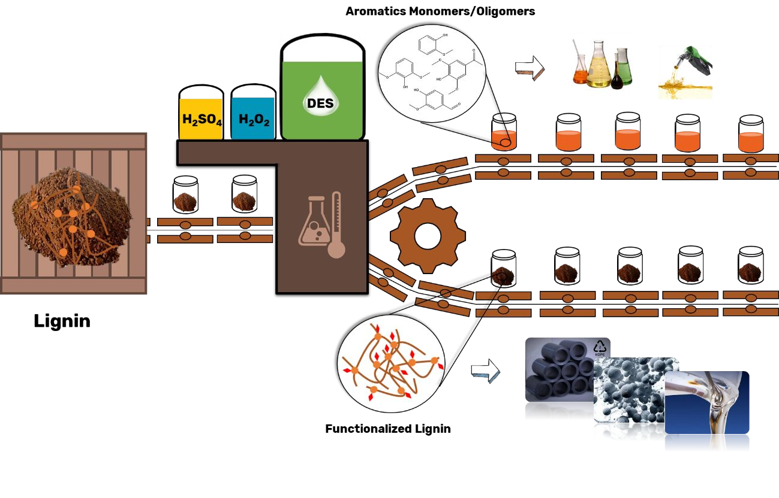
827
828 Synopsis. The valorisation of technical lignins by conversion is herein demonstrated 829 using an acidic deep eutectic solvent in absence or presence of co-catalyst (H₂SO₄ or 830 H₂O₂).

SUPPLEMENTARY INFORMATION

Conversion of Organosolv and Kraft lignins into value-added compounds assisted by an acidic deep eutectic solvent

Filipe H. B. Sosa1,2, Ana Bjelić3, João A. P. Coutinho1, Mariana C. Costa2, Blaž Likozar3 Edita Jasiukaitytė-Grojzdek3, Miha Grilc3, Andre M. da Costa Lopes1,4*

1CICECO, Department of Chemistry, University of Aveiro, Campus Universitário de Santiago, Aveiro, Portugal.
2School of Chemical Engineering (FEQ), University of Campinas (UNICAMP), Campinas, Brazil.
3Department of Catalysis and Chemical Reaction Engineering, National Institute of Chemistry, Hajdrihova 19, 1000 Ljubljana, Slovenia
4CECOLAB - Collaborative Laboratory Towards Circular Economy, R. Nossa Senhora da Conceição, 3405-155 Oliveira do Hospital

* Corresponding author. e-mail address: andremcl@ua.pt

S1 – 2D HSQC NMR characterization of initial Kraft and Organosolv lignins
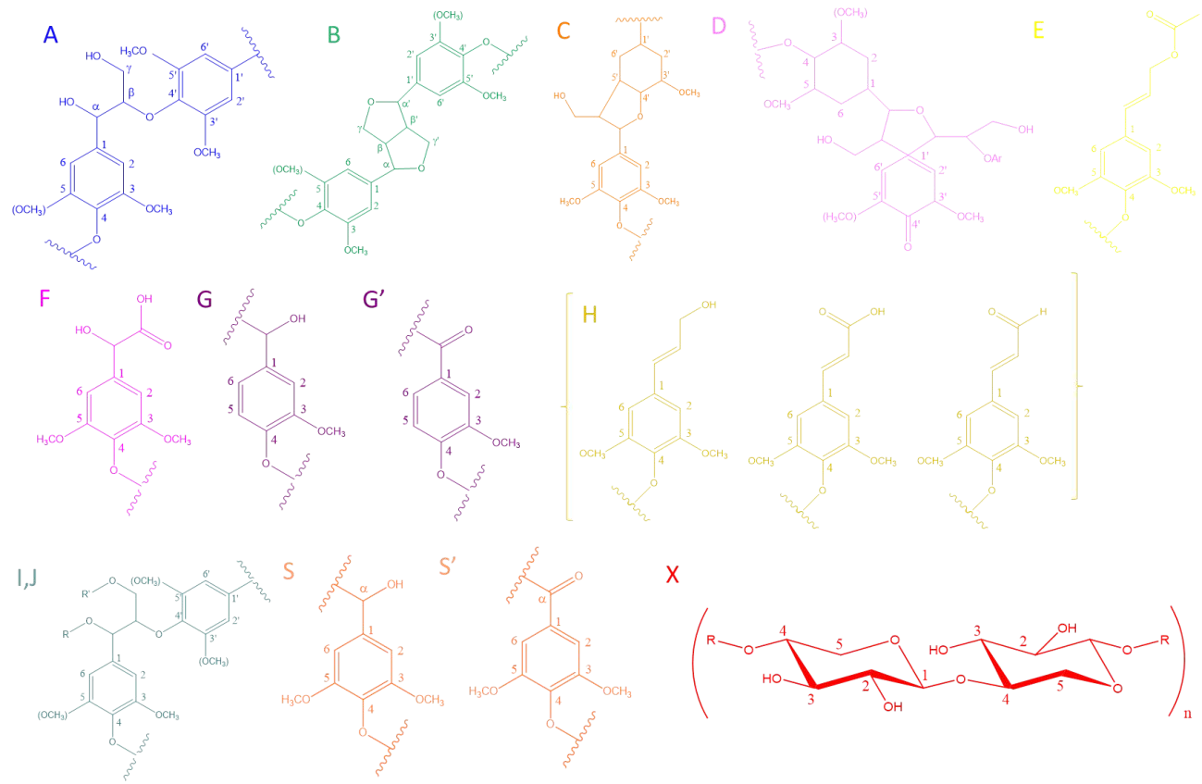
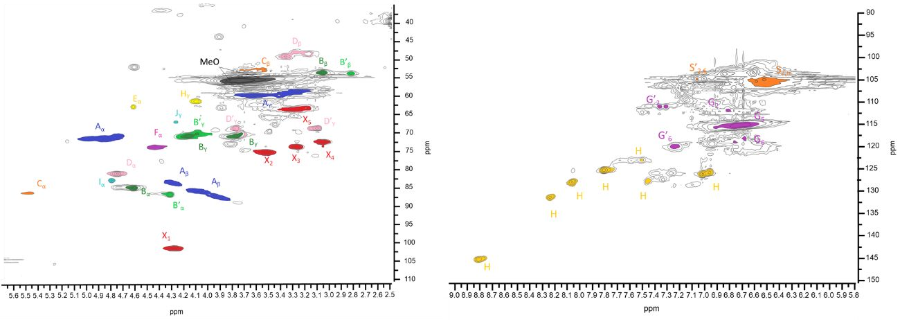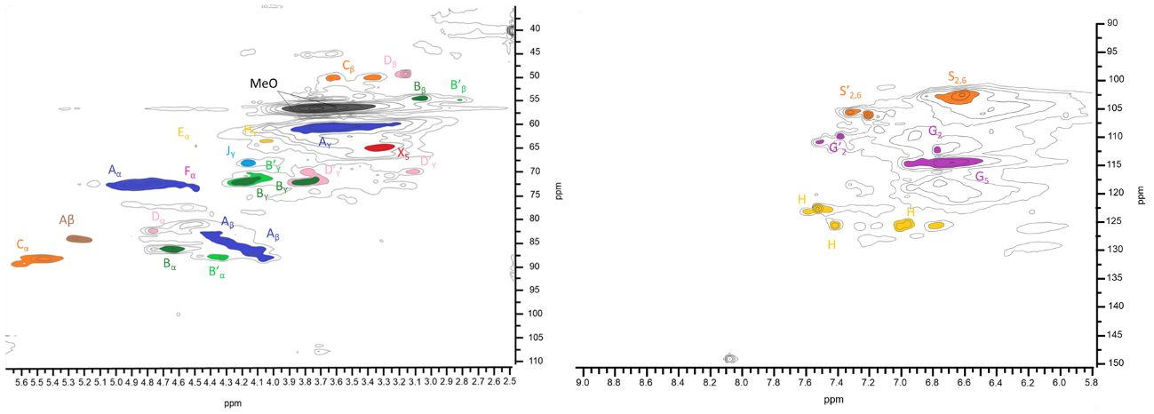
(A)
(B)

Figure S1. 2D HSQC NMR spectra of (A) Kraft lignin and (B) Organosolv Lignin with corresponding assignments of lignin substructures.

Table S1. Assignments of main lignin 1H-13C correlation signals found in the HSQC spectra.

Labels | δC | δH | Assignment
Dβ | 49.61 | 3.39 | C_{β}-H_{β} in β-1’ spirodienone substructures (D)
Bβ | 53.50 | 3.07 | C_{β}-H_{β} in resinol substructures (B)
Cβ | 53.71 | 3.46 | C_{β}-H_{β} in β-5 phenylcoumaran
B’β | 54.20 | 2.82 | C_{β}-H_{β} in epiresinol substructures (B)
MeO | 56.06 | 3.75 | C-H in methoxyls
Aγ | 59.00 | 3.2 | C_{γ}-H_{γ} in β-O-4’ substructures (A)
Aγ | 59.87 | 3.71 | C_{γ}-H_{γ} in β-O-4’ substructures (A)
Hγ | 61.59 | 4.11 | C_{γ}-H_{γ} in p-hydroxycynnamyl alcohol
Eα | 63.16 | 4.64 | C_{α}-H_{α} in p-hydroxycinnamyl alcohol
Cγ | 63.26 | 3.89 | C_{γ}-H_{γ} in β-5 phenylcoumaran
X5 | 63.63 | 3.28 | C₅-H₅ in xylan
Jγ | 66.88 | 4.28 | C_{γ}-H_{γ} in β-O-4’ Cα- etherified with carbohydrate
Dγ’ | 68.89 | 3.79 | C_{γ}-H_{γ} in β-1’ spirodienone substructures (D)
Dγ’ | 68.92 | 3.13 | C_{γ}-H_{γ} in β-1’ spirodienone substructures (D)
B’β | 70.56 | 4.09 | C_{β}-H_{β} in epiresinol substructures (B)
Bγ | 71.07 | 3.79 | C_{γ}-H_{γ} in resinol substructures (B)
Bγ | 71.14 | 4.2 | C_{γ}-H_{γ} in resinol substructures (B)
Aα | 71.62 | 4.91 | C_{α}-H_{α} in β-O-4’ substructures (A)
X4 | 72.85 | 3.06 | C₄-H₄ in xylan
Fα | 74.18 | 4.43 | C_{α}-H_{α} in Ar-CHOH-COOH unit
X3 | 74.28 | 3.28 | C₃-H₃ in xylan
X2 | 75.84 | 3.53 | C₂-H₂ in xylan
B’α | 81.36 | 4.78 | C_{α}-H_{α} in epiresinol substructures (B)
Cα | 82.92 | 5.51 | Cα-Hα in β-5 phenylcoumaran
Iα | 83.41 | 4.83 | Cα-Hα in β-O-4’ Cα- etherified with carbohydrate
Aβ | 83.96 | 4.31 | (G) CβHβ in β-O-4’ linked to G units
Aβ | 83 | 5.2 | Cβ−Hβ in β-O-4′ substructures
Bα | 85.3 | 4.67 | C_{α}-H_{α} in resinol substructures (B)
Dβ’ | 86.89 | 4.44 | C_{β} -H_{β} in β-1’ spirodienone substructures (D)
B’α | 87.22 | 4.33 | C_{α}-H_{α} in epiresinol substructures (B)
Aβ | 87.23 | 3.69 | (S) C_{β}-H_{β} in β-O-4’ linked to S units

X1 | 101.8 | 4.29 | C₁-H₁ in xylan
S’2.6 | 104.88 | 7.07 | C_{2.6} - H_{2.6} in oxidized Syringyl units (S’)
S2.6 | 105.22 | 6.47 | C_{2.6} - H_{2.6} in Syringyl units (S)
G2 | 111.00 | 6.95 | C₂-H₂ in Guaiacyl units (G)
G2’ | 111.04 | 7.33 | C₂-H₂ in oxidized Guaiacyl units (G)
G5 | 115.00 | 6.75 | C₅-H₅ in Guaiacyl units (G)
G6 | 119.00 | 6.75 | C₆-H₆ in Guaiacyl units (G)
G6’ | 120.14 | 7.24 | C₆-H₆ in oxidized Guaiacyl units (G)
H | 122.98 | 7.56 | Cynnamyl alcohols. aldehydes or acids (aromatic and end groups)
H | 125.53 | 7.79 | Cynnamyl alcohols. aldehydes or acids (aromatic and end groups)
H | 126.16 | 4.00 | Cynnamyl alcohols. aldehydes or acids (aromatic and end groups)
H | 127.01 | 7.35 | Cynnamyl alcohols. aldehydes or acids (aromatic and end groups)
H | 128.42 | 8.09 | Cynnamyl alcohols. aldehydes or acids (aromatic and end groups)
H | 131.29 | 8.23 | Cynnamyl alcohols. aldehydes or acids (aromatic and end groups)
H | 145.73 | 8.8 | Cynnamyl alcohols. aldehydes or acids (aromatic and end groups)

S2 – Characterization of lignin depolymerized fraction

Table S2. Main compounds identified in the GC-MS.

Entry Molecular structure Entry Molecular structure

O

OH OH
1 2
O OH

OH

OH
Cl OH
HO
3 4
O O
HO

OH HO
5 6
O O

OH

OH
7 8
O O

O OH

HO

9 10
O
O
OH

OH

Cl O

O
O
O
O
11 12
HO

HO OH

- HO
O

O
O
- OH

O HO

OH
O
Cl
HO
15 16
O O
O OH

OH

HO
O

17 18

O OH O O

OH

O

HO
19 20

O
O
Cl Cl

O O

OH

O
O

O
OH
21 22

HO

Cl OH

Cl O

Cl

O

O O

HO
23 24
HO

O O
O

OH O

Cl Cl O
OH
25 26
O O HO

OH Cl
O O
Cl

O O
OH
27 28
HO HO

O O

O
O
O
Cl
O
HO OH
29 30
HO
O
O
O

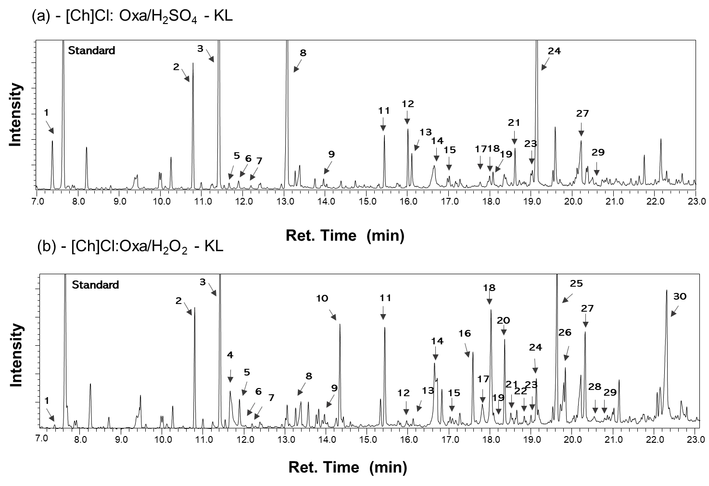
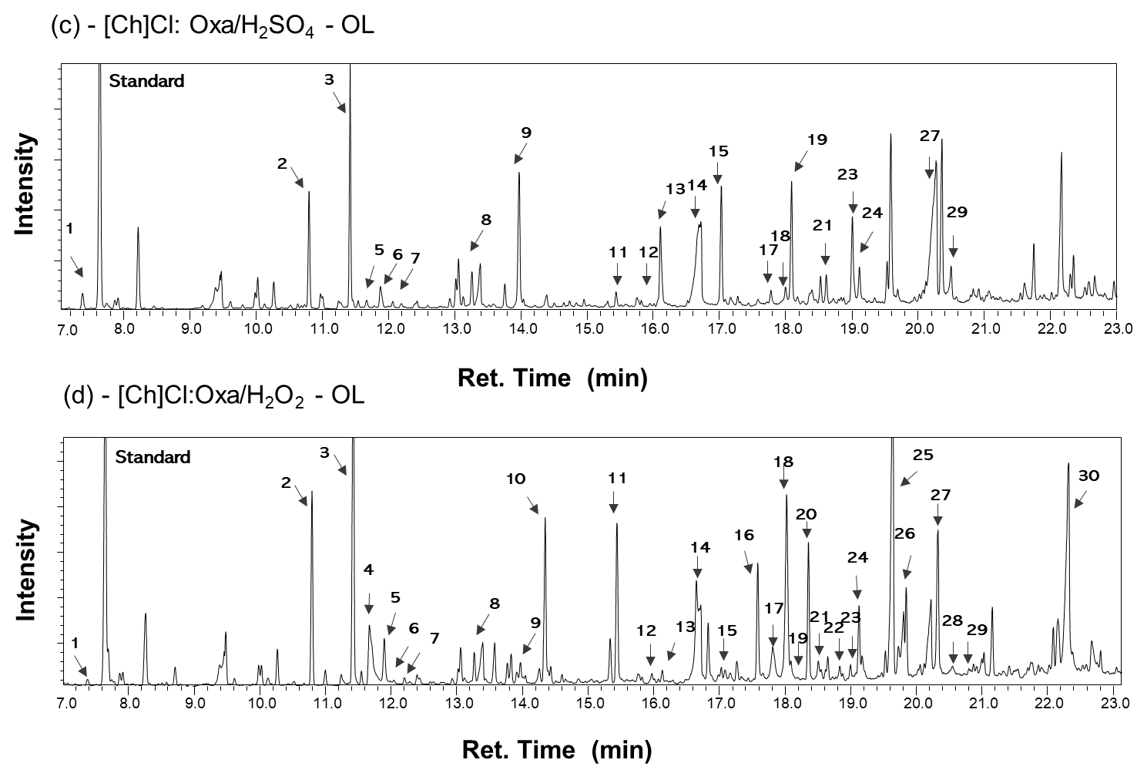
Figure S2. Gas chromatogram of lignin depolymerisation products obtained after treatment of Kraft lignin with (a) [Ch]Cl:Oxa/H₂SO₄ and (b) [Ch]Cl:Oxa/H₂O₂ and Organolsolv lignin with (c) [Ch]Cl:Oxa/H₂SO₄ and (d) [Ch]Cl:Oxa/H₂O₂. The reactions were performed at 80 ºC for 3 h. Methyl benzoate was used as a standard compound.

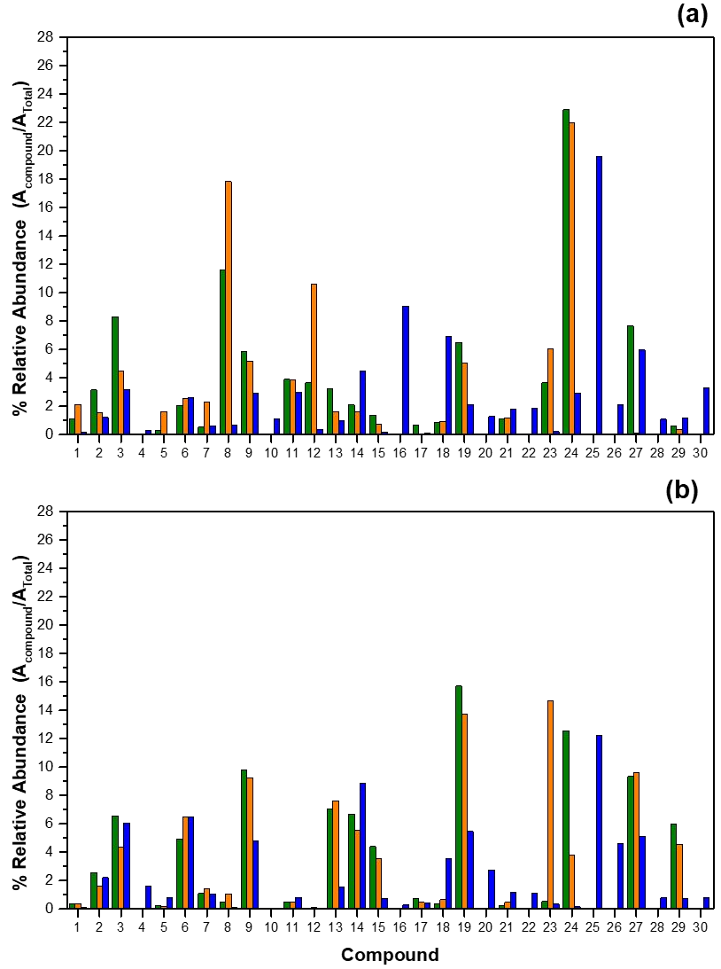
Figure S3. Relative abundance (%) of lignin depolymerisation products from (a) KL and (b) OL treatments at 80 °C for 1 hour with (■) [Ch]Cl:Oxa, (■) [Ch]Cl:Oxa/H₂SO₄ and (■) [Ch]Cl:Oxa/H₂O₂.

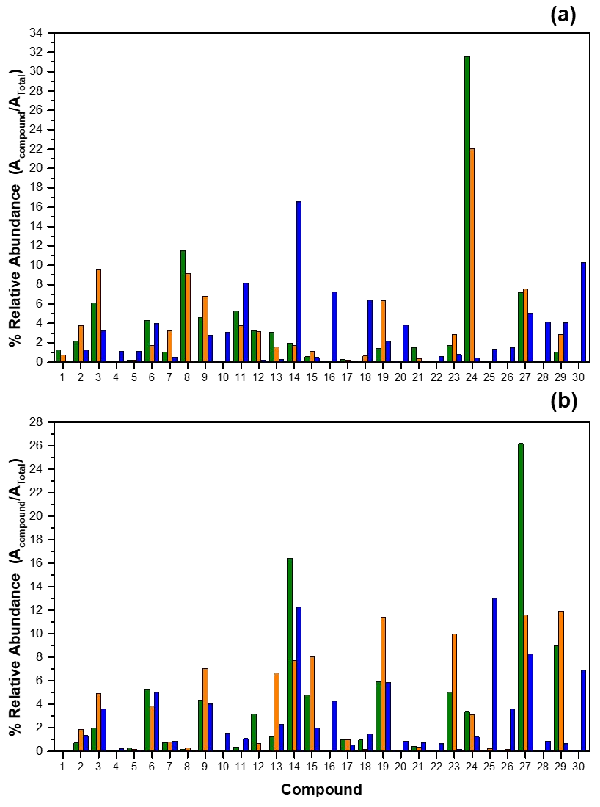

Figure S4. Relative abundance (%) of lignin depolymerisation products from (a) KL and (b) OL treatments at 80 °C for 6 hours with (■) [Ch]Cl:Oxa, (■) [Ch]Cl:Oxa/H₂SO₄ and (■) [Ch]Cl:Oxa/H₂O₂.

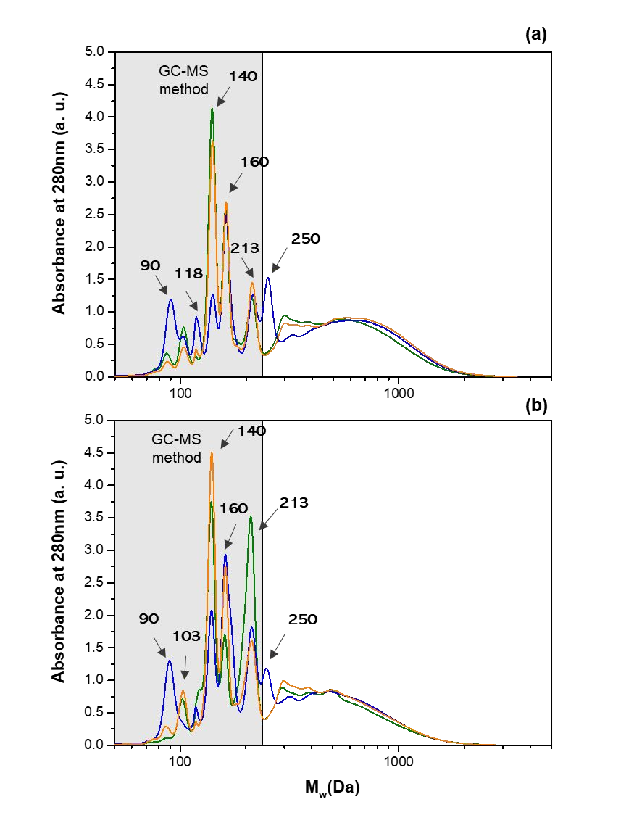

Figure S5. GPC analysis of lignin depolymerisation products from OL treatment at 80

°C during (a) 1 h and (b) 6 h with (■) [Ch]Cl:Oxa, (■) [Ch]Cl:Oxa/H₂SO₄ and (■) [Ch]Cl:Oxa/H₂O₂.

S3 – Kinetics of lignin depolymerisation
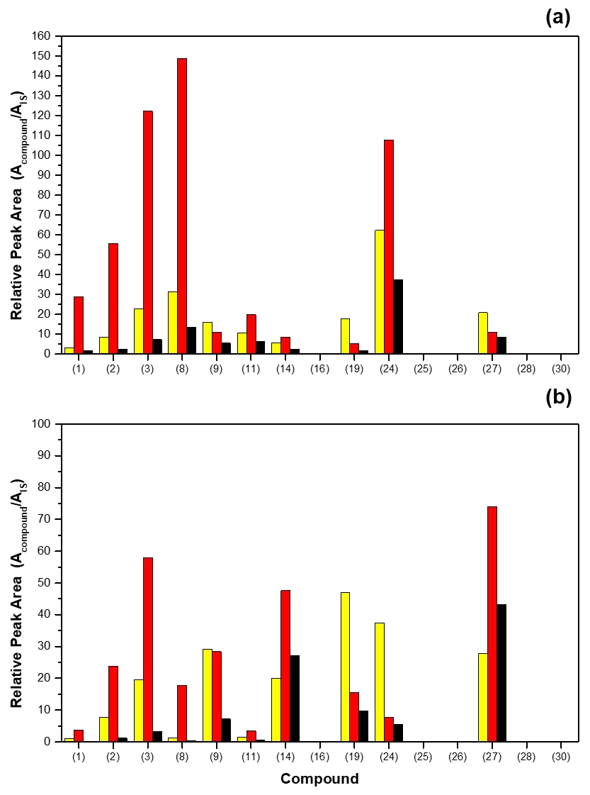
Figure S6. Relative peak area of identified compounds after (a) KL and (b) OL depolymerisation at 80 °C for (■) 1 h, (■) 3 h and (■) 6 h with [Ch]Cl:Oxa.

S4 - Structural characterization of regenerated lignin samples

Table S3. Molecular weight average (Mw), molecular number average (Mn) weights (g.mol−1) and polydispersity (Mw/Mn) of lignin.

Sample | Kraft Lignin |  |  | Organosolv Lignin
Mw |  | Mn | PDI |  | Mw | Mn | PDI
Untreated 2500 |  | 1200 | 2.1 |  | 3300 | 1500 | 2.2
 |  |  | 1 hour
[Ch]Cl:Oxaa 2200 |  | 1100 | 2.0 |  | 2900 | 1300 | 2.2
[Ch]Cl:Oxa +H₂SO₄ 2300  a |  | 1150 | 2.0 |  | 3000 | 1400 | 2.1
[Ch]Cl:Oxa + H₂O₂ 2400  a |  | 1100 | 2.2 |  | 2800 | 1250 | 2.2
 |  |  | 3 hours
[Ch]Cl:Oxa 2500 |  | 1250 | 2.0 |  | 3300 | 1400 | 2.4
[Ch]Cl:Oxa/H₂SO₄ 2600 |  | 1250 | 2.1 |  | 3500 | 1400 | 2.5
[Ch]Cl:Oxa/H₂O₂ 3600 |  | 1450 | 2.5 |  | 4100 | 1600 | 2.6
 |  |  | 6 hours
[Ch]Cl:Oxaa 1800 |  | 1050 | 1.7 |  | 2100 | 1100 | 1.9
[Ch]Cl:Oxa +H₂SO₄ 2100  a |  | 1050 | 2.0 |  | 2600 | 1100 | 2.4
[Ch]Cl:Oxa + H₂O₂ 2000  a |  | 1000 | 2.0 |  | 2600 | 1100 | 2.4

Table S4. FTIR vibrational bands/regions and corresponding assignments for lignin.

Vibrational band (cm-1) Assignments

3200-3500 O-H vibrations1
2844-2980 Aliphatic C–H and CH2 stretching vibrations1
1775-1750 C=O of esters, ketones, aldehydes and acids. ( C=O stretching, non
conjugated2
1731 C=O stretching in xylan, C=O stretching of acetyl or carboxylic acid3,4
1700 Unconjugated C=O (ketone, carboxyl or ester stretching)3,5
1600 - 1690 Aromatic skeletal vibration6–8
1514 Aromatic skeletal vibration6–8
1456 Aromatic skeletal vibration and C-H deformations6–8
1425 Aromatic skeletal vibrations combined with C-H in-plane deformation6–8
1370-1365 Phenolic hydroxyl group9,10
1327 - 1365 Syringyl unit breathing with C=O stretching and condensed Guaiacyl
rings6–8
1241 Guaiacyl ring breathing C–O stretch in lignin and for C–O linkage in guiacyl aromatic methoxyl groups11
1212 C-C plus C-O plus C=O stretch; Guaiacyl condensed > Guaiacyl etherified6–8
1152 C–O–C vibration (Cellulose and hemicellulose)11
1109 β-O-4 ether bond (Ether-O-)12,13
1040 Aromatic C H in-plane deformation (Guaiacyl > Syringyl) plus C-O deformation in primary alcohols plus C=O stretch (unconjugated) 6–8
979 C–O valance vibration; aromatic C–H in plane deformation14
925 Aromatic C-H out-of-plane6
838 Aromatic C-H out-of-plane deformation in Guaiacyl and Syringyl units15

Table S5. Elemental characterization and ash content of Kraft lignin (KL), Organosolv lignin (OL) and recovered lignins from depolymerization reactions with [Ch]Cl:Oxa, [Ch]Cl:Oxa/H₂SO₄, and [Ch]Cl:Oxa/H₂O₂ at 80 °C for 1, 3 and 6 hours.

Elemental Analysis (wt%)
Samples Reaction time
 | C | H | N | S | O
KL | 58.65±0.13 | 5.29±0.16 | 0.19±0.01 | 2.08±0.54 | 32.31±0.26 | 1.47±0.10
1h | 58.69±0.35 | 5.83±0.01 | 0.56±0.01 | 1.89±0.28 | 32.82±0.03 | 0.22±0.02
[Ch]Cl:Oxa 3h | 58.78±0.91 | 5.73±0.02 | 0.54±0.01 | 1.68±0.07 | 32.85v0.50 | 0.42±0.03
6h | 58.07±0.61 | 6.34±0.49 | 0.72±0.04 | 1.16±0.17 | 33.03±0.45 | 0.68±0.03
1h | 59.57±0.26 | 5.27±0.1 | 0.37±0.01 | 1.79±0.27 | 32.63±0.04 | 0.38±0.03
[Ch]Cl:Oxa/H₂SO₄ 3h | 59.33±0.03 | 5.43±0.01 | 0.47 ±0.02 | 1.75±0.07 | 32.16±0.04 | 0.86±0.04
6h | 58.76±0.41 | 5.43±0.17 | 0.59±0.05 | 0.97±0.02 | 33.57±0.32 | 0.68±0.03
1h | 50.05±0.73 | 4.27±0.16 | 0.51±0.02 | 1.02±0.25 | 43.98±0.33 | 0.19±0.03
[Ch]Cl:Oxa/H₂O₂ 3h | 48.53±0.84 | 4.32±0.27 | 0.76±0.06 | 0.76±0.02 | 44.90±0.59 | 0.73±0.05
6h | 50.55±0.38 | 4.87±0.1 | 0.74±0.03 | 0.62±0.03 | 42.63±0.27 | 0.59±0.04
OL | 61.88±0.16 | 5.35±0.03 | 0.23±0.01 | 0.00±0.00 | 32.13±0.10 | 0.42±0.06
1h | 60.30±1.41 | 5.35±0.10 | 0.41±0.00 | 0.00±0.00 | 33.81±0.75 | 0.14±0.02
[Ch]Cl:Oxa 3h | 61.31±0.41 | 5.44±0.04 | 0.46±0.02 | 0.00±0.00 | 32.44±0.23 | 0.36±0.04
6h | 59.79±0.23 | 5.34±0.07 | 0.51±0.02 | 0.00±0.00 | 34.28±0.16 | 0.08±0.01
1h | 60.58±0.07 | 5.59±0.05 | 0.32±0.01 | 0.00±0.00 | 33.27±0.01 | 0.24±0.03
[Ch]Cl:Oxa/H₂SO₄ 3h | 60.36±0.02 | 5.47±0.41 | 0.41±0.01 | 0.00±0.00 | 33.28±0.05 | 0.48±0.03
6h | 60.15±0.12 | 5.26±0.06 | 0.46±0.01 | 0.00±0.00 | 34.00±0.04 | 0.12±0.02
1h | 53.52±0.32 | 4.30±0.02 | 0.38±0.02 | 0.00±0.00 | 41.60±0.16 | 0.20±0.02
[Ch]Cl:Oxa/H₂O₂ 3h | 56.20±0.04 | 4.49±0.02 | 0.47±0.01 | 0.00±0.00 | 38.49±0.01 | 0.35±0.01
6h | 53.53±0.49 | 4.55±0.04 | 0.65±0.01 | 0.00±0.00 | 40.89±0.22 | 0.39±0.03

Ash (%)

(KL)

(KL)

(KL)

(OL)

(OL)

(OL)

REFERENCES

- L. A. M. Nevrez, L. B. Casarrubias, A. Celzard, V. Fierro, V. T. Mũoz, A. C. Davila, J. R. T. Lubian and G. G. Snchez, Science and Technology of Advanced Materials, , DOI:10.1088/1468-6996/12/4/045006.
- J. Rodrigues, O. Faix and H. Pereira, Holzforschung, 1998, 52, 46–50.

- S. Z. Chow, Wood Science and Technology, 1971, 5, 27–39.

- K. Fackler, J. S. Stevanic, T. Ters, B. Hinterstoisser, M. Schwanninger and L. Salmén, Enzyme and Microbial Technology, 2010, 47, 257–267.
- N. Cachet, S. Camy, B. Benjelloun-Mlayah, J. S. Condoret and M. Delmas,

Industrial Crops and Products, 2014, 58, 287–297.

- R. Prado, X. Erdocia, G. F. De Gregorio, J. Labidi and T. Welton, , DOI:10.1021/acssuschemeng.6b00642.
- A. García, X. Erdocia, M. González Alriols and J. Labidi, Chemical Engineering and Processing: Process Intensification, 2012, 62, 150–158.
- S. N. Sun, M. F. Li, T. Q. Yuan, F. Xu and R. C. Sun, Industrial Crops and Products, 2012, 37, 51–60.
- C. G. Boeriu, D. Bravo, R. J. A. Gosselink and J. E. G. Van Dam, Industrial Crops and Products, 2004, 20, 205–218.
- S. Tabasso, G. Grillo, D. Carnaroglio, E. Calcio Gaudino and G. Cravotto,

Molecules, 2016, 21, 2–9.

- K. K. Pandey and A. J. Pitman, International Biodeterioration and Biodegradation, 2003, 52, 151–160.
- A. A. M. A. Nada, M. A. Yousef, K. A. Shaffei and A. M. Salah, Polymer Degradation and Stability, 1998, 62, 157–163.
- A. Casas, M. V. Alonso, M. Oliet, E. Rojo and F. Rodríguez, Journal of Chemical Technology & Biotechnology, 2012, 87, 472–480.
- M. Schwanninger, B. Hinterstoisser, N. Gierlinger, R. Wimmer and J. Hanger,

Holz als Roh - und Werkstoff, 2004, 62, 483–485.

- O. Gordobil, R. Delucis, I. Egüés and J. Labidi, Industrial Crops and Products, 2015, 72, 46–53.

