Assessing the overtaking lateral distance between motor vehicles and bicycles – Influence on energy consumption and road safety
Behnam Bahmankhah^{1,*}, Paulo Fernandes¹, Jose Ferreira¹, Jorge Bandeira¹, Jose Santos¹, Margarida C. Coelho¹
¹ University of Aveiro, Department of Mechanical Engineering, Centre for Mechanical Technology and Automation, Campus Universitário de Santiago, 3810-193 Aveiro, Portugal
{behnam.bahmankhah,paulo.fernandes,ferreira.jose,jorgebandeira, jps,margarida.coelho}@ua.pt
Abstract. The main objective of this paper is to analyse the impacts of the overtaking lateral distance between a bicycle and a motor vehicle (MV) on road safety and energy consumption at two-lane urban roads. An on-board sensor platform was installed on a probe bicycle to measure the overtaking lateral distance and dynamic data. The Bicycle Specific Power (BSP) methodology was used to estimate human required power to ride a bicycle while Vehicle Specific Power (VSP) was used for MVs. The results showed that 50% of overtaking lateral distance were lower than 0.5m in the peak hours. The BSP and VSP analyses for different values of overtaking lateral distance did not result in any relationship between variables. There was a good fit (R² >0.67) between traffic volumes and overtaking lateral distance in the peak hours. On average, the MVs energy consumption in the afternoon was 92% higher than the morning peak periods.

Keywords: Bicycle · BSP · VSP · Traffic · Overtaking lateral distance · Sensor.
- Introduction and Objectives
Cycling offers some important financial, health and social benefits to the users and the environment. Accordingly, cycling is increasing day by day in Europe and in the United States [1, 2]. However, traffic safety concerns could be of high importance for cyclists since they might be more vulnerable to be potentially exposed to injuries in a collision than the driver of a motor vehicle (MV) [3, 4].
In 2016, 2,015 cyclists were killed in road crashes in the European Union (EU28) countries, constituting 8% of all road crashes fatalities [5]. In the same year, 840 cyclists were killed in the United States (US) which accounted for 2.2 percent of all traffic fatalities [6].
Although bicycle-MV crashes are more severe on rural roads compared to the urban areas [7, 8], the frequency of crashes on urban roads is typically higher. One of the main reasons is due to the high speed and manoeuvrability ability of MVs at rural roads [8]. MV speed on rural roads is higher than urban areas, while this high speed can increase safety concerns since it may lead to dangerous overtaking manoeuvres [9].
Other authors also emphasized that MV speed is a fundamental risk factor in cyclist safety mainly when a MV overtaking a bicycle [8], [10]. Ata and Langlois [11] found that the speed of overtaking MVs can affect the lateral distance at urban streets.
Since bicycle size is smaller than MV, it is possible to use more than one bicycle instead of a MV to improve lane use in urban areas. According to the official guidelines from Danish Road Directorate [3], a 2 m wide one-way cycle path has a capacity of 2,000 cyclists while in reality is able to unroll 5,200 cyclists per hour. However, if cyclists use the same lane as MVs, the overtaking lateral distance between bicycle and MV is a key concern regarding cyclists’ safety [10], [12]. The overtaking manoeuvrability of drivers [13] can change the behaviour of other MVs and cyclists such as rapidly braking or acceleration. This can represent some safety challenges, especially in narrow lanes and congested traffic situations.
The minimum standard of overtaking lateral distance (the distance between the overtaking MV and the bicycle) in most of the countries is 1.5 m although it is 1 m in some states of the USA [9]. Generally, MVs are required to keep the minimum distance of 1.5 m [8, 9], [12] when passing a bicycle. Overtaking lateral distance is the distance between a MV and a bicycle when the driver is driving straight in the adjacent lane to overtake the bicycle on a road [7, 9].
It is well-recognized that MV overtaking speed is one of the most important parameters affecting MV-bicycle lateral distance, and therefore, the cyclist safety [8], [14]. Debnath et al. [10] measured the overtaking lateral distance between bicycles and MVs based on the speed limit at different zones in the State of Queensland, Australia. They found that when the speed limit is between 70-80 km/h and lower than 40 km/h, the overtaking distance variation comply with the law at curved road sections, and on roads with narrower traffic lanes.
Several studies have shown how the lateral distance variation is influenced by infrastructure design [14, 15, 16], MV speed at rural roads [8, 9] and urban roads [17], and driving behaviour [12], [18, 19]. However, there is a lack of research to evaluate the relationship between overtaking lateral distance and specific power considering both MVs and bicycles.
Drivers’ decision to keep constant speed or instantaneous decisions to change the speed and subsequently acceleration/deceleration (aggressive driving behaviours) can affect energy consumption, pollutant emissions and safety [15], [20]. Cyclists have more manoeuvrability than MVs but they are more exposed to damage than a MV during a crash [3, 4].
Although riding a bicycle is a simple activity, it requires more human energy for long distances when a conventional bicycle is used. Due to the long-distance travel between origin and destination or road conditions (uphill), a cyclist can feel tired and he/she may not be to use a bicycle [21]. In this context, Mendes et al. [22] developed a methodology to quantify the expended energy of a cyclist using a conventional bicycle which stands for Bicycle Specific Power (BSP). BSP followed a concept widely used to estimate engine load for MV that is the Vehicle Specific Power (VSP) [23]. This regression-based methodology uses dynamic information (speed and acceleration on a second-by-second basis) and topographic conditions (slope) for MV trips.
This paper addressed the impacts of overtaking lateral distance variation between a bicycle and a motor vehicle (MV) on road safety and energy consumption in two urban corridors with variations in cyclist and traffic volumes, and speeds using Global Navigation Satellite System (GNSS) receivers. The main novelty of this paper is the establishment of a relationship between overtaking lateral distance, and BSP, VSP and traffic flow characteristics in different peak hour periods.
The outcome of this work is ultimately to increase the cycling safety at two-lane urban roads by developing a methodology based on the overtaking lateral distance measurements and cyclist/MV energy consumption during the overtaking manoeuvre. Therefore, the specific objectives of this paper are as follows:
- To analyse the driving volatility impact on road safety considering the bicycle and MV overtaking lateral distance variation and acceleration/deceleration variation;
- To assess the relationship between bicycle-MV overtaking lateral distance variation with Vehicle Specific Power (VSP) and Bicycle Specific Power (BSP);
- To assess the impact of traffic volume variation on bicycle-MV overtaking lateral distance variation.
- Methodology
The methodology of this study relies on field measurements and on-board platform of sensors to measure the overtaking lateral distance between bicycle and MVs (see Fig. 1). Site-specific operations were characterized using videotaping system and manual counting. Concurrently, second-by-second bicycle and vehicle dynamic data were collected using GNSS travel recorders. After that, VSP and BSP were used to compute MV and cyclist energy used during the peak hours, then correlations between overtaking lateral distance and above variables were explored.

Bicycle & Vehicle volumes
Bicycle/MV dynamic data (GPS)
Bicycle Specific Power (BSP)
Vehicle Specific Power (VSP)
On-road monitoring
(Movable Camera)
Platform of sensors
(Overtaking lateral distance)
Data processing & hypothesis testing
Results and discussion
Fig. 1. Methodological framework.

  - Instrumented Bicycle
The bicycle was instrumented with different sensors and hardware components, as illustrated in Fig. 2. A microcontroller, ESP8266, was used to control and manage the peripheral hardware. The software was developed and compiled on the microcontroller. This component is able to store and process an instruction from the developed software [24].
To obtain the real-time location coordinates of the vehicle, a GNSS module named GPS-NEO-M8N was used. The system has low power consumption and small dimensions (25x35mm [boars] + 25x25mm [antenna]), and it can receive a signal from various satellite constellations (such as GPS and GLONASS) and follows the NMEA (National Marine Electronics Association) data protocol to communicate with other devices [25].
To track the linear acceleration and angular velocity, the motion-processing unit MPU-6050 was used. This device collects and processes the data from its accelerometers and gyroscopes (one for each axis) and stores the output into memories that can read by the microcontroller. The device also has a temperature sensor [26].
An ultrasonic distance sensor (LV-MaxSonar-EZ1) records the lateral distance of vehicles overtaking by sending ultrasonic waves that are subsequently detected after its reflection in the obstacles. From the time between the sending signal and its echo, the sensor determines the distance to the reflecting object considering the speed of the sound, 340 m/s [27]. All the data obtained by the sensors are collected and pre-processed by the microcontroller. Then it is sent to a GSM/GPRS modem (SIM900) that is responsible for the data transmission to the database server through a mobile network, using TCP/IP messages. To be able to connect to the mobile network, a SIM card is required [28].
This platform of sensors (Fig. 2) can store all dynamic and non-dynamic data in the database server and send it to the end user in real time. The end user can track the cyclist and monitor the bicycle's position and real-time data sent by the sensors. All sensor collected distances that were less than 1.5m. For purpose of analysis, the results are classified into three groups: x<0.5m, 0.5m≤x<1m and 1.0m≤x<1.5m (x<1.6ft, 1.6ft ≤x<3.3ft and 3.3ft≤x<4.9ft).

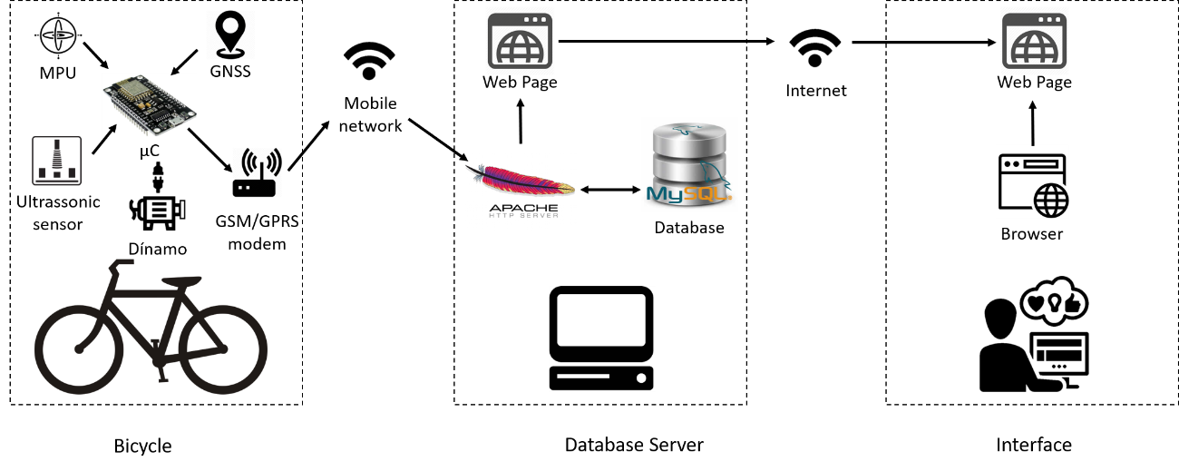
Fig. 2. On-board platform of sensors for enhancing safety of cyclists.
  - Data collection and processing
Two case studies with different specifications, such as different average speeds (section 3.2), traffic volumes (Table 1) and road conditions for both bicycle and MV were selected to develop the methodology in the city of Aveiro, Portugal.
The first case study (A) is a corridor with two-lane urban roads at each direction and four intersections with 4 traffic lights (Fig. 3) that is located in the city centre. This corridor was selected since it connects the train station to the city centre, thus representing a relevant trip generator of MVs and bicycles. Case study A has 760 vehicles per hour (vph) and 26 bicycles per hour (bph) at peak hours. The distance between points A and B is 1.1 km, approximately 4m road width at each direction. Between B and C (~250 m) road has only 3m width with one lane in the travel direction. The second case study (B) is an urban network with four alternative routes (A, B, C and D) between University of Aveiro campus area and one of the city shopping malls (Fig. 3). Traffic movements included two three-leg intersections, one roundabout and four alternative routes. This case study has 460 vph and 10 bph at peak hours. Both case studies A and B are located in a flat terrain.
The sensors, camera and GPS were installed on a conventional bicycle to collect dynamic data and using two different male and female riders between 24 and 37 years old. An equipped light-duty gasoline vehicle with GPS performed several trips along the studied locations where a GNSS device recorded vehicle speed and deceleration/acceleration rates in a 1-second interval. The minimum number of runs (sample size) was 9 for each direction in each case study based on site-specific traffic signal density (<3 traffic lights/1.6 km) [29]. Thus, 40 GP runs were conducted in this research (20 per site) [29].
Table 1. Data collection specification for each case study.
Case study A |  | Case study B
Average (vph) – 8h00-9h30 AM | 536 | Average (vph) – 8h00-9h30 AM | 328
Average (vph) – 5:00-7:00 PM | 984 | Average (vph) – 5:00-7:00 PM | 592
Average (bph) - 8h00-9h30 AM | 22 | Average (bph) – 8h00-9h30 AM | 9
Average (bph) – 5:00-7:00 PM | 30 | Average (bph) – 5:00-7:00 PM | 12
Total road coverage (km) | 55 | Total road coverage (km) | 65
Number of runs | 25 | Number of runs | 23
Note: AM between 8:00-9h30 AM;

Data were collected in four typical weekdays (Tuesday and Wednesday for each case study) during the morning (8h00-9h30 AM) and the afternoon (5h00-7h00 PM) peak periods. Traffic volumes were counted manually at 5 different points in each direction (Fig. 3) with 15-minute intervals for case study A. For case study B, traffic volumes were recorded manually at the entrance of each route by video recording at two signalized intersections and a roundabout near the destination point of the case study (Fig. 3). As in case study A, the traffic volumes were classified in 15-minute intervals.
Driving volatility represents the extent of speed and consequently acceleration/deceleration variations during the MVs movement [30]. The speed and acceleration/deceleration profiles of bicycles and MVs were extracted to analyse the driving volatility such as sudden or rapid acceleration/deceleration during bicycle-MV interactions.
Critical and extreme variations can occur due to hard acceleration or braking by drivers [30]. After identifying these critical points from data, the reason of these behaviours (peak points) was analysed using video recording.

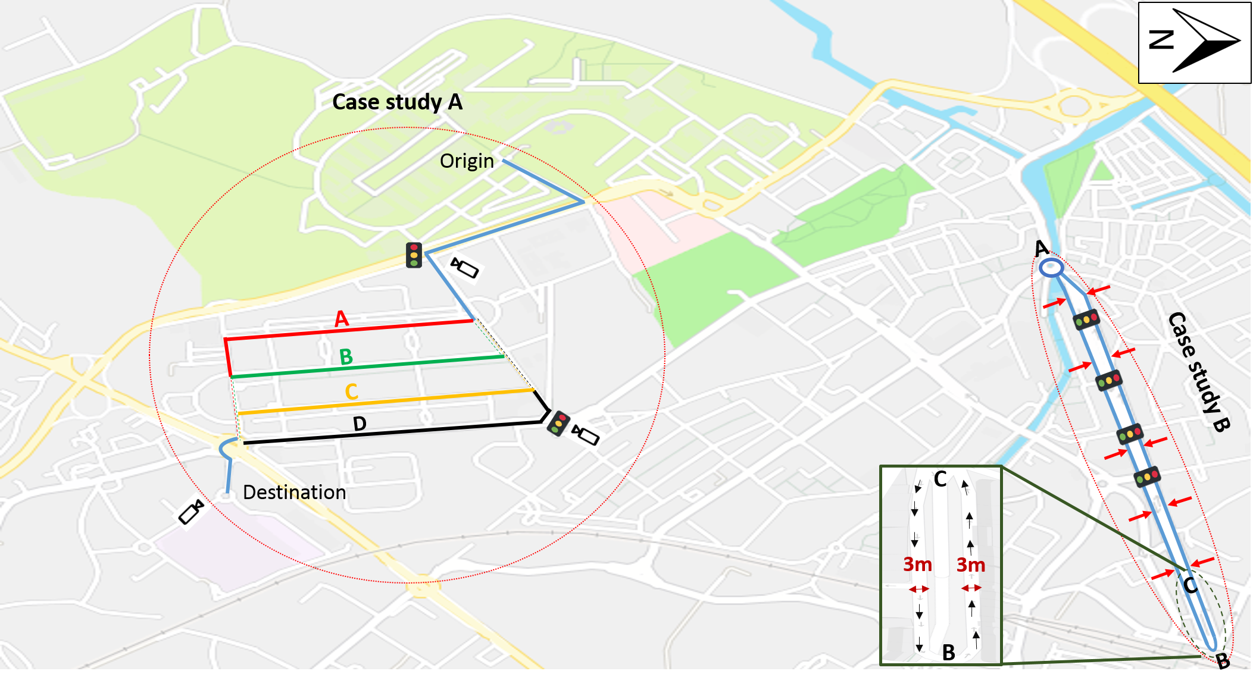
Fig. 3. Layout of the case study with the identification of traffic monitoring points ( ), case study A (on the left) and case study B (on the right) [Background Source: Bing Maps].
  - VSP and BSP Data Analysis
The selected methodology to estimate the vehicle power consumption variation was based on the concept of VSP that is mathematically defined as follows (Equation 1) [23], [31]:

VSP = v.[1.1 a + 9.81 sin (arctan (grade)) + 0.132] + 0.000302v³ (1)

where:

VSP =Vehicle specific power [kilowatt/ton];
v = motor vehicle instantaneous speed [m/s];
a = motor vehicle acceleration/deceleration rates [m/s²];
grade – terrain gradient [slope].

Each VSP value refers to one of 14 modes for Light Duty Vehicles (LDV) (see Table 2) which in turn are associated with a rate of energy consumption and emissions [22], [32].
BSP is estimated second-by-second using the power needed to ride a conventional bicycle, as given by Equation 2 [25]:

BSP = v_{cyclist}.[1.01 a_{cyclist} + 9.81 sin (G) + 0.078] + 0.0041 v_{cyclist}³ (2)

where:

BSP = Bicycle specific power [watt/kg];
v_{cyclist} = Cyclist instantaneous speed [m/s];
a_{cyclist} = Cyclist acceleration/deceleration rates [m/s²];
G = Road grade [slope].

Each BSP value is divided into 11 modes (Table 2) that represent one levels of human energy consumption to ride a conventional bicycle. It should be mentioned that the definition of modes and BSP values varied according to the type of bicycle (e.g. electric bicycle, conventional bicycle [22].

Table 2. Binning method for VSP in LDV [23], and BSP for conventional bicycles [22].
VSP |  |  | BSP
Range (kW/ton) | Mode |  | Range (W/kg) | Mode
VSP < -2 | 1 |  | BSP < -4 | < -4
-2 ≤ VSP < 0 | 2 |  | -4 ≤ BSP < -3 | -4
0 ≤ VSP < 1 | 3 |  | -3 ≤ BSP < -2 | -3
1 ≤ VSP < 4 | 4 |  | -2 ≤ BSP < -1 | -2
4 ≤ VSP < 7 | 5 |  | -1 ≤ BSP < -0 | -1
7 ≤ VSP < 10 | 6 |  | BSP = 0 | 0
10 ≤ VSP < 13 | 7 |  | 0 ≤ BSP < 1 | 1
13 ≤ VSP < 16 | 8 |  | 1 ≤ BSP < 2 | 2
16 ≤ VSP < 19 | 9 |  | 2 ≤ BSP < 3 | 3
19 ≤ VSP < 23 | 10 |  | 3 ≤ BSP < 4 | 4
23 ≤ VSP < 28 | 11 |  | BSP > 4 | > 4
28 ≤ VSP < 33 | 12
33 ≤ VSP < 39 | 13
VSP ≥ 39 | 14
- Results and Discussion
In this section, the main results from the field measurements are analysed during the bicycle-MV interactions. It proceeds in four sections: First, the overtaking lateral distances are presented (Section 3.1) followed by acceleration/deceleration profiles (Section 3.2) and resulting VSP-BSP mode distributions (Section 3.3). Lastly, the hypotheses are defined and tested (Section 3.4).
  - Bicycle-MV overtaking distance
The extracted data from sensor showed most of the overtaking lateral distance (~75%) occurred in values lower than 1.0 m in both periods (Fig. 4), regardless of the case study. However, the distribution of intervals varied between periods. Regarding case study A, about 56% of bicycle-vehicle overtaking distances were below 0.5 m during afternoon peak but it decreased (in relative terms) in the morning peak (42%). The reason for this result may be due to the differences in traffic volumes between periods (on average, 84% higher in the afternoon peak) that results in less available space for overtaking. Similarly, the results for case study B indicated that about 34% of bicycle-vehicle overtaking distances were below 0.5 m during morning peak hours and increased up to 49% in the afternoon.
It is important to emphasise that frequency of the overtaking lateral distance situations for case study B (~25%) is lower than case study A (Fig. 4). It could be due to lower traffic volumes in case study A compared with case study B.
Another explanation for these distances was due to the location where overtaking occurred. For instance, most of these situations occurred near point B (Fig. 3), which has only one circulating lane by direction. Cyclists should avoid riding close to the right edge of the road while at the same time they should care about the overtaking distance from the left side. This situation can increase the risk of a crash in narrow shared lanes.

Fig. 4. Bicycle-MV overtaking distance variation (metres) in morning and afternoon peak hours.

3.2. Bicycle-MV Acceleration/Deceleration Profile
Bicycles moving at lower speeds than MVs can have more manoeuvrability to use any part of the lane for safety purposes. The average speed values by mode and case study were as follows:
- MVs in case study A – 20 km/h in the morning peak hour and 17 km/h in the afternoon peak hour;
- Bicycles in case study A – 13 km/h in the morning peak hour and 10 km/h in the afternoon peak hour;
- MVs in case study B – 28 km/h in the morning peak hour; 22 km/h in the afternoon peak hour;
- Bicycles in case study B – 15 km/h in the morning peak hour and 12 km/h in the afternoon peak hour.

The above-mentioned results indicated higher speed values in case study B, regardless of the peak period. This point may be explained by the high volume-to-capacity ratio in case study A (up to 0.65) even though corridor has two lanes in travel direction.
The analysis of the bicycle acceleration/deceleration profiles showed similar profiles within transport mode in the morning and afternoon regardless of the case study. Bearing this in mind, one profile was selected from the morning and afternoon data samples for bicycles and MVs, as shown in Fig. 5. It was found that, regardless of the case study, the range of acceleration/deceleration rates in the morning was higher than in the afternoon. This may be due to the fact that traffic volumes are higher in the afternoon peak periods, resulting thus in more stop-and-go cycles due red signals, pedestrians at crosswalks or yielding to circulating traffic at roundabouts. Other reason behind these peak points of driving volatility is that MVs or cyclists did braking manoeuvres to avoid the crash with those vehicles that were moving from the parking area to the travel lane or because of suddenly opening of the door into the path of the bicycle. There was some evidence that the high bicycle acceleration/deceleration rates were caused by drivers who opened car doors into the path of an approaching cyclist or others who illegally parked MVs at the right-hand side of the road (mainly on the bicycle path).
Riding and driving behaviours of cyclists and drivers were analysed at narrow sections of lanes (250m from C to B and B to C) in case study A (see Fig. 2). Travel start and stop times from point C to B were extracted from videotapes using GPS data. The results showed that there is no evidence of high acceleration/deceleration rates and MVs behaviour and manoeuvrability were proper at narrow sections of lanes while the most overtakes of less than 0.5m overtaking lateral distance occurred at these sections of lanes. Cyclists have to pay more attention to left and right sides when the lane is narrow, whereas it seems that drivers also care more about cyclists in these areas.

a)
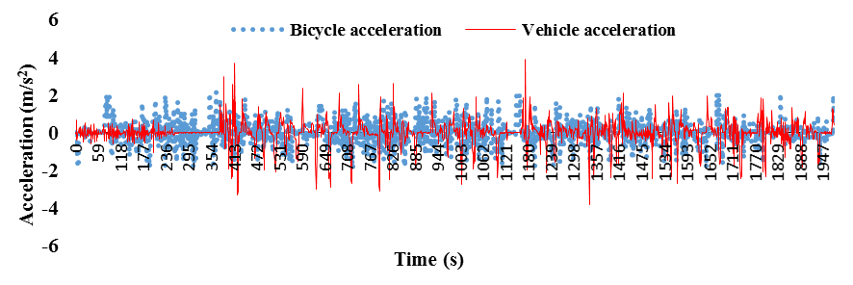
b)
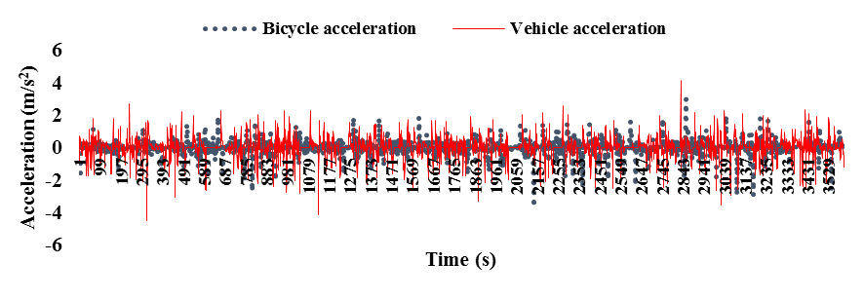
c)
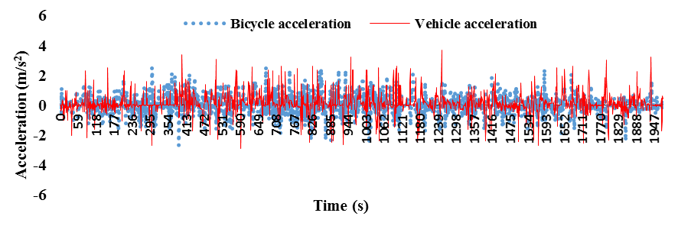
d)
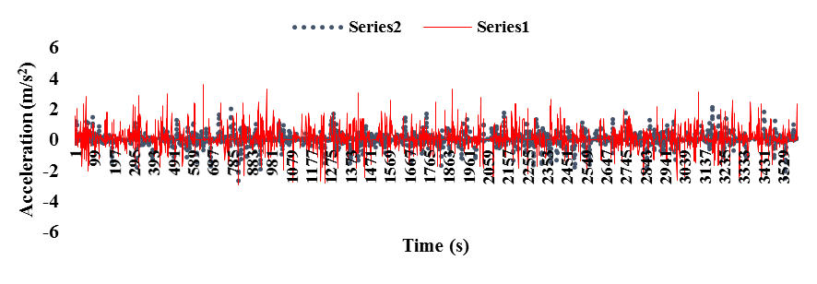

Fig. 5. Bicycle and MV acceleration/deceleration profiles at peak hours: (a) morning case study A; (b) afternoon case study A; (c) Morning case study B;(d) afternoon case study B.

3.3. VSP and BSP Modes Distribution
VSP and BSP values were calculated against the time spent by MV and bicycle in their modes. Fig. 6 a, and c represent the distribution of BSP modes for a conventional bicycle during the peak hours. On average, the bicycle spent more time in mode 1 (50%) than other modes in both morning and afternoon periods regardless of the case study. This finding was confirmed by Mendes et al. [22] about conventional bicycles. The higher percentage of mode 1 may be since cyclists do not need high human power to ride a bicycle or may be due to the low speeds of bicycles. Regarding the distribution of the modes, no significant differences were observed between the morning and the afternoon peak hours. To examine the consistency between the morning and afternoon VSP mode distributions, the two-sample Kolmogorov-Smirnov statistical test (K-S test) for the analysis of histograms with 99% confidence level was used for both case studies A and B. The mean of BSP values showed only 7% and 9% difference between morning and afternoon in case studies A and B, respectively.

a) | b)
c) | d)

Fig. 6. (a) Bicycle Specific Power (BSP); (b) Vehicle Specific Power (VSP) modes distribution in case study A; (c) Bicycle Specific Power (BSP); (d) Vehicle Specific Power (VSP) modes distribution in case study B, in morning and afternoon peak hour.

The results confirmed that on positive BSP modes, the bicycle spent more time (83% and 79% in case study A and B, respectively) compared with the negative modes (17% and 21% in case studies A and B, respectively) in both morning and afternoon peak hours. Fig. 6 b, and d represent the distribution of VSP modes for MVs during the peak hours. VSP modes distribution in case study A are approximately same in the morning and the afternoon peak hours while the variation of VSP modes is higher in case study B. It can be due to the more space available for the movement in case study B than A. The average speed of case study B (25.2 km/h) (considering both the morning and afternoon periods) was 34% more than case study A value (18.8 km/h).
MVs spent on average more time in mode 3 (31% and 28% in case study A and B respectively) and mode 4 (27% and 23% in case study A and B respectively) than other modes in both the morning and afternoon peak hours. Mode 3 represents idling and low speed situations while mode 4 represents accelerations at low speeds.
CO₂ emissions were calculated based on the VSP concept [23] for the gasoline MVs in peak hours in order to assess the energy consumption. Regarding the direct correlation between CO₂ emissions and energy consumption, energy consumption was found to be increased by 92% in the afternoon compared with the morning.
The results showed that 17% and 32% of CO₂ emissions in the morning and 16% and 37% in the afternoon were generated in mode 3 (idling or low speed situations) and mode 4 (acceleration at low speeds) in case study A. About case study B, mode 3 and 4 have corresponded to 14% and 27% of CO₂ emissions in the morning and 12% and 16% in the afternoon in case study B. As shown in Fig. 6 b-c, the frequency of time distribution for modes 3 and 4 was approximately the same in the morning and the afternoon. The mean of VSP values showed only 4%-6% difference between morning and afternoon.

3.4. Hypothesis testing
The relationships between overtaking lateral distance and VSP/BSP mode and traffic volume were investigated. The morning overtaking lateral distance values were on average higher than the afternoon period when the traffic volumes were lower. Therefore, the authors decided to evaluate the impact of traffic volume on overtaking lateral distance variation and the following hypothesis was defined:

- Overtaking lateral distance variation was expected to have less impact on VSP and BSP modes than traffic volumes.

The results from Fig. 7 seem to confirm above hypothesis. First, no correlation (coefficient of determination – R² < 0.07 and R² < 0.02 in case studies A and B, respectively) was found between VSP/BSP and overtaking distance variation, regardless of the time period.

a) | b)

Fig. 7. Correlation between overtaking distance variation and traffic volume variation: (a) Morning and afternoon peak in case study A; (b) Afternoon and afternoon peak hour in case study B

Second, scatter plots indicated that traffic volumes (15-min intervals) and overtaking lateral distance followed a linear trend both in the morning and afternoon peak hours (R² = 0.68 and R² = 0.73 in case studies A and B, respectively). Both intercept and slope parameters had p-values lower than 0.05, thus indicating statistical significance. Table 3 summarises the statistical analysis of models separately for the morning and afternoon periods.
Table 3. Summary of statistical analysis for model coefficients between traffic volumes and overtaking lateral distance variation.
Period |  | Model  Parameter | Coefficients | Standard  Error | T statistics | p-value
Case study  A | Morning peak | Intercept | 946.2 | 199.7 | 4.7 | 0.003
 |  | Variable X1 | -1565.2 | 445.8 | -3.5 | 0.013
 | Afternoon peak | Intercept | 252.0 | 43.9 | 5.7 | 0.004
 |  | Variable X2 | -195.6 | 72.1 | -2.7 | 0.037
Case study  B | Morning peak | Intercept | 736.21 | 217.6 | 3.1 | 0.011
 |  | Variable X1 | -423.3 | 332.1 | -2.2 | 0.004
 | Morning peak | Intercept | 317.1 | 100.5 | 3.8 | 0.002
 |  | Variable X2 | -1205.4 | 215.3 | -4.1 | 0.027

Results from Fig. 7 and Table 3 confirmed that the traffic volume variation had a moderate effect on overtaking lateral distance between bicycles and MVs during the peak hours. Regardless of the case studies, it can be concluded that overcoming lateral distance between the bicycle and the MVs decreases with increasing traffic volume.
Since the traffic volumes were collected at different segments of case study A and at different routes of case study B, the results of correlation between overtaking lateral distance and traffic volume variation can be applied to all the corridor (case study A) and the network (case study B). The linear coefficient model within a 95% confidence level was applied to show the relationship between traffic volumes and overtaking lateral distance. Variable Y represents the overtaking lateral distance while X1 and X2 represent traffic volumes in the morning and afternoon periods, respectively.
- Conclusions
This paper represents an evaluation of the impacts of the bicycle-MV overtaking lateral distance on driver and cyclist behaviours, safety and BSP/VSP mode distributions. Field measurements were conducted in a real-world corridor with traffic lights and an urban network with four alternative routes. The analysis was based on overtaking lateral distance measurements extracted from a platform of sensors installed on a conventional bicycle. Measurements were carried out in morning and afternoon peak hours. Bicycle and MV GPS data were also used to characterize road user behaviours.
More than 75% of the total overtaking lateral distances were lower than 1 m, and 50% were lower than 0.5 m, thus confirming some issues regarding the cyclist safety. It was found that lowest overtaking lateral distances (<0.5 m) occurred in segments with high traffic volumes segments with resulting lack of road space during the interaction between motor vehicles and cyclists. The analysis of acceleration/deceleration profiles confirmed that bicycles and MVs had similar behaviour in both periods, but the trend of acceleration/deceleration for MVs was higher than bicycles regardless the case studies.
The analysis of relationship for traffic volumes and overtaking lateral distances showed moderate to good fit between these variables (R² = 0.68 and R² = 0.73 for case studies A and B respectively). In contrast, no correlation was observed between overtaking lateral distance and BSP/VSP modes.
Although dynamic data used in this paper was stored before processing, one of the main contributions of this paper is the integration of real-time driving volatility information on a platform to alert road users about potential proximity with cyclists, and as result, some crashes.
Future study would consider the impact of age, gender or colours of clothes of cyclists on overtaking distances, and different types of road.

Acknowledgments
The authors acknowledge to the following projects: Centre for Mechanical Technology and Automation Strategic Project UID/EMS/00481/2019-FCT and CENTRO-01-0145-FEDER-022083; @CRUiSE (PTDC/EMS-TRA/0383/2014), funded within Project 9471–Reforçar a Investigação, o Desenvolvimento Tecnológico e a Inovação (Project 9471–RIDTI) and supported by European Community Fund FEDER; MobiWise (P2020 SAICTPAC/0011/2015), co-funded by COMPETE2020, Portugal2020-Operational Program for Competitiveness and Internationalization (POCI), European Union’s ERDF (European Regional Development Fund) and FCT – Portuguese Science and Technology Foundation; CISMOB (PGI01611, funded by Interreg Europe Programme); DICA-VE - Driving Information in a Connected and Autonomous Vehicle Environment: Impacts on Safety and Emissions (POCI-01-0145-FEDER-029463), funded by FEDER, through COMPLETE2020-Portuguese Operational Program Competitividade e Internacionalização (POCI), and by National funds (OE), through FCT/MCTES. The authors also acknowledge to Órbita Bikes, which allowed the use the bicycle also Mariana Vilaca and Carlos Sampaio for their cooperation in data collection.

References
- Pucher, J., Buehler, R., Seinen, M.: Bicycling renaissance in North America? An update and re-appraisal of cycling trends and policies. Transportation research part A: policy and practice. vol. 45(6), pp. 451-475 (2011)
- Pucher, J., Buehler, R.: Cycling towards a more sustainable transport future, Transport reviews, vol. 37(6), pp. 689-694 (2017)
- Van Hout, K.: Annex I: Literature search bicycle use and influencing factors in Europe, BYPAD. EIE-programme 05/016 Intelligent Energy Europe (2008)
- Götschi, T., Garrard, J., Giles-Corti, B.: Cycling as a part of daily life: A review of health perspectives, Transport Reviews, vol. 36(1), pp. 45-71(2016)
- EC. Traffic Safety Basic Facts 2018 – Cyclists. European Road Safety Observatory Documentation. Traffic Safety Basic Facts. 24p. (2018)
- National Center for Statistics and Analysis: Bicyclists and other cyclists: 2016 data. Washington, DC: National Highway Traffic Safety Administration, Traffic Safety Facts. Report No. DOT HS 812 507 (2018)
- Dozza, M., Schindler, R., Bianchi-Piccinini, G., Karlsson, J.: How do drivers overtake cyclists?, Accident Analysis & Prevention, vol. 88, pp. 29-36 (2016)
- Stone, M., Broughton, J.: Getting off your bike: cycling accidents in Great Britain in 1990–1999. Accident Analysis & Prevention, vol. 35(4), pp. 549-556 (2003)
- Llorca, C., Angel-Domenech, A., Agustin-Gomez, F., Garcia, A.: Motor vehicles overtaking cyclists on two-lane rural roads: Analysis on speed and lateral clearance. Safety science, vol. 92, pp. 302-310 (2017)
- Debnath, A.K., et al.: Factors influencing noncompliance with bicycle passing distance laws. Accident Analysis & Prevention, vol. 115, pp. 137-142 (2018)
- Ata, M.K., Langlois, R.G.: Factoring cycling in transportation infrastructure: design considerations based on risk exposure, ITE Journal, pp. 49-53 (2011)
- Feng, F., Bao, S., Hampshire, R.C., Delp, M.: Drivers overtaking bicyclists—An examination using naturalistic driving data. Accident Analysis & Prevention, vol. 115, pp. 98-109 (2018)
- Chapman, J., Noyce, D.: Observations of driver behavior during overtaking of bicycles on rural roads. Transportation Research Record: Journal of the Transportation Research Board, (2321), pp. 38-45 (2012)
- Shackel, S.C., Parkin, j.: Influence of road markings, lane widths and driver behaviour on proximity and speed of vehicles overtaking cyclists. Accident Analysis & Prevention, vol. 73, pp. 100-108 (2014)
- Wang, X., et al.: What is the level of volatility in instantaneous driving decisions? Transportation Research Part C: Emerging Technologies, vol. 58, pp. 413-427 (2015)
- Mehta, K., Mehran, B., Hellinga, B.: Evaluation of the passing behavior of motorized vehicles when overtaking bicycles on urban arterial roadways. Transportation Research Record: Journal of the Transportation Research Board, (2520), pp. 8-17 (2015)
- Chuang, K.H., et al.: The use of a quasi-naturalistic riding method to investigate bicyclists’ behaviors when motorists pass. Accident Analysis & Prevention, vol. 56, pp. 32-41 (2013)
- Kay, J.J., Savolainen, P.T., Gates, T.J., Datta, T.K.: Driver behavior during bicycle passing maneuvers in response to a Share the Road sign treatment. Accident Analysis & Prevention, vol. 70, pp. 92-99 (2014)
- Duthie, J., Brady, J., Mills, A., Machemehl, R.: Effects of on-street bicycle facility configuration on bicyclist and motorist behavior. Transportation Research Record: Journal of the Transportation Research Board, (2190), pp. 37-44 (2010)
- Liu, J., Khattak, A.J., Wang, X.: A comparative study of driving performance in metropolitan regions using large-scale vehicle trajectory data: Implications for sustainable cities. International Journal of Sustainable Transportation, vol. 1(3), pp. 170-185 (2017)
- Dill, J., Rose, G.: E-bikes and transportation policy: Insights from early adopters. Transportation Research Record: Journal of the Transportation Research Board, 37 (2012)
- Mendes, M., Duarte, G., Baptista, P.: Introducing specific power to bicycles and motorcycles: Application to electric mobility. Transportation research part C: emerging technologies, vol. 51, pp. 120-135 (2015)
- Frey, H.C., Unal, A., Chen, J., Li, S., Xuan, C.: Methodology for developing modal emission rates for EPA’s multi-scale motor vehicle & equipment emission system. Ann Arbor, Michigan: US Environmental Protection Agency (2002)
- User Manual V1.2, ESP8266 NodeMCU WiFi Devkit. Hanson Technol [Internet], http://www.handsontec.com/pdf_learn/esp8266-V10.pdf
- U-BLOX. NEO-M8, u-blox concurrent GNSS modules - Data Sheet. u-blox, https://www.u-blox.com/sites/default/files/NEO-M8_DataSheet_(UBX-13003366).
- InvenSense, MPU-6000 and MPU-6050 Product Specification. InvenSense Inc., www.invensense.com
- MaxBotix. LV-MaxSonar ® -EZTM Series. MaxBotix Inc., www.maxbotix.com
- SIMCom, SIM900: Hardware Design. Smart Mach Smart Decis [Internet]. Shangai: SIMCom Wireless Solutions Ltd.,
ftp://imall.iteadst dio.com/IM120417009_IComSat/DOC_SIM900_Hardware Design_V2.00.pdf
- Li, S., et al.: Reconsideration of Sample Size Requirements for Field Traffic Data Collection with Global Positioning System Devices. Transportation Research Record: Journal of the Transportation Research Board, (1804), pp. 17-22 (2002)
- Khattak, A.J., Wali, B.: Analysis of volatility in driving regimes extracted from basic safety messages transmitted between connected vehicles. Transportation research part C: emerging technologies, vol. 84, PP. 48-73 (2017)
- Anya, A.R., Rouphail, N.M., Frey, H.C., Liu, B.: Method and Case Study for Quantifying Local Emissions Impacts of Transportation Improvement Project Involving Road Realignment and Conversion to Multilane Roundabout. Presented at 92nd Annual Meeting, Transportation Research Board, Washington, DC, (2013)
- Coelho, M.C., et al.: Assessing methods for comparing emissions from gasoline and diesel light-duty vehicles based on microscale measurements. Transportation Research Part D: Transport and Environment, vol. 14(2), pp. 91-99 (2009)

