Supplementary Information

Lipidomic reveals similar changes in serum phospholipids signatures of overweight and obese paediatric subjects
Sara Anjos¹, Eva Feiteira¹, Frederico Cerveira³, Tânia Melo¹, Andrea Reboredo³, Simone Colombo¹ Rosa Dantas⁴, Elisabete Costa¹, Ana Moreira¹, Sónia Santos⁵, Ana Campos¹, Rita Ferreira¹, Pedro Domingues¹, M. Rosário M. Domingues^{1,2*}

¹Mass Spectrometry Centre, Department of Chemistry & QOPNA, University of Aveiro, Campus Universitário de Santiago, 3810-193 Aveiro, Portugal
²Department of Chemistry & CESAM, University of Aveiro, Campus Universitário de Santiago, 3810-193 Aveiro, Portugal
³Clinical Pathology, Centro Hospitalar do Baixo Vouga, Aveiro, Portugal
⁴Endocrinology, Diabetes and Nutrition, Centro Hospitalar do Baixo Vouga, Aveiro, Portugal
⁵Department of Chemistry & CICECO, University of Aveiro, Campus Universitário de Santiago, 3810-193 Aveiro, Portugal

Corresponding author: M. Rosário Domingues¹

Address reprint requests to: M. Rosário M Domingues, Lipidomic laboratory, Departamento de Química, Universidade de Aveiro, Campus Universitário de Santiago, 3810-193 Aveiro (PORTUGAL)
Phone: +351 234 370698
Fax: +351 234 370084
E-mail: mrd@ua.pt

Table of contents:
Table S1. MS-based identification of the phospholipid molecular species quantified in the present study. The total chain length (C) and degree of unsaturation (N) are included.
Figure Table S2. Peak area of each lipid molecular species identified obtained using MZmine software.S1. An example of the total ion chromatogram (TIC)
Figure S2. ESI-MS/MS spectrum of the [M+H]⁺ ion of PC 34:2 (m/z 758.57). Fragment ion characteristic for the PC class was highlighted in red.
Figure S3. ESI-MS/MS spectrum of the [M+H]⁺ ion of LPC 16:0 (m/z 496.34). Fragment ion characteristic for the LPC class was highlighted in red.
Figure S4. ESI-MS/MS spectrum of the [M+H]⁺ ion of SM 34:1 (m/z 703.50). Fragment ion characteristic for the SM class was highlighted in red.
Figure S5. ESI-MS/MS spectrum of the [M+H]⁺ ion of PE 38:6 (m/z 764.63). Fragment ion formed by the characteristic neutral loss of 141 Da for the PE class was highlighted in red.
Figure S6. ESI-MS/MS spectrum of the [M-H]⁻ ion of PI 38:4 (m/z 885.54). Fragment ion at m/z 241 characteristic for the PI class was highlighted in red.
Figure S7. Representation of the distribution of the normalized peak area.

Figure S8. Principal component analysis in a three-dimensional score plot of phospholipid profiles obtained from children with normal weight (CT), overweight (OW) and obese children (OB).
Figure S9. Loading plot for PCA analysis shown on figure 1.
Figure S10. Principal component analysis in a two-dimensional score plot of phospholipid profiles obtained from male and female individuals with overweight (EP) and obesity (OB).
Figure S11. Loading plot for PLSDA analysis shown on figure 2.

Supplementary Table S1. MS-based identification of the phospholipid molecular species quantified in the present study. The total chain length (C) and degree of unsaturation (N) are included.

PC, [M+H]⁺
Espécie molecular (C:N) | m/z observado | Espécie molecular (C:N) | m/z observado
PC(O-30:1) /PC(P-30:0) | 690,54 | PC(38:7) | 804,55
PC(O-30:0) | 692,56 | PC(38:6) | 806,57
PC(30:1) | 704,52 | PC(38:5) | 808,58
PC(30:0) | 706,54 | PC(38:4) | 810,60
PC(P-32:1) | 716,56 | PC(38:3) | 812,61
PC(O-32:1) /PC(P-32:0) | 718,57 | PC(P-40:6) | 818,60
PC(O-32:0) | 720,59 | PC(O-40:6) /PC(P-40:5) | 820,62
PC(32:2) | 730,54 | PC(O-40:5) /PC(P-40:4) | 822,64
PC(32:1) | 732,55 | PC(O-40:4) /PC(P-40:3) | 824,65
PC(32:0) | 734,57 | PC(40:10) | 826,54
PC(O-34:4) /PC(P-34:3) | 740,56 | PC(40:9) | 828,55
PC(O-34:3) /PC(P-34:2) | 742,57 | PC(40:8) | 830,57
PC(O-34:2) /PC(P-34:1) | 744,59 | PC(40:7) | 832,58
PC(O-34:1) /PC(P-34:0) | 746,60 | PC(40:6) | 834,60
PC(34:4) | 754,54 | PC(40:5) | 836,61
PC(34:3) | 756,55 | PC(40:4) | 838,63
PC(34:2) | 758,57 | PC(P-42:6) | 846,64
PC(34:1) | 760,58 | PC(O-42:6) /PC(P-42:5) | 848,65
PC(P-36:5) | 764,56 | PC(O-42:5) /PC(P-42:4) | 850,67
PC(O-36:5) /PC(P-36:4) | 766,57 | PC(42:11) | 852,55
PC(O-36:4) /PC(P-36:3) | 768,59 | PC(O-42:4) /PC(P-42:3) | 852,68
PC(O-36:3) /PC(P-36:2) | 770,60 | PC(42:9) | 856,59
PC(36:7) | 776,52 | PC(42:9) | 856,59
PC(36:6) | 778,54 | PC(42:8) | 858,60
PC(36:5) | 780,55 | PC(42:7) | 860,61
PC(36:4) | 782,57 | PC(42:6) | 862,63
PC(36:3) | 784,58 | PC(P-44:6) | 874,67
PC(36:2) | 786,60 | PC(O-44:6) /PC(P-44:5) | 876,69
PC(P-38:6) | 790,57 | PC(44:12) | 878,57
PC(O-38:6) /PC(P-38:5) | 792,59 | PC(O-44:5) /PC(P-44:4) | 878,70
PC(O-38:5) /PC(P-38:4) | 794,61 | PC(44:11) | 880,58
PC(O-38:4) /PC(P-38:3) | 796,62 | PC(44:10) | 882,60
PC(38:8) | 802,54 | PC(P-46:6) | 902,70
LPC, [M+H]⁺
Espécie molecular (C:N) | m/z observado | Espécie molecular (C:N) | m/z observado
LPC(14:1) | 466,29 | LPC(18:0) | 524,37
LPC(14:0) | 468,31 | LPC(P-20:0) | 536,41
LPC(O-16:1)/LPC(P-16:0) | 480,35 | LPC(O-20:0) | 538,42
LPC(O-16:0) | 482,36 | LPC(20:5) | 542,32
LPC(16:1) | 494,32 | LPC(20:4) | 544,34
LPC(16:0) | 496,34 | LPC(20:3) | 546,35
LPC(P-18:1) | 506,36 | LPC(20:2) | 548,37
LPC(O-18:1) | 508,38 | LPC(20:1) | 550,39
LPC(P-18:0) | 508,38 | LPC(20:0) | 552,40
LPC(O-18:0) | 510,39 | LPC(22:6) | 568,34
LPC(18:4) | 516,31 | LPC(22:5) | 570,36
LPC(18:3) | 518,32 | LPC(22:4) | 572,37
LPC(18:2) | 520,34 | LPC(24:0) | 608,47
LPC(18:1) | 522,36
SM, [M+H]⁺
Espécie molecular (C:N) | m/z observado | Espécie molecular (C:N) | m/z observado
SM(d30:1) | 647,51 | SM(d36:1) | 731,61
SM(d32:2) | 673,53 | SM(d38:3) | 755,61
SM(d32:1) | 675,54 | SM(d38:2) | 757,62
SM(d32:0) | 677,56 | SM(d38:1) | 759,64
SM(d34:2) | 701,56 | SM(d40:3) | 783,64
SM(d34:1) | 703,58 | SM(d40:2) | 785,65
SM(d34:0) | 705,59 | SM(d40:1) | 787,67
SM(d36:3) | 727,58 | SM(d42:3) | 811,67
SM(d36:2) | 729,59 | SM(d42:2) | 813,68
PE, [M+H]⁺
Espécie molecular (C:N) | m/z observado | Espécie molecular (C:N) | m/z observado
PE(30:3) | 658,44 | PE(38:9) | 758,48
PE(O-34:3) /PE(P-34:2) | 700,53 | PE(38:7) | 762,51
PE(34:2) | 716,52 | PE(38:6) | 764,52
PE(34:1) | 718,54 | PE(38:4) | 768,55
PE(O-36:5) /PE(P-36:4) | 724,53 | PE(O-40:10) /PE(P-40:9) | 770,51
PE(O-36:4) /PE(P-36:3) | 726,54 | PE(O-40:9) /PE(P-40:8) | 772,53
PE(O-36:3) /PE(P-36:2) | 728,56 | PE(O-40:8) /PE(P-40:7) | 774,54
PE(36:4) | 740,52 | PE(O-40:7)/PE(P-40:6) | 776,56
PE(36:3) | 742,54 | PE(O-40:5) /PE(P-40:4) | 780,59
PE(P-38:8) | 744,50 | PE(40:10) | 784,49
PE(36:2) | 744,55 | PE(40:9) | 786,50
PE(O-38:8) /PE(P-38:7) | 746,51 | PE(40:8) | 788,52
PE(O-38:7) /PE(P-38:6) | 748,53 | PE(40:6) | 792,55
PE(O-38:6) /PE(P-38:5) | 750,54 | PE(40:5) | 794,57
PE(O-38:5) /PE(P-38:4) | 752,56 | PE(42:10) | 812,52
PE(O-38:4) /PE(P-38:3) | 754,56 | PE(42:9) | 814,54
 |  | PE(48:12) | 892,59
PE, [M-H]⁻
Espécie molecular (C:N) | m/z observado | Espécie molecular (C:N) | m/z observado
PE(O-34:3) /PE (P-34:2) | 698,51 | PE(O-38:4) /PE(P-38:3) | 752,56
PE(O-34:2) /PE(P-34:1) | 700,53 | PE(38:6) | 762,51
PE(34:2) | 714,51 | PE(38:5) | 764,52
PE(34:1) | 716,52 | PE(38:4) | 766,54
PE(O-36:5) /PE(P-36:5) | 720,50 | PE(38:3) | 768,55
PE(O-36:5) /PE(P-36:4) | 722,51 | PE(O-40:9) /PE(P-40:8) | 770,51
PE(O-36:4) /PE (P-36:3) | 724,53 | PE (O-40:8) /PE(P-40:7) | 772,53
PE(O-36:3) /PE(P-36:2) | 726,55 | PE(O-40:7) /PE(P-40:6) | 774,55
PE(O-36:2) /PE(P-36:1) | 728,56 | PE(O-40:6)/PE(P-40:5) | 776,56
PE(O-38:7) /PE(P-38:6) | 746,51 | PE(O-40:5) /PE(P-40:4) | 778,57
PE(O-38:6) /PE(P-38:5) | 748,59 | PE(40:7) | 788,52
PE(O-38:5) /PE(P-38:4) | 750,55 | PE(40:5) | 792,55
PG, [M-H]⁻
Espécie molecular (C:N) | m/z observado
PG(38:7) | 791,49
PI, [M-H]⁻
Espécie molecular (C:N) | m/z observado | Espécie molecular (C:N) | m/z observado
PI(30:2) | 777,45 | PI(36:1) | 863,56
PI(34:2) | 833,52 | PI(38:5) | 883,53
PI(34:1) | 835,53 | PI(38:4) | 885,55
PI(36:4) | 857,52 | PI (38:3) | 887,57
PI(36:3) | 859,53 | PI(42:0) | 949,67
PI(36:2) | 861,55
PS, [M-H]⁻
Espécie molecular (C:N) | m/z observado | Espécie molecular (C:N) | m/z observado
PS(30:2) | 702,43 | PS(48:12) | 934,56

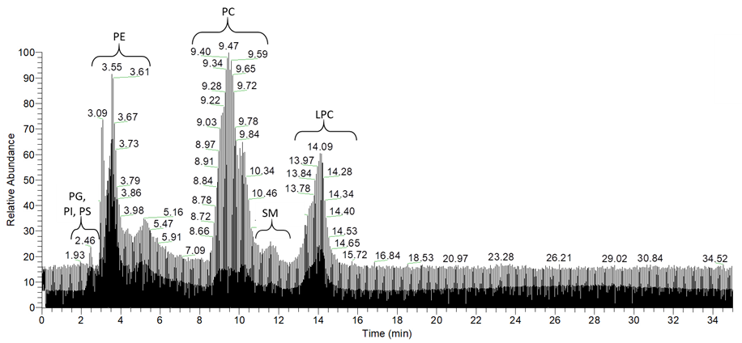

Supplementary Figure S1. An example of the total ion chromatogram (TIC)

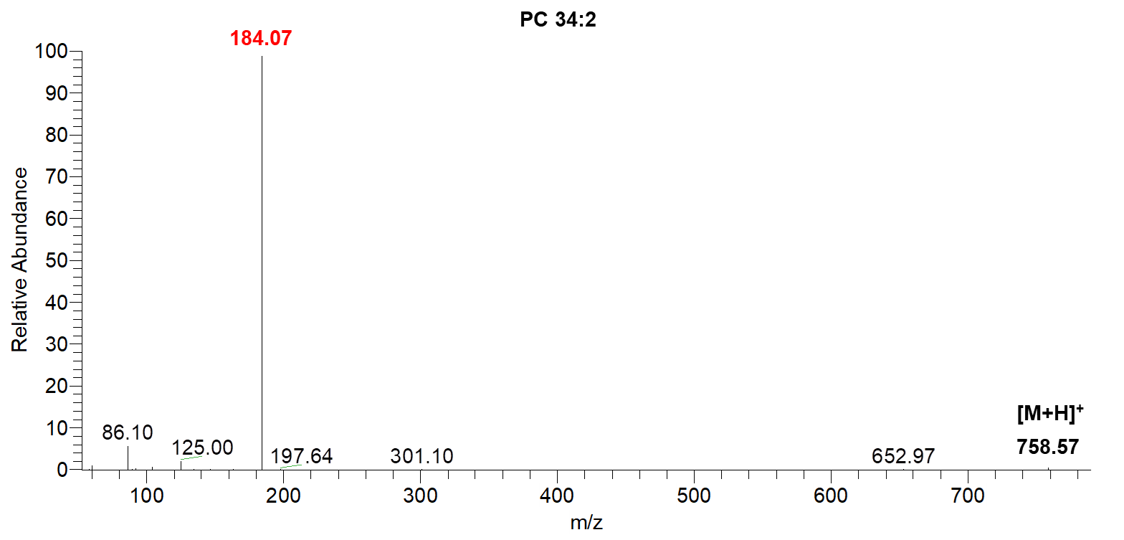
Supplementary Figure S2. ESI-MS/MS spectrum of the [M+H]⁺ ion of PC 34:2 (m/z 758.57). Fragment ion characteristic for the PC class was highlighted in red.
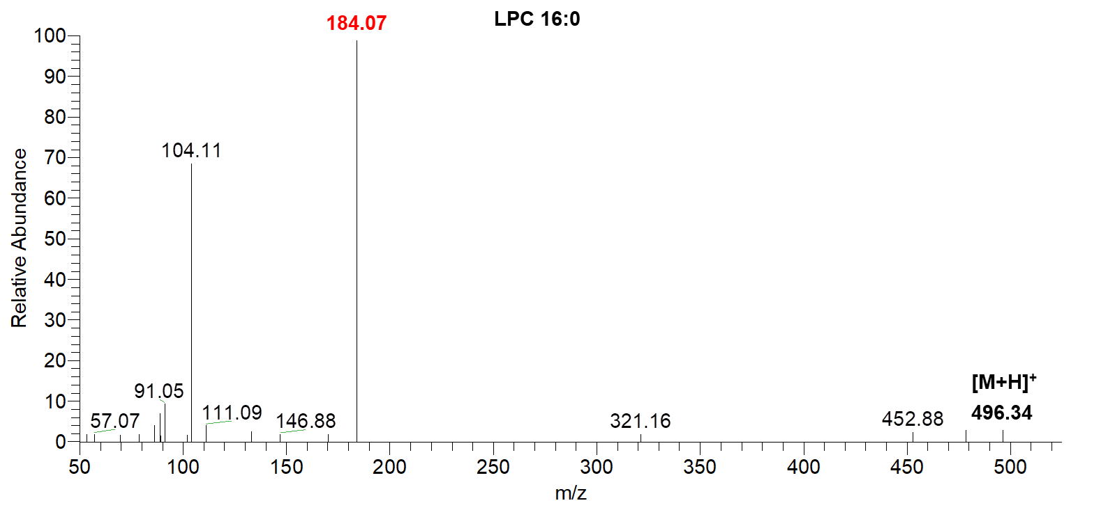
Supplementary Figure S2. ESI-MS/MS spectrum of the [M+H]⁺ ion of LPC 16:0 (m/z 496.34). Fragment ion characteristic for the LPC class was highlighted in red.
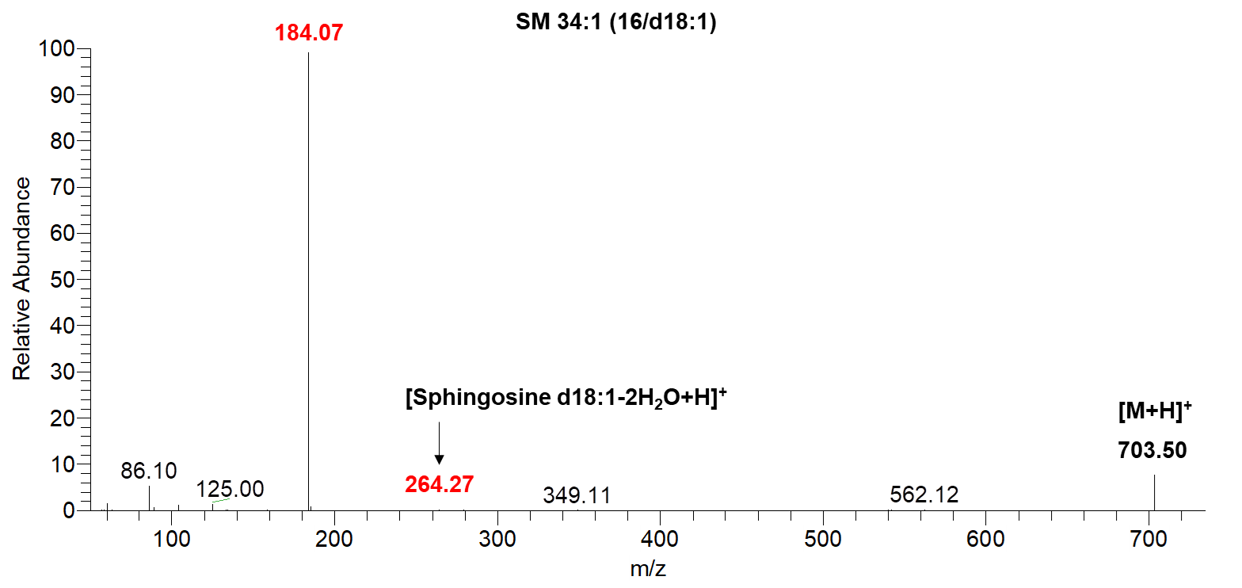
Supplementary Figure S2. ESI-MS/MS spectrum of the [M+H]⁺ ion of SM 34:1 (m/z 703.50). Fragment ion characteristic for the SM class was highlighted in red.

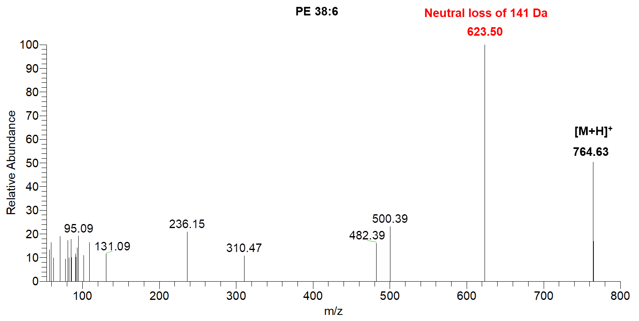
Supplementary Figure S5. ESI-MS/MS spectrum of the [M+H]⁺ ion of PE 38:6 (m/z 764.63). Fragment ion formed by the characteristic neutral loss of 141 Da for the PE class was highlighted in red.
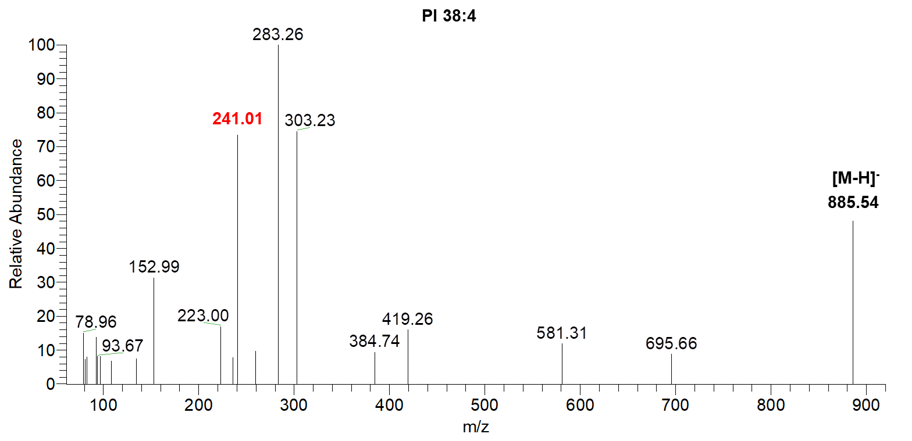
Supplementary Figure S6. ESI-MS/MS spectrum of the [M-H]⁻ ion of PI 38:4 (m/z 885.54). Fragment ion at m/z 241 characteristic for the PI class was highlighted in red.

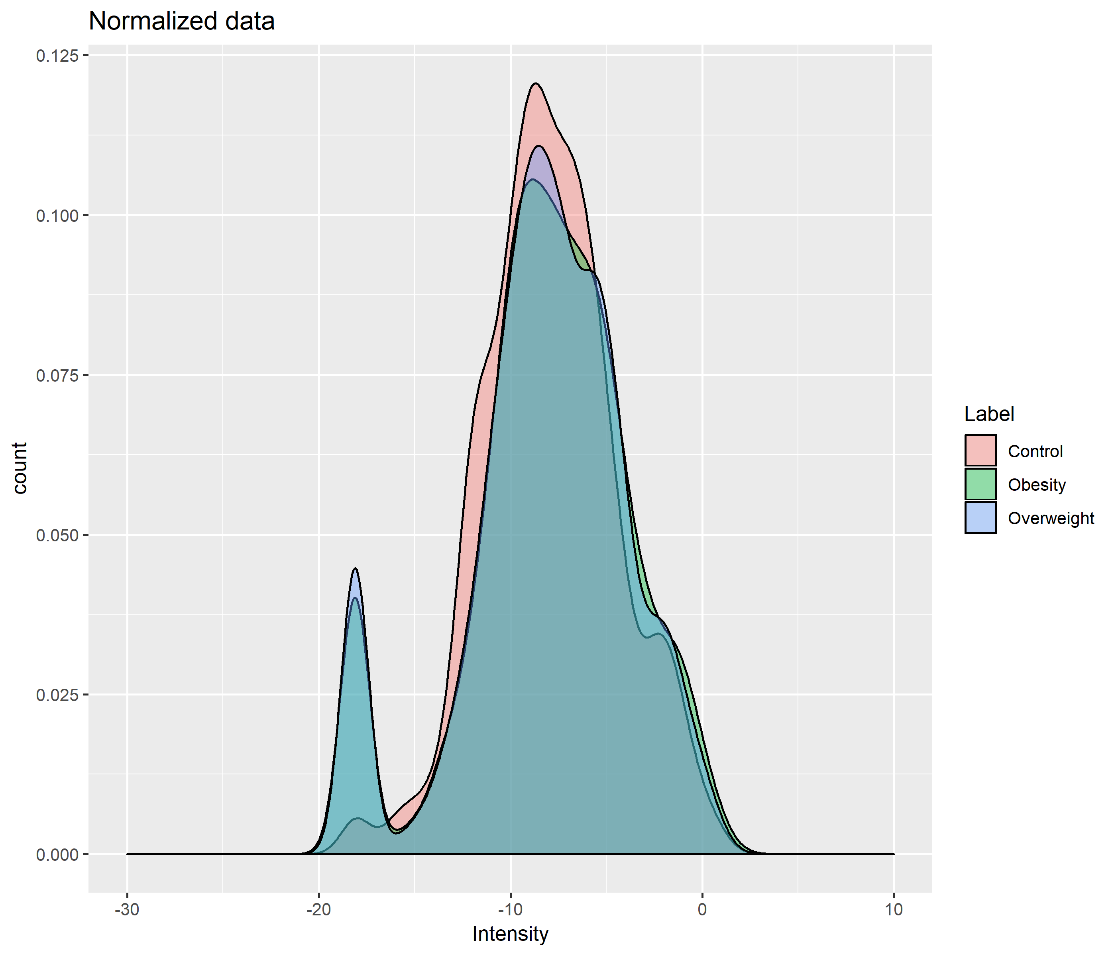
Supplementary Figure S7. Representation of the distribution of the normalized peak area.
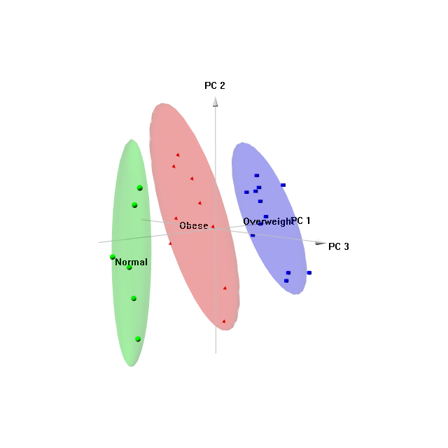
Supplementary Figure S8. Principal component analysis in a three-dimensional score plot of phospholipid profiles obtained from children with normal weight (CT), overweight (OW) and obese children (OB).

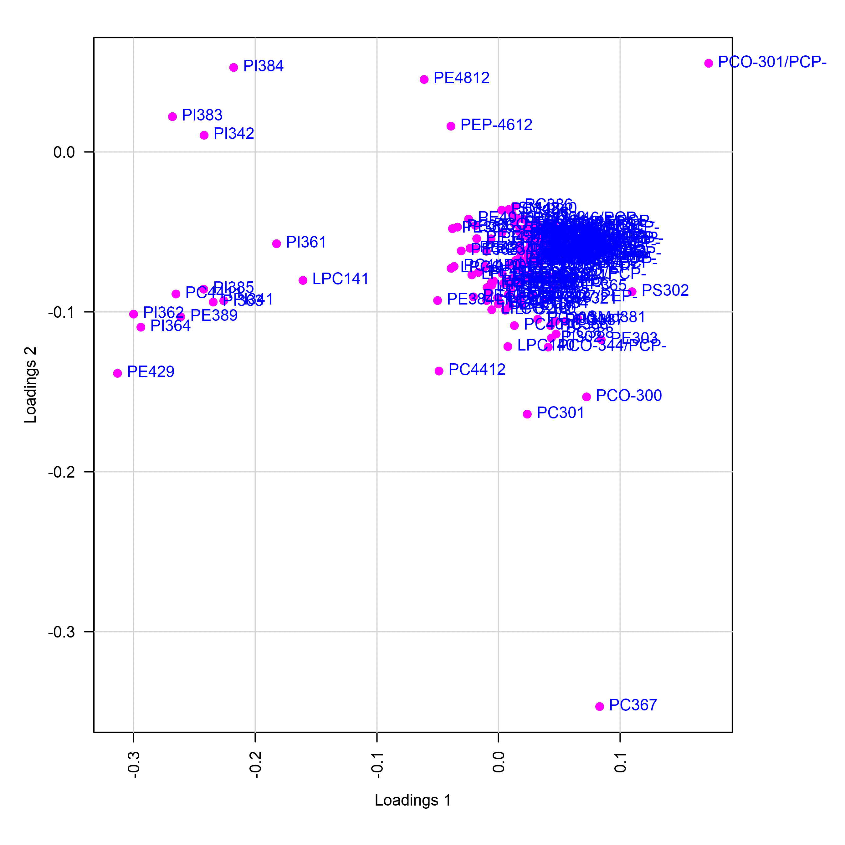

Supplementary Figure S9. Loading plot for PCA analysis shown on figure 1.

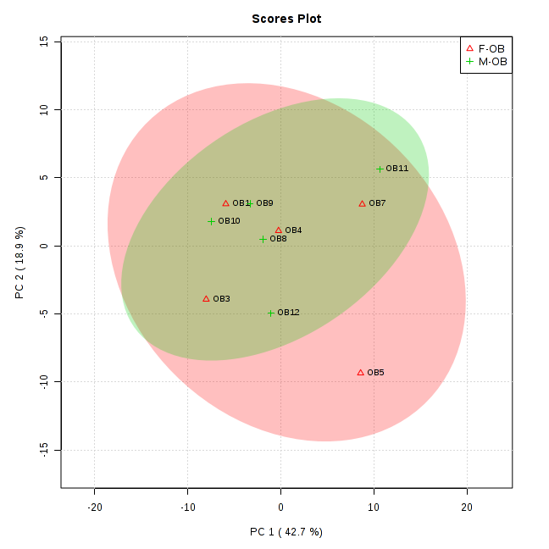
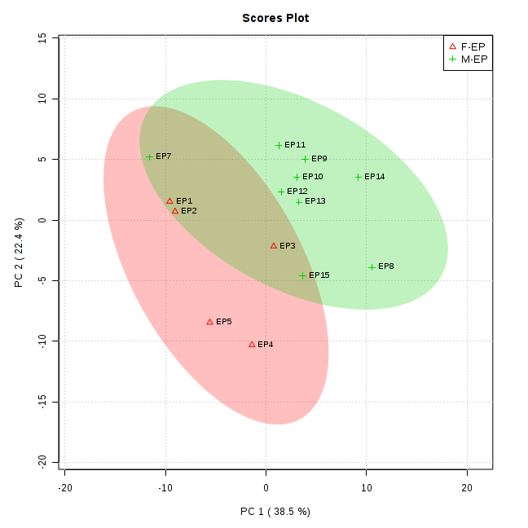
Supplementary Figure S10. Principal component analysis in a two-dimensional score plot of phospholipid profiles obtained from male and female individuals with overweight (EP) and obesity (OB).

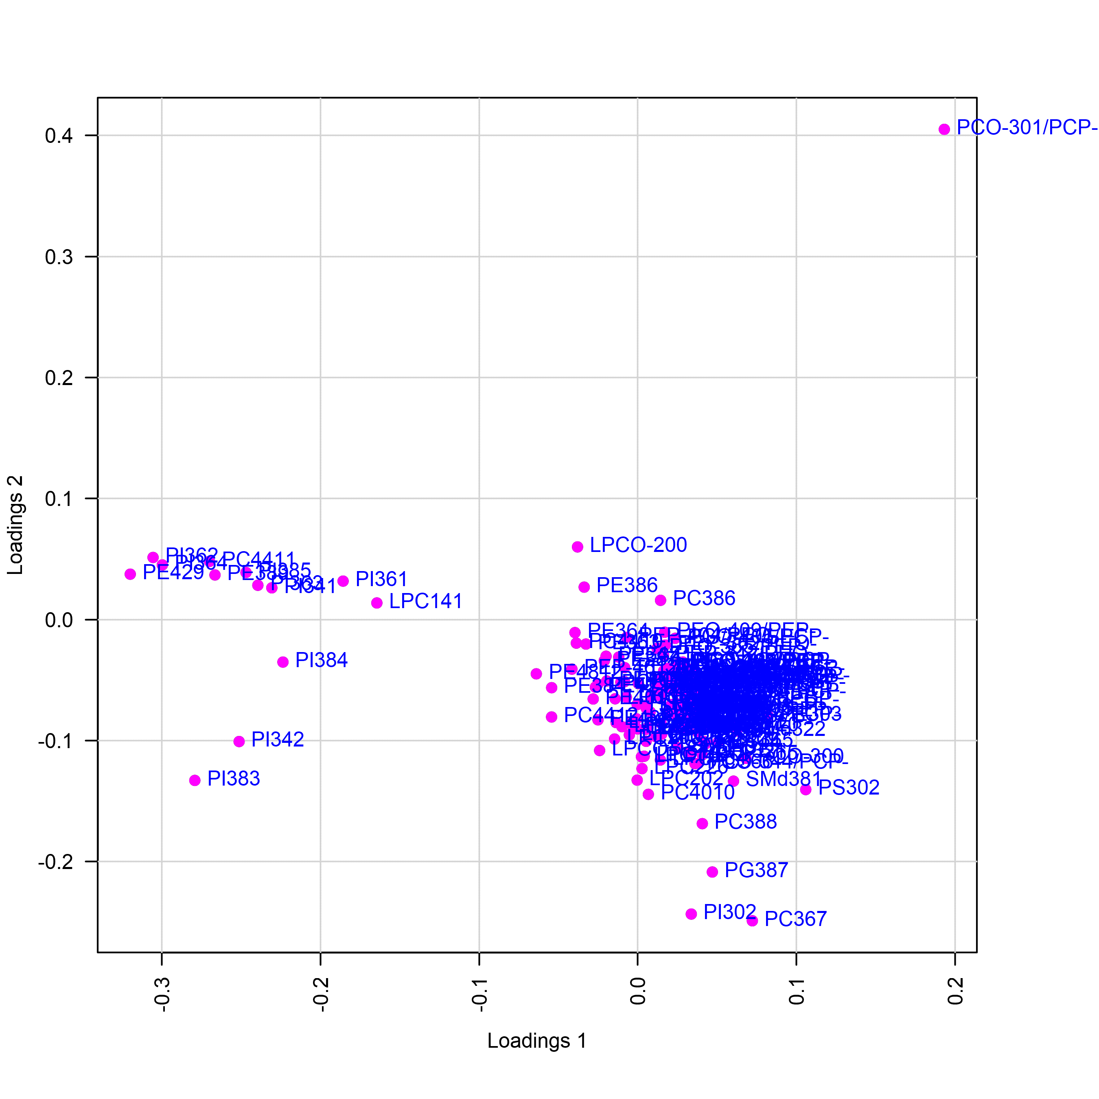
Supplementary Figure S11. Loading plot for PCA analysis shown on figure 2.

