Piezoelectricity in self -assembled peptides: a new way towards electricity generation at nanoscale

Vladislav Slabov1, Svitlana Kopyl1, Marco P. Soares dos Santos2,3, Andrei Kholkin1,4*

1Department of Physics & CICECO-Aveiro Institute of Materials, University of Aveiro, Aveiro, Portugal

2Department of Mechanical Engineering & Centre for Mechanical Technology & Automation (TEMA), University of Aveiro, Aveiro, Portugal

3Associated Laboratory for Energy, Transports and Aeronautics (LAETA), Porto, Portugal

4School of Natural Sciences and Mathematics, Ural Federal University, Ekaterinburg, Russian Federation

## kholkin@ua.pt

Abstract

Self-assembled nanostructured peptides are of great interest nowadays due to their biocompatibility and an array of outstanding functional properties. Among them, strong piezoelectricity combined with low dielectric constant is beneficial for high voltage and power generation at the nanoscale. This Chapter is an overview of the piezoelectric phenomena in self-assembled peptides including effects of the growth conditions, self-assembly, and measurement techniques on their functional response as well as the origin of strong piezoelectricity in this material. The current status of electrical energy harvesting in self-assembled peptides useful for biomedical applications along with the challenges and perspectives for using these piezoelectric biomaterials will be discussed. This chapter is expected to provide a guidance towards future design and application of novel functional self-assembled materials based on nanostructured peptides.

**Keywords:** self-assembly, peptide, piezoelectricity, nanogenerator, energy harvesting

1. Introduction

One of the most important trends in modern microelectronics has been the dramatic reduction in size, decrease in power consumption and, finally, increase in the functionality. However, the batteries supplying the energy for the devices did not decrease significantly in size over the last years (power density increased but only several times, [1]). They represent currently a significant volume and weight as compared to the overall size and weight of the device itself. As such, advances in low power design of many electronic components opened up the possibility of using energy from the environment to power these microdevices. This increases their functionality as they can be completely autonomous and wearable and will not require replacing batteries for the entire lifetime of the device. One of the major mechanisms to achieve electric energy harvesting is piezoelectric effect, which converts mechanical vibrations into electricity, and pyroelectric energy generation, which uses temperature changes. The vibration sources are quite abundant and can be found, e.g., in the human motion, blood flow, low-frequency vibrations of buildings, motion of the cars, and acoustic noise. These can be directly applied to piezoelectric material to generate electric power. In fact, piezoelectric harvesting allows easy miniaturization because piezoelectric effect is scale-independent and can be even higher at the nanoscale [2].

The interest in the application of piezoelectrics and pyroelectrics for electrical energy harvesting has grown significantly last years. Most piezoelectric harvesting sources can produce power on the order of milliwatts but it is still small for large systems. However, the generated power is just enough for hand-held and implanted devices and miniaturized wearable electronics (e.g. sensor networks). Piezoelectric energy harvesting has been investigated since the late '90s and it is currently considered as an emerging technology. Miniaturization of the devices requires using nanoscale dimensions, so that electricity must be harvested timely and exactly where it can be consumed. For example, it can be used for biomedical purposes, the piezoelectric scaffolds for cell regeneration being one of such applications [3] and for instrumented orthopedic implants [4].

Pyroelectric materials are a subclass of piezoelectric crystals with a polar structure. All pyroelectric materials are also piezoelectric, although the *vice versa* does not occur. They exhibit a change in polarization with temperature change [5]. It is well known that there is a noticeable temperature difference between the human body and the ambient environment (the average human body temperature being 37 °C). Therefore, there is always a heat loss from the human body to the ambient environment, mainly through skin and through the process of respiration. This waste heat can be converted into electric energy using pyroelectric effect. Several pyroelectric nanogenerators have already been reported, which utilized pyroelectric/ferroelectric materials [6–8].

Inorganic ferroelectrics, such as lead zirconate titanate (PZT), lithium niobate (LNO) and barium titanate (BTO), are widely used as efficient piezoelectrics, pyroelectrics, memory cells, and electrooptic modulators [9]. They possess high switchable polarization, strong piezoelectric response, remarkable pyroelectric and electrooptic properties, but have some disadvantages, such as poor biocompatibility and brittle nature that limits their use in biomedical applications. Moreover, their processing requires high temperatures, so their miniaturization and integration with microelectromechanical systems (MEMS) is difficult. Novel organic or polymer materials (e.g. polyvinylidene fluoride, PVDF) seem to not have these disadvantages, but still may require a protection from the tissue or cell in the in the direct contact [10] because they are not biocompatible.

In this context, bioinspired materials with biocompatibility, easy preparation, nontoxicity and environmental friendliness have been regarded as promising alternatives [11]. Until recently, properties of organic and biomolecular piezoelectrics were considered by far inferior to those of their inorganic counterparts, thus making their applications as piezoelectrics and pyroelectrics unfeasible. Recent studies revealed that the softness of hydrogen bonds in some representative classes of biomolecular polar materials may be the origin of strong piezoelectric effects at room temperature [12]. It has been reported that the piezoelectric coefficients in self-assembled short peptides (diphenylalanine, NH2-Phe-Phe-COOH) are practically the same as in popular transducer material LNO [13]. This discovery has led to a surge in research on piezoelectric biomaterials. A variety of microstructures and phases have been produced that could lead to the enhancement of physical and chemical properties by designing molecular structures, fabricating heterostructures and introducing dopants [14]. Several reports show that the piezoelectric response in biomaterials is directly related to their phase, shape and growth direction [15]. It has been found that piezoelectricity of peptide fibrils and phages in axial direction is stronger than that in the radial direction [15]. Electric charges generated by the physical stimulation of piezoelectric biomaterials were found to stimulate bone growth, wound healing and tissue regeneration [16].

This Chapter is an overview of the piezoelectric phenomena in self-assembled peptides, focusing on diphenylalanine, and includes effects of the growth conditions, self-assembly, and polarization of self-assembled nanostructures peptides on their piezoelectric properties. The discussion will further focus on their applications as nanogenerators and energy-storage devices.

2. Introduction to self-assembled peptides

Supramolecular self-assembly plays a significant role in building highly ordered and functional structures in biology. Natural biological tissues are hierarchically structured, and these structures appear to correlate strongly with tissue properties and functionalities. A single macromolecule can form various functional structures when self-assembled under different conditions. Nanotechnology is trying to imitate what Nature has achieved, with the precision at the nanometer level paving a way to nanobiotechnology, a division of nanotechnology that involves exploitation of bioorganic molecules on the nanoscale. The nanostructures obtained from self-assembly of bioorganic molecules are attractive due to their biocompatibility, ability for molecular recognition and ease of chemical modification, thus providing an innovative route for fabricating multifunctional bioorganic electronic devices [17]. Molecular self-assembly is the main bottom-up approach for the affordable production of bulk quantities of well-defined nanostructures. Proteins and peptides are the most versatile natural molecular building blocks, due to their extensive chemical, conformational and functional diversity [18]. Various peptide-based building blocks, such as aromatic dipeptides have been designed and developed for the construction of organized supramolecular nanostructures [19].

Diphenylalanine (FF), a fragment of the Alzheimer’s β-amyloid peptide, is one of the self-assembling dipeptides that have recently been a subject of intense research in nanotechnology due to unique assembly characteristics [20]. It was found [21] that the FF self-assemble into semi-crystalline nanotubes in an aqueous solution. X-ray crystallographic analysis, first presented by Görbitz [22], showed that FF dipeptide has hexagonal crystal structure (P61 space group) and can form channel structures as well as that these simple compounds crystallize with hydrogen-bonded head-to-tail chains in the shape of helices with four or six peptide molecules per turn. The resulting structures have chiral hydrophilic channels with a van der Waals' diameter up to 10 Å.

It was later shown that FF peptides can also self-assemble into diverse structures, such as nanotubes [13, 23], nanowires [24, 25], nanospheres [26], microcrystals [27, 28] or can be further designed as 0D quantum dots, depending on the deposition conditions and the type of solvent.

The self-assembling mechanism, in which FF nanostructures are produced, is not yet fully understood. However, the most acceptable explanation suggests that FF self-assembling mechanism is governed by non-covalent intermolecular interactions such as electrostatic, hydrophobic, van der Waals, as well as by hydrogen bonds between aromatic rings and π-π stacking interactions [21].

The FF nanostructures are of a special interest due to their unique physical, chemical and mechanical properties. For example, FF nanotubes exhibit a high Young’s modulus of ≈ 19 GPa [28], a huge mechanical stiffness of 160 N/m [29] and are stable under extreme conditions, including boiling water, organic solvents such as ethanol, acetone and various acidic conditions [30]. The discovery of strong piezoelectric activity[13], temperature-dependent spontaneous polarization and phase transitions in these aromatic dipeptides have established them as nanomaterials with possible ferroelectric properties [13].

3. Fabrication methods and piezoelectric properties

The self-assembly process of the FF dipeptide in tubes, as well as in rods, microribbons, fibers, among others, is carried out in the presence of liquid (mostly water) [21, 31–33]. The water molecules are contributing by electrostatic charge, allowing FF molecules to move closer to each other to start the assembly process [34]. Before mixing the original FF powder with water, it is necessary to prepare a stock solution. Many studies [35] describe a standard stock solution prepared in a concentration of 100 mg/ml in a polar solvent (acetic acid or hexafluoroisopropanol (HFIP)). Usually, to ensure the growth of a different structures, the stock solution is mixed in a different ratio with water. The standard method for preparing FF tubes is to dilute the stock solution in deionized water to a final FF concentration of 2 mg/ml [13, 21, 27]. This method produces a multitude of tubes of various lengths and diameters from tens of nm to hundreds of µm. Studies of these FF nanotubes via Piezoresponse Force Microscopy (PFM) revealed a strong piezoelectric effect, with the orientation of polarization along the tube axis [13]. The shear piezoelectric coefficient (d15~60 pm/V) was obtained for the nanotubes with ~200 nm in diameter and was explained considering the dipeptide nanotubes as a crystalline nanoceramic with polar structure.

Recently, FF tubes fabricated using this method were studied in two different configurations [27]: (i) suspended ones (cantilever-type) with one edge clamped to a rigid support. For the cantilever-like configuration, the tube edge was picked up with tweezers and placed on the top of a conducting carbon tape whereas for the study in (ii) longitudinal extensional mode, the tubes were prepared directly on a patterned glass substrate coated with Au so as to comprise a conducting electrode.Figure 1 illustrates these structures, focusing on the harvesting mode and experimental configuration.

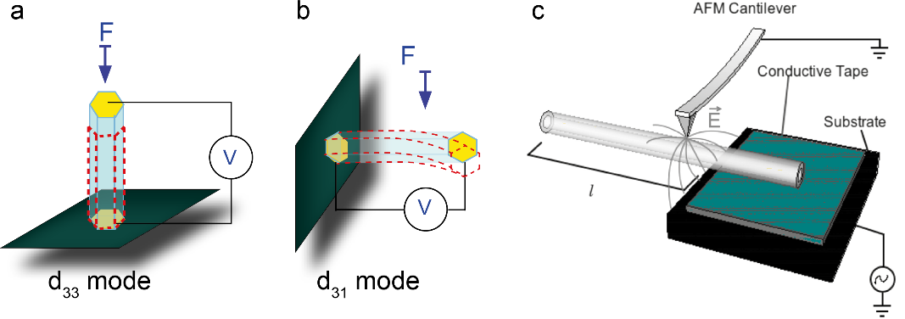

Figure 1. Schematic of the energy harvesting configurations in (a) d33 and (b) d31 modes. (c) FF tube arrangement in the experimental situation. AFM cantilever is used to excite piezoelectric resonances and to measure induced vibrations as a function of frequency. Arrows are used to highlight inhomogeneous distribution of electric field that helps to induce bending resonances in the system. Reproduced from [27], with the permission of AIP Publishing.

The vibrational response was investigated using an Atomic Force Microscopy (AFM) setup where the conducting tip is used both to excite the piezoelectric vibrations and to study the vibrational response via an additional lock-in amplifier connected to the photodiode and synchronized with the driving voltage. The measurement scheme is analogous to that used in the PFM method [36] but the external ac driving was replaced with the internal one commonly used in AFMs for the cantilever resonance calibration. Figure 2 represents the measured amplitude of the deflection (DFL) signal in respect to the excitation frequency for the cantilever configuration shown in Figure 1 for two different tip positions. The studied tube was 885 μm long and 13 μm in diameter. The measured resonance frequencies and respective quality factors are shown in the inset to Figure 2. As it is clear from this Figure, the peaks shift to higher frequencies with increasing distance between the voltage application point (AFM tip) and the clamping point. However, the ratio between the second and the first resonance modes is approximately the same, about 3.05–3.1. The quality factors are in the range 20–50 and are close to those reported for piezoelectrically driven PVDF fibers prepared by electrospinning [37].

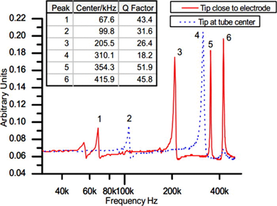

Figure 2. Piezoelectric resonances excited in the FF microtube. Solid line represents the resonance structure for the AFM tip located in the middle. Dotted line is the example of the resonance peaks for the AFM tip close to the support. Table in the set summarizes resonance frequencies and quality factors for both configurations. Reproduced from [27], with the permission of AIP Publishing.

It was demonstrated [27] that self-assembled diphenylalanine microtubes prepared from the solution can be used as piezoelectric resonators with the potential to perform sensing and actuating functions in micro- and nanoelectromechanical systems. The sharp piezoelectric resonance in the MHz range with the quality factor >100 was already demonstrated. These parameters can be further improved by scaling down the sizes of the devices down to sub-µm ranges.

An in-depth study of the piezoelectric properties of similar FF microtubes using the advanced PFM were reported by Vasilev *et al* [38]. Piezoelectric coefficients of the microtubes were measured in three different configurations (Figure 3). The full matrix of piezoelectric coefficients was also determined in this work. Piezoelectric coefficients are important input parameters for the design and fabrication of harvesting devices based on nanostructured materials, including FF peptides.

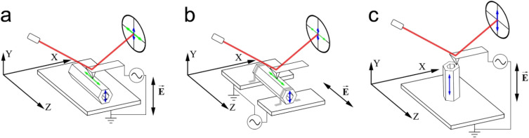 Figure 3. Schematics ofdifferent configurations for the measurements of piezoelectric coefficients. (a) Measurement of d15 (LF signal, displacements are shown by horizontal arrow) and d14 (DFL signal, vertical arrow). (b) Measurement of clamped d33 (LF signal, horizontal arrow) and d31 (DFL signal, vertical arrow). Tube was fixed by conductive glue (c) Measurement of d33 (DFL signal, vertical arrow). Red line shows the laser beam reflecting from the cantilever. Reprinted from [38], Copyright (2016), with permission from Elsevier.

Kim *et al* [25] have shown the influence of the different ratios between the stock solution and water that impact on the hydrogen bond density, which leads to a change of the self-assembled microstructure. This fact allows to understand how the fabrication structure can be controlled. As concerned the manufacturing methods, it is important to find the deposition techniques suitable for mass production. By this way, the combination of the solution properties and deposition technique will allow forming suitable structures for the applications. Today, several liquid deposition methods can be implemented, e.g. simple drop-casting and inkjet printing technology. These will be overviewed in the following section.

3.1 Drop casting method

The first method we discuss here is the drop casting. This method has a similar principle of operation as inkjet printing, but does not need rheology adjustment and special techniques to perform the directed growth. For the drop casting method, one just needs micropipettes, stock solution, and water. Since the crystal growth occurs in the radial direction of drying drops (from their edges to the center) on the substrate, the initial form of the droplet determines the orientation of the crystals. Thus, it is possible to control the growth direction of elongated structures. In order to implement an unidirectional growth, the method of masking with hydrophilic/hydrophilic areas was used [39]. In this study, a surface patterning technique was conducted to align FF peptide nanotubes (PNTs). Patterned regions of Si substrate were created by the growth of a silicon oxide via UV/ozone exposure through a Si mask. Further control over the diameter and density of the PNTs is achieved by heating the FF solution prior to drop casting. Figure 4 highlights the results from solution with 2 mg/ml concentration grown on the different size of opening masks (hydrophilic regions).

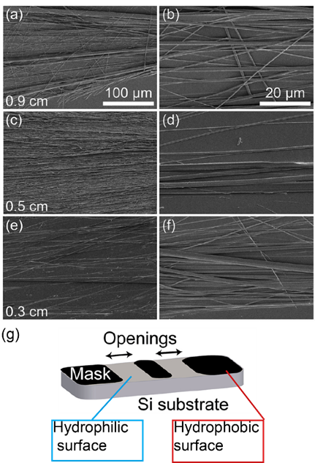

Figure 4. SEM images grown tubes on the different size of opening masks: a,b – 0.9 cm; c,d – 0.5cm; e,f – 0.3 cm; g – schematic of Si substrate preparation: opening regions treated by UV/ozone for good wettability. Reproduced from Ref. 39 with permission from The Royal Society of Chemistry.

This method demonstrates high-quality results by simple control of FF nanotubes growing using different wettability of patterned substrates. The modification of these aligned microtubes allows their application in microdevices.

3.2. Inkjet printing technology

Inkjet printing (IJP) of the materials is a method that allows to form the solid structure from liquid microdrops. The inkjet printing technology can be used for directing self-assembly of peptides to create controlled shapes of grown crystals, by drop geometry for useful for microelectronic applications. IJP structuring of peptides would allow depositing micro volumes with high precision on different substrates. However, the IJP method requires special sample preparation. The main parameters of materials for IJP are rheology, surface tension, pH and particle size. As was described above, the standard method for self-assembly FF molecules and microstructure growth is a mixing of stock solution and water. Since this mixture forms a precipitate, it cannot be used directly for the printing method. Recently, an ink composition suitable for printing and allowing one to self-assemble the structure has been developed [40]. This work demonstrated the controlled deposition of FF using drop-on-demand piezoelectric printing technology combined with high resolution and reproducibility (Figure 5a). A new conformation of the printed FF-based crystals grown from the ink, which was developed for this deposition method was also demonstrated (Figure 5b). As is well known [40], printing ink must have certain parameters for successful application. Viscous solvents and surfactants are commonly used to change the viscosity and surface tension. But how do they affect the self-assembled structure and its properties? Nowadays, it is known that solvents act on FF molecules and cause significant electrostatic interactions between them [21]. This interaction allows the formation of various microstructures, which is quite evident as exemplified by the methanol – water mixture for the growth FF crystals [41].

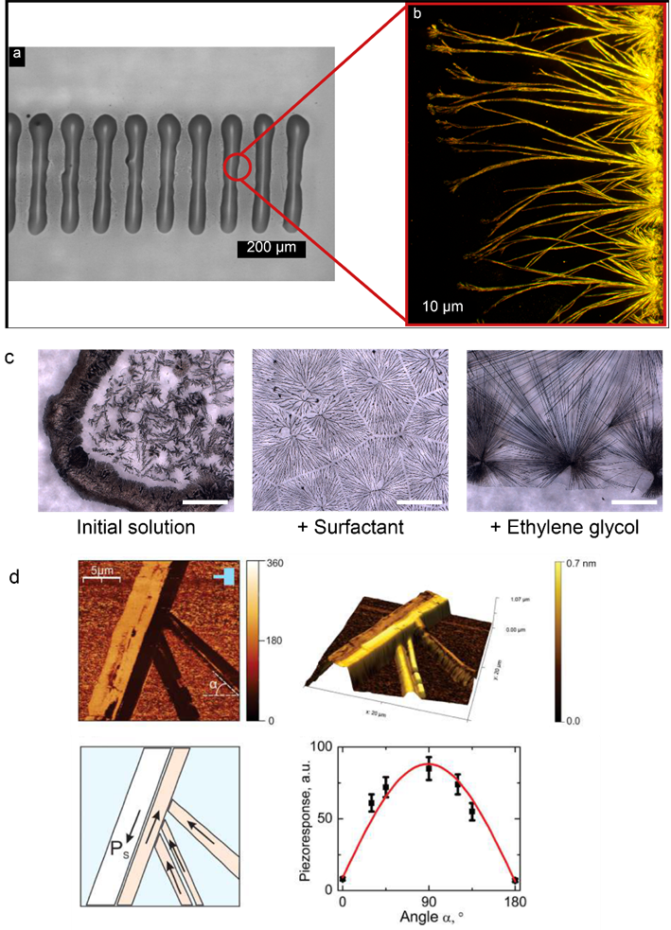

Figure 5. Optical and PFM investigation of printed FF structure: (a,b) Inkjet printed FF crystals grown orthogonal to the drop edge; (c) influence of the additives on the microstructure FF crystals (scale bar 500 µm); (d) PFM measurement of printed crystals. Reprinted with permission from [40]. Copyright © 2018 American Chemical Society.

In the case of ethylene glycol and surfactant, a change of grown microstructure was noticed (Figure 5c). That should mean the change in the self-assembly process. As a result, a new crystalline structure was formed: this is not a hexagonal tube, but a flat rhombic belt. The piezoresponse of that structure was investigated by PFM method. The obtained FF belt-like crystals exhibited a high piezoelectric response (Figure 5d), a piezoelectric coefficient deff of 40 ± 5 pm/V; this value is smaller than the one observed for typical hexagonal FF microtubes (60 ± 10 pm/V) [13], but it is still higher than those measured in many organic piezoelectrics including polyvinylidene fluoride [42]. The value of the piezoelectric coefficient allows the use this material for microdevice applications. In addition, the solution was adapted to IJP technology which opened new possibilities for the application and fabrication functional structure on the different substrates. In contrast to the simple drop cast method, IJP allows depositing microstructures with controlled self-assembly order.

3.3. Dip coating technology

The dip-coating method is a common technique for the material deposition from liquids. This method allows fabricating thin and thick films by dipping and pulling the substrate in the bath with the solution. Since this method allows to control the velocity of pulling and dipping, – it can be used for crystal growth and it was suggested to align FF nanotubes on the polymer substrate (Figure 6a) [43].

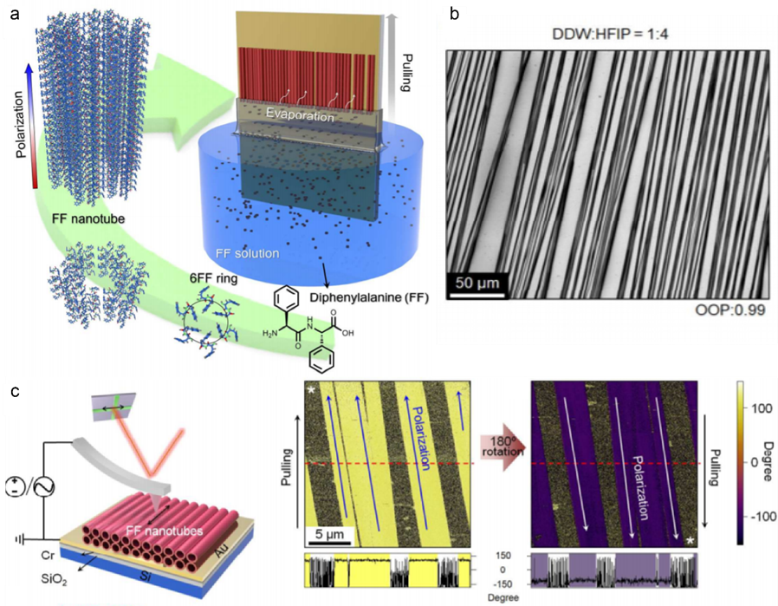

Figure 6. Dip-coated aligned FF nanotubes: a – schematic of the substrate pulling from a mixture of FF stock solution and water: b – SEM image of the aligned FF tubes: c – PFM measurement demonstrated one direction of polarization in parallel tubes. Reprinted with permission from [43]. Copyright © 2018 American Chemical Society.

By controlling the stock solution concentration in water and pulling speed, the morphology of FF peptide nanostructures from the vesicles to elongated and aligned nanotubes was found (Figure 6b). Furthermore, FF nanotubes show unipolarity (Figure 6c), which is critical for the fabrication as piezoelectric energy harvesters as nanogenerators.

3.4 Benefits and limitations of methods.

Before comparing the discussed methods, the application areas must be first defined. If the device to be designed does not require directed growth and the cost should be low, the drop-casting method will be enough, because it is the simplest technique and cost-efficient. However, if the device should be anisotropic and directional response is needed drop casting on hydrophilic and hydrophobic surfaces is required [39]. , By the puling and dipping of substrate (dip-coating method), the deposition of oriented tubes on many surfaces can be performed, although it depends on wettability of the substrates. But two big limitations of dip-coating are: (1) both sides of the substrate are covered by tubes (2) deposition occurs everywhere and additional patterning will be required. For the directed deposition, the most effective method is inkjet printing, which allows jet drop the volumes as small as 10 pL. The complexity of this method is to find an appropriate solution formulation. A stock solution, mixed with many solvents, is demanded to prepare a solution with required rheology, so that the microstructure can be adjusted to specific application [40]

4. Examples of energy harvesting applications

4.1. Nanogenerator

The discovery of ZnO-based nanogenerators in 2006 [44] significantly boosted the research on piezoelectric materials for energy harvesting applications. Piezoelectric nanogenerators are based on the piezoelectric effect through which mechanical energy is converted into electricity and vice versa via linear coupling of mechanical strain and electric field. Since the discovery of piezoelectric nanogenerators based on ZnO, many other nanogenerators have also been developed, e.g. based on flexible PVDF [45, 46], [47], triboelectric [48–50] and pyroelectric ones [6–8].

Peptide-based biomaterials were also recognized suitable for electrical energy conversion. Recently, it has been reported [51] that FF vertical microrod arrays grown under an external applied electric field, exhibit an effective piezoelectric constant d33 of 17.9 pm/V The effect of the electric field resulted in a stretching of the peptide backbone with a concurrent increase of the dipole moment. A power generator was developed based on vertical FF microrod arrays with uniform polarization by applying electric fields (Figure 7 a, b) [51]. The FF-based power generator provided an open-circuit voltage of 1.4 V with an applied force of 60 N (Figures 7 c, d), and a power density of 3.3 nW cm−2 at 50 MΩ, which is about 4 times higher than the energy harvested by zinc oxide nanowires [44]. The FF-based nanogenerator was integrated with a single-electrode triboelectric nanogenerator to form a hybrid device [52]. Hybrid nanogenerator combines the advantages of both piezoelectric and triboelectric nanogenerators, being able to provide the output voltages of 2.2 V.



Figure 7. (a) Schematic of the FF peptide-based generator connected to the measurement equipment. Bottom-right inset: photography of a real device. (b) Schematic of the measurement set-up in which a linear motor pushes with controlled forces on the top electrode in (a). The linear motor was programmed to always keep contact with the top electrode to minimize the effect of static charges. (c,d) Open-circuit voltage (c) and short-circuit current (d) from a generator using microrods from positive-EF growth. Reproduced from [51] with the permission.

Recently, a meniscus-driven self-assembly process was used to fabricate horizontal large-scale FF microtube arrays with an asymmetric shape (Figure 8a) [43]. The FF nanostructure was adjusted by the type of the solvent, the solubility and pulling speed. The resulting FF nanotube devices produce electrical energy upon application of mechanical force. The FF-based device exhibited a voltage of 2.8 V, a current of 37.4 nA and a power of 8.2 nW, respectively, when a force of 42 N was applied [43] and can power multiple liquid-crystal display (LCD) panels and can power multiple liquid-crystal display panels (Figure 8b,c). These peptide-based energy-harvesting materials are considered as compatible energy source for biomedical applications in a recent future. The parameters of several types of piezoelectric nanogenerators are compared in Table 1. It can be seen that piezoelectric nanogenerator based on horizontal FF tubes is the most efficient one.

Table 1. Parameters of piezolectric (PENG) nanogenerators

|  |  |  |  |  |
| --- | --- | --- | --- | --- |
| Generator | VOC, V | Energy density | d33, pm/V | Applied force, N |
| PENG based on ZnO [53] | 1.26 | 2.7 nW/cm3 | 12.0 [54] | - |
| PENG based on vertical FF [51] | 1.4 | 3.3 nW/cm2 | 17.9 | 60 |
| PENG based on horizontal FF [43] | 2.8 | 8.2 nW | - | 42 |

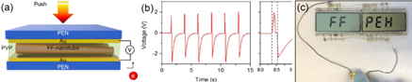

Figure 8. (a) Schematic illustration of FF peptide-based piezoelectric energy harvester (PEH); (b) Output voltage responses with 1 GΩ external load; (c) Photograph of the LCD driven by pressing the PEH with a finger.Reprinted with permission from [43]. Copyright © 2018 American Chemical Society.

**Energy storage**

Piezoelectric biomaterials as exemplified by nanostructured peptides can be also used for supercapacitors, due to their large specific surface area. Vapor deposition technology has been recently used to grow FF peptide nanotubes arrays as a part of electric double layer capacitor (EDLC) [55]. The capacitor based on these nanotubes asmodified electrode showed a high areal capacitance of 480 µF cm−2 which was is four times as high as that for carbon nanotubes modified electrodesand 30 times higher than that for carbon electrodes without any modification. The FF nanotubes-based capacitor demonstrated very high cycle stability and no significant capacity loss after 10000 charge–discharge cycles [55]. An external electric field was applied to generate unidirectionally aligned and stable FF nanotube/microtube arrays at room temperature [56]. The FF nanotube/microtubes with open ends morphology and multi-layer walls were considered as the origin of the large specific surface area. The FF nanostructures were used as electrodes to fabricate a supercapacitor, and a high specific capacity of 1000 µF cm−2 at a scan rate of 50 mV s−1 was obtained (Figure 9).

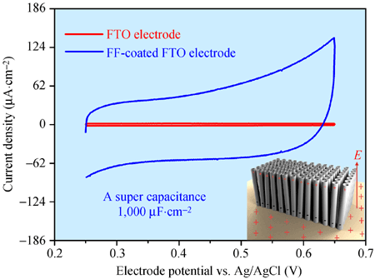

Figure 9. Cyclic voltammetry measurements of the FTO electrode coated with unidirectionally aligned NTs/MTs (red line). Reprinted by permission from [56]. Springer Nature. Copyright © 2014

It has been reported [55, 57, 58] that FF nanostructures hold a potential as high-capacity ultracapacitors for fast charging in energy storage applications such as batteries for mobile devices and electric vehicles. In particular, vertical FF nanostructures can increase the effective activation area of ​​modified electrodes and increase electrical conductivity [55].

Conclusions

The purpose of this book chapter was to give an overview of the most relevant findings in the piezoelectric studies on self-assembled peptides, in particular using diphenylalanine. Diphenylalanine, as a piezoelectric self-assembled dipeptide, is important fromboth the fundamental point of view and real-world energy harvesting applications. The morphology of FF peptide, the mechanism of self-assembly, the doping/composite structure are of particular interestdue to their effect on piezoelectricity From the point of view of applications, two major applications were highlighted: nanogenerators based on piezoelectric biomaterials, such as FF peptides, and energy storage capacitors. Both types of nanogenerators described in this Chapter combine high efficiency, stability and self-assembled features for energy harvesting and storage that are desirable for future applications. Further, the research on self-assembled materials with a high piezoelectric response, by controlling their composition and structure, can lead to the next generation of nanogenerators in a near future.

Acknowledgments

This work was developed within the scope of the project CICECO-Aveiro Institute of Materials, FCT ref. UID/CTM/ 50011/2019, financed by national funds through the FCT/ MCTES. S.K. and A.K. were partly supported by FCT (Portugal) through the Project PTDC/CTM-CTM/31679/ 2017 - “BioPiezo” and joint Portugal-Turkey project (TUBITAK/0006/2014). M. Soares dos Santos was also supported by FCT, through the grant references SFRH/BPD/117475/2016. All authors were partly supported by FCT through the project ‘‘SelfMED” (POCI-01-0145-FEDER-031132). Part of this work was funded by national funds (OE), through FCT − Fundação para a Ciência e a Tecnologia, I.P., in the scope of the framework contract foreseen in the numbers 4, 5, and 6 of the article 23, of the Decree-Law 57/ 2016, of August 29, changed by Law 57/2017, of July 19.

Conflict of Interest

The authors declare no conflict of interest.

References

[1] Priya, S, Inman, D. J, editors. Energy Harvesting Technologies. Springer US; 2009. 524 p. DOI: 10.1007/978-0-387-76464-1

[2] Eliseev E. A, Morozovska A. N, Glinchuk M. D, Zaulychny B. Y, Skorokhod V. V. Blinc R. Surface-induced piezomagnetic, piezoelectric, and linear magnetoelectric effects in nanosystems. Phys. Rev. B. 2010; 82: 085408. DOI: 10.1103/PhysRevB.82.085408

[3] Gouveia PJ, Rosa S, Ricotti L, Abecasis B, Almeida HV, Monteiro L , Nunes J, Carvalho FS, Serra M, Luchkin S, Kholkin AL, Alves PM, Oliveira PJ, Carvalho R, Menciassi A, Pires das Neve, R, Ferreira, LS. Flexible nanofilms coated with aligned piezoelectric microfibers preserve the contractility of cardiomyocytes. Biomaterials. 2017; 139: 213-228. DOI: 10.1016/j.biomaterials.2017.05.048

[4] Soares dos Santos M. P, Coutinho J, Marote A, Sousa B, Ramos A, Ferreira J. A. F, Bernardo R, Rodrigues A, Torres Marques A, da Cruz e Silva O. A. B, Furlani E. P, Simões J. A. O, Vieira S. I. Capacitive technologies for highly controlled and personalized electrical stimulation by implantable biomedical systems. Scientific Reports. 2019; 9: 5001. DOI: 10.1038/s41598-019-41540-3

[5] Li X, Lu S-G, Chen X-Z, Gu X, Qian X-S, Zhang Q. M. Pyroelectric and electrocaloric materials. J. Mater. Chem. C. 2001; 1: 23-37. DOI:10.1039/C2TC00283C

[6] Wang Z L, Zhu G, Yang Y, Wang S, Pan C: Progress in nanogenerators for portable electronics. Mater. Today. 2012; 15: 532–543. DOI: 10.1016/S1369-7021(13)70011-7

[7] Lee J-H, Ryu H, Kim T-Y, Kwak S-S, Yoon H-J, Kim T-H, Seung W, Kim S-W: Thermally induced straincoupled highly stretchable and sensitive pyroelectric nanogenerators Adv. Energy Mater. 2015; 5: 1500704. DOI: 10.1002/aenm.201500704

[8] Yang Y, Wang S, Zhang Y, Wang Z: Pyroelectric nanogenerators for driving wireless sensors. Nano Lett.2012; 12: 6408–13. DOI: 10.1021/nl303755m

[9] Lines M.E, Glass A.M. Principles and Applications of Ferroelectrics and Related Materials, 1st ed.; Clarendon Press: Oxford, England; 1977, pp. 559–604. DOI:10.1093/acprof:oso/9780198507789.001.0001

[10] Cardoso V.F, Correia D.M, Ribeiro C, Fernandes M.M. Lanceros-Méndez, S. Fluorinated polymers as smart materials for advanced biomedical applications. Polymers. 2018; 10:161.DOI: 10.3390/polym10020161

[11] Hutmacher D.W. Scaffolds in tissue engineering bone and cartilage. Biomaterials. 2000; 21: 2529–2543. DOI: 10.1016/S0142-9612(00)00121-6

[12] Guerin S, Stapleton A, Chovan D, Mouras R, Gleeson M, McKeown C, Radzi Noor M, Silien C, F. M. F. Rhen F. M. F, Kholkin A.L., Liu N, Soulimane T, Tofail S. A. M, Thompson D. Control of piezoelectricity in amino acids by supramolecular packing. Nat. Mater. 2018; 17:180–186. DOI: 10.1038/nmat5045

[13] Kholkin A.L, Amdursky N, Bdikin I, Gazit E. Rosenman G. Strong piezoelectric activity in peptide nanotubes. ACS Nano. 2010; 4: 610–614. DOI: 10.1021/nn901327v

[14] Tao K, Makam P, Aizen R, Gazit E Self-assembling peptide semiconductors. Science. 2017; 358: 6365. DOI: 10.1126/science.aam9756.

[15] Minary-Jolandan M, Yu M. F. Nanoscale characterization of isolated individual type i collagen fibrils: polarization and piezoelectricity. Nanotechnology. 2009; 20: 085706. DOI: 10.1088/0957-4484/20/8/085706

[16] Yuan H, Lei T, Qin Y, He J-H, Yang R. Design and application of piezoelectric biomaterials. J. Phys. D: Appl. Phys. 2019; 52: 194002. DOI: 10.1088/1361-6463/ab0532

[17] Lee J. S, Yoon I, Kim J, lhee H, Kim B, Park C. B. Self-assembly of semiconducting photoluminescent peptide nanowires in the vapor phase, Angew. Chem.2011; 123:1196-1199. DOI: 10.1002/anie.201003446.

[18] Bystrov V.S, Bdikin I, Heredia A, Pullar R.C, Mishina E, Sigov A.S, Kholkin AL. Chapter 7. “Piezoelectricity and ferroelectricity in biomaterials: from proteins to self-assembled peptide nanotubes”. - In: Piezoelectric nanomaterials for biomedical applications. - Ed. Ciofani G., Menciassi A. - Berlin Heidelberg: Springer-Verlag. 2012, 187-211. DOI: 10.1007/978-3-642-28044-3_7

[19] Huang R. L, Wu S. K, Li A. T, Li Z. Integrating interfacial self-assembly and electrostatic complexation at an aqueous interface for capsule synthesis and enzyme immobilization. J. Mater. Chem. A 2014; 2: 1672-1676. DOI: 10.1186/1556-276X-9-653

[20] Cipriano T, Knotts G, Laudari A, Bianchi R.C, Alves W.A, Guha S. Bioinspired peptide nanostructures for organic field-effect transistors. ACS Appl. Mater. Interf. 2014; 6: 21408. doi: 10.1021/am5064124

[21] Reches M, Gazit E. Casting metal nanowires within discrete self-assembled peptide nanotubes. Science. 2003; 300: 625. DOI: 10.1126/science.1082387

[22] Gorbitz C. H. Nanotube Formation by Hydrophobic Dipeptides. Chem. Eur. J. 2001; 7: 5153-5159. DOI: 10.1002/1521-3765(20011203)7:23<5153::AID-CHEM5153>3.0.CO;2-N

[23] Bdikin I, Bystrov V, Kopyl S, Lopes R, Delgadillo I, Gracio J, Mishina E, Sigov A, Kholkin A. Evidence of ferroelectricity and phase transition in pressed diphenylalanine peptide nanotubes. Appl. Phys. Lett. 2012; 100: 043702. DOI: 10.1063/1.3676417

[24] Sasso L, Vedarethinam I, Emnéus J, Svendsen WE, Castillo-León J. Self-assembled diphenylalanine nanowires for cellular studies and sensor applications. J. Nanosci Nanotechnol. 2012; 12(4):3077-3083. DOI: 10.1166/jnn.2012.4534

[25] Kim J, Han T.H, Kim Y-I, Park J.S, Choi J, Churchill D.G, Kim S.O, Ihee H. Role of water in directing diphenylalanine assembly into nanotubes and nanowires. Adv Mater. 2010, 22: 583–587. DOI: 10.1002/adma.200901973

[26] Guo C, Luo Y, Zhou R, Wei G. Probing the Self-Assembly Mechanism of Diphenylalanine-Based Peptide Nanovesicles and Nanotubes. ACS Nano. 2012; 65:3907-3918. DOI: /10.1021/nn300015g

[27] Bosne E. D, Heredia A, Kopyl S, Karpinsky D. V, Pinto A. G, Kholkin A. L. Piezoelectric resonators based on self-assembled diphenylalanine microtubes, Appl. Phys. Lett. 2013; 102: 073504. DOI: 10.1063/1.4793417

[28] Nikitin T, Kopyl S, Shur V.Ya, Kopelevich Y. V, Kholkin A. L. Low-temperature photoluminescence in self-assembled diphenylalanine microtubes. Physics Letters A. 2016; 380: 1658-1662. DOI: 10.1016/j.physleta.2016.02.043

[29] Kol N, Adler-Abramovich L, Barlam D, Shneck R Z, Gazit E. Rousso I. Self-assembled peptide nanotubes are uniquely rigid bioinspired supramolecular structures. Nano Lett. 2005; 5: 1343–1346. DOI:10.1021/nl0505896

[30] Adler-Abramovich L, Reches M, Sedman V. L, Allen S, Tendler S. J. B, Gazit E. Thermal and Chemical Stability of Diphenylalanine Peptide Nanotubes: Implications for Nanotechnological Applications. Langmuir. 2006; 22: 1313. DOI: DOI: 10.1021/la052409d

[31] Nuraeva A, Vasilev S, Vasileva D, Zelenovskiy P, Chezganov D, Esin A, Kopyl S, Romanyuk K, Shur VY, Kholkin AL. Evaporation-Driven Crystallization of Diphenylalanine Microtubes for Microelectronic Applications. Cryst. Growth Des. 2016; 16: 1472-1479. DOI: 10.1021/acs.cgd.5b01604

[32] Levin A, Mason T.O, Adler-Abramovich L, Buell A.K, Meisl G, Galvagnion C, Bram Y, Stratford S.A, Dobson C.M, Knowles T.P.J, Gazit E. Ostwald's rule of stages governs structural transitions and morphology of dipeptide supramolecular polymers. Nat Commun. 2014; 13;5219. DOI: 10.1038/ncomms6219

[33] Wang M, Du L, Wu X, Xiong S, Chu P.K. Charged Diphenylalanine Nanotubes and Controlled Hierarchical Self-Assembly. ACS Nano. 2011; 5: 4448–4454. DOI: 10.1021/nn2016524

[34] Ciferri, A, Perico, A, editors. Ionic Interactions in Natural and Synthetic Macromolecules, John Wiley & Sons, Inc; Hoboken. New Jersey .2012. 872 p. DOI: 10.1002/9781118165850

[35] Mason T.O, Chirgadze D.Y, Levin A, Adler-Abramovich L, Gazit E, Knowles T.P.J, Buell A.K. Expanding the solvent chemical space for self-assembly of dipeptide nanostructures, ACS Nano. 2014; 8: 1243–1253. DOI: 10.1021/nn404237f

[36] Balke N, Bdikin I.K, Kalinin S.V, Kholkin A.L. Electromechanical Imaging and Spectroscopy of Ferroelectric and Piezoelectric Materials: State of the Art and Prospects for the Future. J. Am. Ceram. Soc. 2009; 92: 1629-1647. DOI: 10.1111/j.1551-2916.2009.03240.x

[37] Urwyler P, Schif H, Gobbrect J, Hafeli O, Altana M, Battiston F, Muller B. Surface patterned polymer micro-cantilever arrays for sensing. Sensors Actuat A-Phys. 2011; 172:2-8. DOI:10.1016/j.sna.2010.12.007

[38] Vasilev S, Zelenovskiy P, Vasileva D, Nuraeva A, Shur V.Ya, Kholkin AL. Piezoelectric properties of diphenylalanine microtubes prepared from the solution. J. Phys. Chem. Solids. 2016; 93: 68-72. DOI: /10.1016/j.jpcs.2016.02.002

[39] Almohammed S, Oladapo S.O, Ryan K, Kholkin A.L, Rice J.H, Rodriguez B.J. Wettability gradient-induced alignment of peptide nanotubes as templates for biosensing applications. RSC Advances. 2016; 6: 41809–41815. DOI: 10.1039/C6RA05732B

[40] Safaryan S, Slabov V, Kopyl S, Romanyuk K, Bdikin I, Vasilev S, Zelenovskiy P, Shur V.Ya, Uslamin E.A, Pidko E.A. Vinogradov A.V, Kholkin A.L. Diphenylalanine-Based Microribbons for Piezoelectric Applications via Inkjet Printing. ACS Appl. Mater. Interfaces. 2018; 10:10543–10551. DOI: 10.1021/acsami.7b19668

[41] Zelenovskiy P.S, Shur V.Y, Nuraeva A.S, Vasilev S.G, Vasileva D.S, Alikin D.O, Chezganov D.S, Krasnov V.P, Kholkin A.L. Morphology and Piezoelectric Properties of Diphenylalanine Microcrystals Grown from Methanol-Water Solution. Ferroelectrics. 2015; 475: 127–134. DOI: 10.1080/00150193.2015.995577

[42] Ramadan K.S, Sameoto D, Evoy S. A review of piezoelectric polymers as functional materials for electromechanical transducers. Smart Mater. Struct. 2014: 23: 033001.DOI: 10.1088/0964-1726/23/3/033001

[43] Lee J.-H, Heo K, Schulz-Schönhagen K, Lee J.H, Desai M.S, Jin H.-E., Lee S-W. Diphenylalanine Peptide Nanotube Energy Harvesters. ACS Nano. 2018; 12: 8138-8144. DOI: 10.1021/acsnano.8b03118

[44] Wang Z. L, Song J. Piezoelectric nanogenerators based on zinc oxide nanowire arrays. Science.2006; 312: 242–246. DOI: 10.1126/science.1124005

[45] Yan J, Liu M, Jeong l..G, Kang W, Li L, Zhao Y, Deng N, Cheng B, Yang G. Performance enhancements in poly(vinylidene fluoride)-based piezoelectric nanogenerators for efficient energy harvesting. Nano Energy 2019; 56: 662-692. DOI: 10.1016/j.nanoen.2018.12.010

[46] Hu D, Yao M, Fan Y, Ma C, Fan M, Liu M. Strategies to achieve high performance piezoelectric nanogenerators. Nano Energy 2019; 55: 288-304. DOI: 10.1016/j.nanoen.2018.10.053

[47] Fan F.R, Tang W, Wang Z.L. Flexible Nanogenerators for Energy Harvesting and Self‐Powered Electronics. Adv. Mater. 2016; 28: 4283-4305. DOI: 10.1002/adma.201504299

[48] Chen J, Zhu G, Yang W, Jing Q, Bai P, Yang Y, Hou T-C, Wang Z. Harmonic-resonator-based triboelectric nanogenerator as a sustainable power source and a self- powered active vibration sensor. Adv. Mater.2013; 25: 6094–6099. DOI: 10.1002/adma.201302397

[49] Niu S, Wang S, Lin L, Liu Y, Zhou Y S, Hu Y, Wang Z. Theoretical study of contact-mode triboelectric nanogenerators as an effective power source. Energy Environ. Sci. 2013; 6: 3576–3583. DOI: 10.1039/C3EE42571A

[50] Cheng L, Xu Q, Zheng Y, Jia X, Qin Y: A selfimproving triboelectric nanogenerator with improved charge density and increased charge accumulation speed. Nat. Commun. 2018; 9: 3773. DOI: 10.1038/s41467-018-06045-z

[51] Nguyen V, Zhu R, Jenkins K, Yang R. Self-assembly of diphenylalanine peptide with controlled polarization for power generation. Nat. Commun. 2016; 7 : 13566. DOI:10.1038/ncomms13566

[52] Vu N, Kelly S, Yang R. Piezoelectric peptide-based nanogenerator enhanced by single-electrode triboelectric nanogenerator. APL Mater.2017; 5: 074108. DOI: 10.1063/1.4983701

[53] Xu S, Qin Y, Xu C, Wei Y, Yang R, Wang Z.L.. Self-powered nanowire devices. Nat. Nanotechnol. 2010; 5: 366–373. DOI: 10.1038/nnano.2010.46

[54] Bdikin I.K, Gracio J, Ayouchi R, Schwarz R, Kholkin AL. Local piezoelectric properties of ZnO thin films prepared by RF-plasma-assisted pulsed-laser deposition method. Nanotechnology 2010; 21: 235703. DOI: 10.1088/0957-4484/21/23/235703

[55] Adler-Abramovich L, Aronov D, Beker P, Yevnin M, Stempler S, Buzhansky L, Rosenman G, Gazit E. Self-assembled arrays of peptide nanotubes by vapour deposition Nat. Nanotechnol. 2009; 4: 849–54. DOI: 10.1038/nnano.2009.298

[56] Zhang J, Wu X, Gan Z, Zhu X, Jin Y. Unidirectionally aligned diphenylalanine nanotube/ microtube arrays with excellent supercapacitive performance. Nano Res. 2014; 7: 929–37. DOI: 10.1007/s12274-014-0455-6.

[57] Beker P, Koren I, Amdursky N, Gazit E, Rosenman G. Bioinspired peptide nanotubes as supercapacitor electrodes. J Mater Sci. 2010;45:6374–6378. DOI: 10.1007/s10853-010-4624-z

[58] Tao K, Makam P, Aizen R, Gazit E. Self-assembling peptide semiconductors. Science 2017; 358:6365. DOI: 10.1126/science.aam9756