Enhancing productivity by means of high feed in the drilling of Al 2011 aluminium alloy
R. E. R. Pacheco^{1,a}, C. H. Lauro^{1,2,b,#}, R.B.D. Pereira^{1,2,c}, D. Carou^{3,d}, J. P. Davim^{1,e}
¹ Dept. of Mechanical Engineering, University of Aveiro, Campus Santiago, 3810-193 Aveiro, Portugal.
² Department of Mechanical Engineering, Centre for Innovation in Sustainable Manufacturing, Federal University of São João del Rei, Praça Frei Orlando 170, 36307-352 São João del Rei, Brazil.
³ Department of Mechanical and Mining Engineering, University of Jaén, Campus de las Lagunillas sn, 23071, Jaén, Spain.
ª ruipacheco@ua.pt; ^{b} carlos.lauro@ua.pt; ^{c} robsondutra@ufsj.edu.br; ^{d} dcarou@ujaen.es, ^{e} pdavim@ua.pt
#Corresponding author
Abstract: Drilling is one of the most popular machining operations for industry. It is employed for manufacturing a large number of materials (e.g., steel, aluminium and composite) and sectors (e.g., aeronautic, automotive and medical). Nowadays, increasing productivity and reducing costs, without compromising of the quality of the products, are two of the main objectives for most manufacturing companies. In machining, the increase of the feed rate can cause the reduction of the cutting time and, thus, increase productivity. Based on that, the present work analyses the use of high feed rates in the drilling of Al 2011 aluminium alloy. For that purpose, the diameter and surface roughness obtained with the tool feed rate recommended by the manufacturer (conventional feed) and high feed, in both dry and wet conditions, were compared. In general, the use of high feed improves surface roughness, mainly in wet condition. When comparing the optimal condition for both conventional and high feed processes, the diameter of the hole did not present significant variation. However, the surface roughness was lower with high feed, between 26.7% and 81.6%, diminishing cutting time by 84.3%.
Keywords: Drilling; High feed; Productivity; Aluminium alloy; Surface roughness

Nomenclature

f feed rate (m/min)
R_{a} Arithmetic average roughness (μm)
R_{t} Maximum roughness height (μm)
R_{z} Mean roughness depth (μm)
S/N Signal to noise ratio
v_{c} Cutting speed (m/min)

- Introduction
Making holes is of great importance in manufacturing engineering because holes facilitate the assembly/disassembly, weight relief, and other. Drilling can be the ultimate stage in a manufacturing process or can be used to assist other operations such as tapping and broaching. Although drilling could be identified as a simple operation, the operation is complex and operational parameters such as feed rate, cutting speed and the geometry of the drill can play an important role on the results of the process. The importance of drilling can be identified by considering the number of holes needed in the assembly of aircrafts (e.g., around 1 million holes for an Airbus A300, and 3 million for a Boeing B747) [1]. Several alternatives are open for creating holes, being helical drilling one of the most popular operations.
Light alloys are of special interest for sectors such as transportation because of the advantages that they provide in terms of weight reduction and, thus, energy consumption and emissions to the atmosphere [2]. Some applications include the fabrication of car wheels, panels, and structures, pistons, brake discs, brake drums, and piston sleeves [3]
In the literature, they can be found different studies for the drilling of several materials ranging from conventional alloys to hybrid materials. For instance, Rubio et al. [4] studied the drilling of a sandwich material, emphasizing the importance of the optimization of the operation to avoid or at least reduce the appearance of burrs, because the burr height influences the cost in the assembly due to the deburring. Zhu et al. [5] analysed the influence of different point geometries (multipoint drill, step drill, and double cone) in the drilling of aluminium/titanium hybrid composites. The authors highlighted that still more studies need to be developed for novel point geometries, mainly for drilling laminates materials.
Costa et al. [6] analysed the height and shape of the burr in the drilling of micro-alloyed steel DIN 38MnS6 at different stages of tool wear with cutting speed of 45 and 60 m/min. The authors observed that the burr height increased as the wear increased, which were practically exponential after 64% (45 m/min) and 82% (60 m/min) of the tool life.
According to Brandão et al. [7], to qualify the hole, the most important variable is the diameter variation, which was evaluated in the drilling of AISI H13 employing the flooded systems and high cutting speeds. De Sousa et al. [8] used the Finite Elements Method to develop a heat transfer study for drilling with small deviation compared to validation tests. Le Coz et al. [9] studied the dry drilling in aluminium and titanium aeronautical alloys. They observed that the temperature distributions along the cutting edge are due to the thermo-mechanical properties of the workpiece and the thermal sensitivity to cutting speed and rake angle.
To improve the understanding of the drilling process, Caggiano et al. [10] developed a processing signal method to observe the influence of the tool wear. According these authors, the increase of the spindle speed makes more complicated the drilling of carbon fibre reinforced polymer/aluminium alloy stacks, recommending spindle speeds and feed rate in the range 3,000 to 4,500 rpm, 0.10 to 0.15 mm/rev, respectively. In similar process, Angelone et al. [11] employed a thermographic camera to analyse the temperature, which is related to the quality of holes. The authors observed that low feed values were less effective for the quality of hole and temperature profiles.
Among the main materials used in the drilling studies, aluminium alloys and composites are of great interest because the weight/strength ratio that is beneficial in applications such as aeronautics. According to Antunes et al. [12], a great number of applications of aluminium alloys can be found in the aeronautic industry such as fuselage, wing or internal structure. In general, aluminium can be considered an easy to machine material, even at high speed [13]. In the literature is possible to find several works that used the Al 2011 aluminium alloy, as the ones presented by Montross et al. [14], Jeelani and Reddy [15], Jímenez and Bermúdez [16], Bononi and Giovanardi [17] and others. Cardoso and Davim [18] used the Al 2011 alloy in micro-milling due to its good machinability and mechanical properties.
Although a big number of studies on aluminium machining are already available, there are still a limited number of studies on important topics such as the use of high feed rates in drilling of aluminium alloys. Some studies for improving productivity in the case of other machining processes were carried out by several researchers. For instance, Coelho et al. [19] and Hense et al. [20] studied the use of high feed rate in milling. Biermann and Iovkov [21] employed the high feed, feed rate between 1 and 4 mm, in the deep drilling of EN AC-46000 aluminium alloy. The authors observed that the heat flux was reduced when employing high feed, which improves the heat dispersion by the chips.
The present study analyses the influence of the feed rate on the diameter and surface roughness obtained in the drilling of Al 2011 aluminium alloy, employing the feed rate suggested by the tool’s manufacturer, conventional feed, and a higher feed. Drilling was carried out in both dry and wet conditions using solid carbide drill with TiAlN coating. The objective of this work is to understand the problems associated to the use of high feed in a production process, particularly to evaluate the quality of the drilled workpieces.

- Materials and methods
To perform the experiment, a Mikron VCE 500TM CNC vertical machining centre, with 11 kW of power and maximum spindle speed of 7,500 rpm was used. The solid carbide and coating of TiAlN helicoidal drill from Sandvik was chosen, R846-0500-30-A1A 1220 CoroDrillTM Delta-C. The tool diameter was of 5 mm and the chip flute length of 28 mm.
For the conventional feed, the selection of the cutting parameters, cutting speed (v_{c}) and feed rate (f), was based on the manufacturer’s catalogue. For the high feed, the cutting speed was fixed based on the manufacturer’s catalogue and the feed rate was increased about 8 times. However, the cutting parameters should be adjusted because of the limits of the machine tool. The experimental design was disbalanced with four corner points and one centre point. The tests were carried out randomly and all tests were replicated twice. The cooling condition was another input in this study, dry or wet (external flow) condition. Table 1 shows the design of experiments used in the drilling of the Al 2011 aluminium alloy.
Table 1 – Design of experiments used in the drilling of aluminium alloy
Factor | Conventional feed |  |  | High feed
 | Level 1 | Level 2 | Level 3 | Level 1 | Level 2 | Level 3
v_{c} (m/min) | 30 | 70 | 110 | 30 | 50 | 70
f (mm/rev) | 0.15 | 0.20 | 0.25 | 1.00 | 1.50 | 2.50
Cooling |  | Dry | Wet |  | Dry | Wet

The workpieces with a diameter of 25 mm and height of 10 mm were made in the Al 2011 aluminium alloy, which is an Al-Cu-Bi-Pb age-hardened alloy [18]. They were fixed using a chuck with a foam protector that was placed between the workpiece and the chuck for safe exit burr, Figure 1. In each workpiece, three holes were drilled.
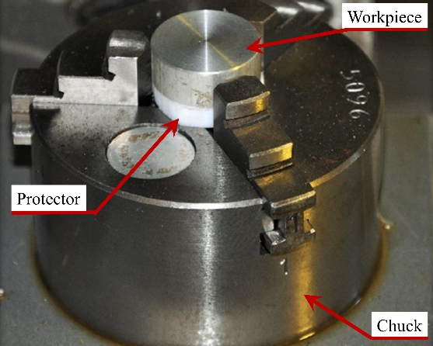
Figure 1 – Clamping of the workpiece
Surface roughness was measured using a Hommel TesterTM T1000 profilometer. For each repetition, the R_{a}, R_{t}, and R_{z} (DIN) profiles were measured at angles of 120º. The quality of the hole (diameter and the exit burr) was analysed with a MitutoyoTM microscope model TM-510 equipped with a Moticam 2.0 CMOS cam (MoticTM), MoticTM MLC-150 fibre optic illuminator, and MoticTM Images Plus 2.0 software. The diameter of the hole was calculated by the average of the parts measured, Figure 2.
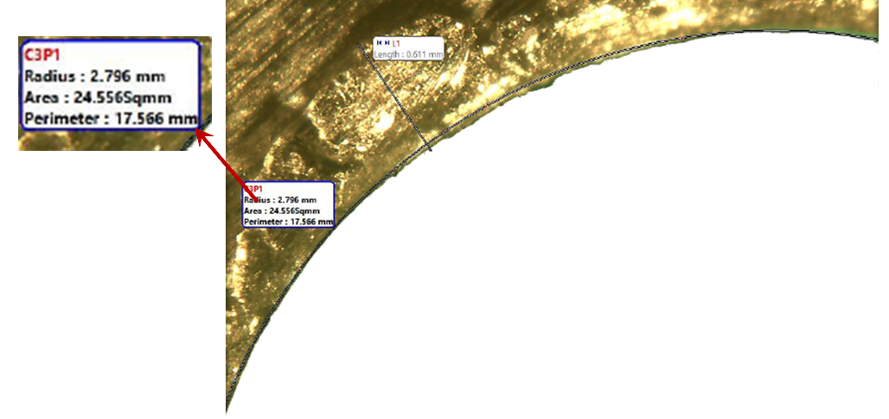
Figure 2 – Example of the measurement of the hole
The optimum conditions, for each output, were defined using the mean signal-to-noise (S/N) ratio (smaller is better). To determine the values of the outputs in the combination not performed, models were developed using multiple regression to obtain these values, Eq. 1 to Eq. 8.

$R_{a_{Conv}}=−0.768+28.89∗{10}^{−3}∗v_{c}+6,905f−0,103Cooling−0,000152Vc∗Vc−0,06032Vc∗f−0,000376Vc∗Cooling+2,051f∗Cooling0.396−4.97∗{10}^{−3}∗v_{c}+3.919∗f+0.298∗cooling$ (Eq. 1)
$R_{t_{Conv}}=−6.84+0.2376∗v_{c}+74.0∗f−0.57∗Cooling−1.277∗{10}^{−3}∗v_{c}∗v_{c}−0.584∗v_{c}∗f+23.2∗{10}^{−3}∗v_{c}∗Cooling−3.1∗f∗Cooling$ (Eq. 2)
$R_{z_{Conv}}=−4.15+0.164∗v_{c}+45.62∗f+0.09∗Cooling−0.941∗{10}^{−3}∗v_{c}∗v_{c}−0.347∗v_{c}∗f+0.013∗v_{c}∗Cooling−0.29∗f∗Cooling$ (Eq. 3)
$D_{Conv}=6,052−10.1∗{10}^{−3}∗v_{c}−2,85∗f−0,005∗Cooling+14∗{10}^{−6}∗v_{c}∗v_{c}+42.8∗{10}^{−3}∗v_{c}∗f−0,94∗{10}^{−3}∗v_{c}∗Cooling+0,62∗f∗Cooling$ (Eq. 4)

where, v_{c} is the cutting speed (between 30 and 110 m/min); f is the feed rate (between 0.15 and 0.25 mm/rev); and cooling is the use of cutting fluid, 0 (dry) or 1 (wet).
$R_{a_{High}}=−64.2{10}^{−3}∗v_{c}−2.983∗f−1.267∗cooling+5.672+0.402∗{10}^{−3}∗{v_{c}}^{2}+0.813∗f^{2}+9.83∗{10}^{−3}∗v_{c}∗cooling+0.126∗f∗cooling$ (Eq. 5)
$R_{t_{High}}=22.4−0.063∗v_{c}−7.5∗f+0.22∗Cooling−0.95∗{10}^{−3}∗v_{c}∗v_{c}+2.81∗f∗f−5.4∗{10}^{−3}∗v_{c}∗Cooling−3.64∗f∗Cooling$ (Eq. 6)
$R_{z_{High}}=24.24−0.227∗v_{c}−13.49∗f−1.95∗Cooling+1.51∗{10}^{−3}∗v_{c}∗v_{c}+4.02∗f∗f+0.041∗v_{c}∗Cooling−1.85∗f∗Cooling$ (Eq. 7)
$D_{High}=6.728−0.024∗v_{c}−0.545∗f−0.421∗Cooling+0.195∗{10}^{−3}∗v_{c}∗v_{c}+0.105∗f∗f+3.12∗{10}^{−3}∗v_{c}∗Cooling+0.256∗f∗Cooling$ (Eq. 8)

where, v_{c} is the cutting speed (between 30 and 70 m/min); f is the feed rate (between 1.00 and 2.50 mm/rev); and cooling is the use of cutting fluid, 0 (dry) or 1 (wet).

- Analysis of results and discussion
In the Figure 3, they are shown the values of the measured diameters for the conventional and high feed in the drilling of Al 2011 aluminium alloy. The increase of the cutting speed varied the diameter between -4.1% and 5.5% for conventional feed and -9.1% and 2.1% for high feed. When comparing the cooling conditions, under wet conditions, the values of the diameter increased on average by 1% for the conventional feed and by 1.4% for the high feed. The increase of feed rate increased the diameters, on average, by 0.9% in conventional feed and decreased by 1.6% in high feed.
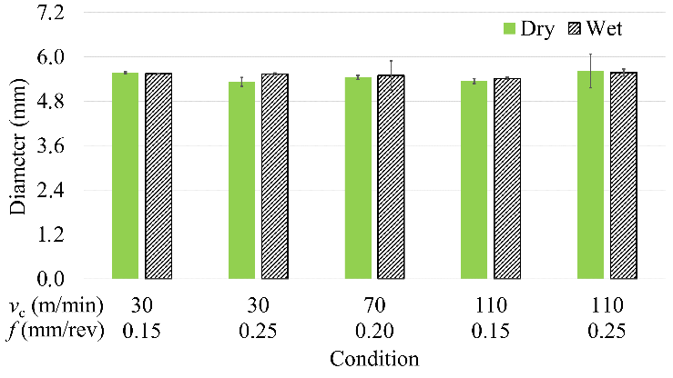 | 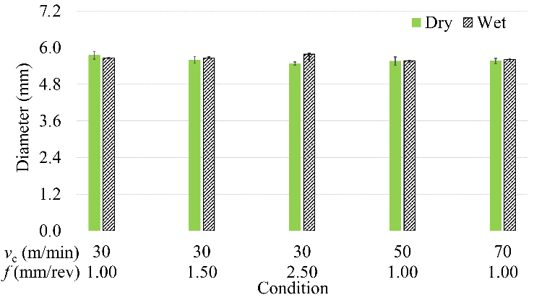
a) Conventional feed | b) High feed
Figure 3 – Values of diameter for conventional and high feed
The high deviation in the dimension of the diameter can be related to the geometry deviation, the circularity. To analyse the diameter, the holes were divided into several parts and the measurement was developed by picking 3 points, which were chosen in the region more furthest from hole centre, i.e., the circular runout influenced the diameter dimension. The circular runout is influenced by circularity and concentricity imperfections [22]. In the drilling, the circularity is directly proportional to the vibration [23].
The S/N ratios for the diameters for both feed rate classes are shown in Table 2. When comparing the conventional and high feed, the cooling and cutting speed were the parameters with the biggest and smallest influence in the diameter, respectively, in the conventional feed. The opposite was observed for the high feed.
Table 2 – The S/N ratios for diameters in the conventional and high feed (Smaller is better).
Level | Conventional feed |  |  |  | High feed
 | v_{c} | f | Cooling |  | v_{c} | f | Cooling
1 | -14.80 | -14.76 | -14.74 |  | -15.05 | -14.99 | -14.94
2 | -14.76 | -14.76 | -14.83 |  | -14.91 | -15.01 | -15.05
3 | -14.79 | -14.83 |  |  | -14.94 | -15.01
Delta | 0.03 | 0.07 | 0.09 |  | 0.36 | 0.17 | 0.12
Rank | 3 | 2 | 1 |  | 1 | 2 | 3

The values of the R_{a} profiles are exhibited in Figure 4 for both feed rate classes. For the conventional feed, the increase of the cutting speed reduced the values of R_{a} between 12.5% and 50.5%; while, for the high feed, the reduction was between 18.5% and 50.8%. The increase of feed rate, for the conventional feed, increased the values of R_{a} for all conditions, on average, 74.5% (30 m/min) and 16.4% (110 m/min). For the high feed, the increase of the feed rate varied the values of R_{a}, -30,5% (1 to 1.5 mm/rev) and 35.6% (1.5 to 2.5 mm/rev), on average.

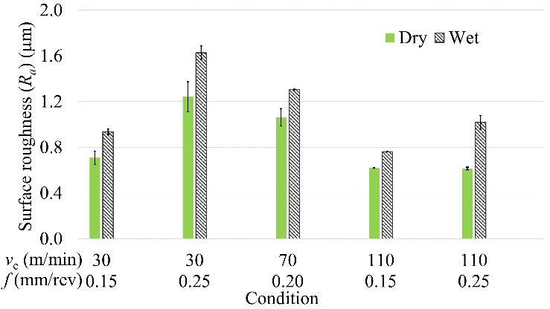 | 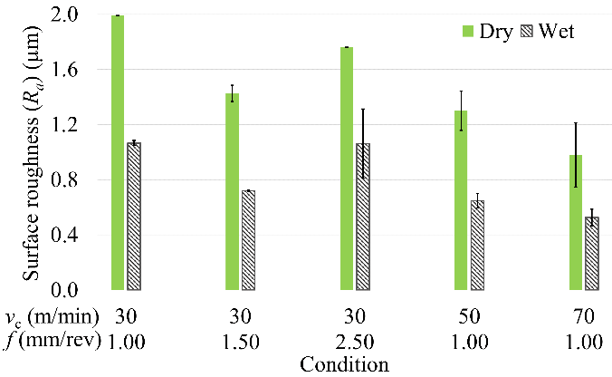
a) Conventional feed | b) High feed
Figure 4 – Values of Ra for conventional and high feed
The values of the R_{t} surface roughness, for the two feed classes, are presented in Figure 5. The increase of the cutting speed decreased the values of R_{t} for all conditions of conventional (on average, 30.5%) and high (on average, 24.2%) feed, practically. The increase of feed rate increased the values of R_{t} for all conditions of conventional (on average, 41.8%). For the high feed, the increase of the feed rate presented different behaviour for dry (on average, 18.3%) and wet (on average, -12.8%) conditions.

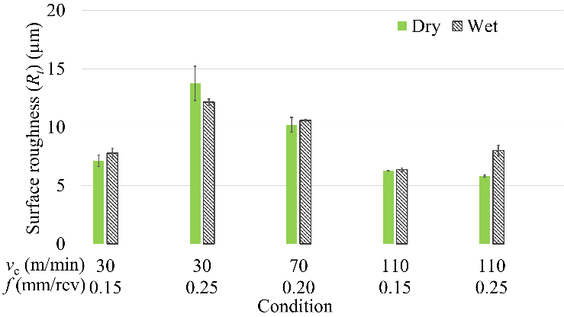 | 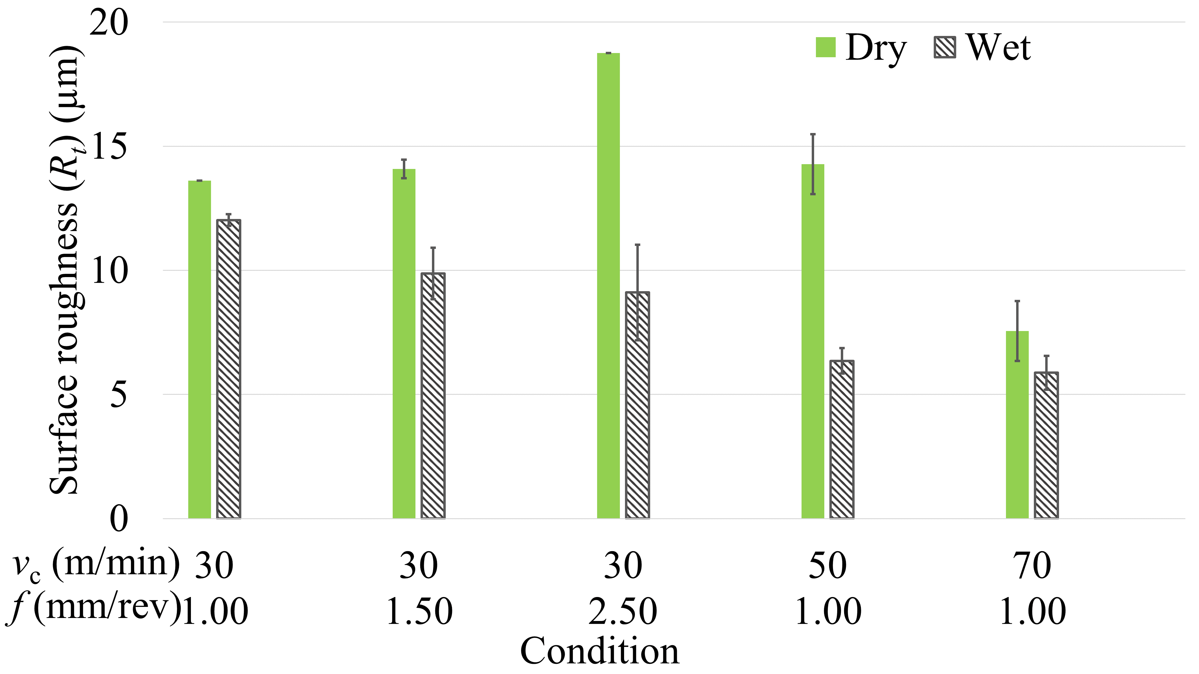
a) Conventional feed | b) High feed
Figure 5 – Values of R_{t} for conventional and high feed
The values of the R_{z} surface roughness are shown in Figure 6 for conventional and high feed. The increase of the cutting speed decreased the values of R_{z} for conventional feed, 29.9% on average but, for the high feed, the increase of the cutting speed varied the values of R_{z} between -43.7% and 38.9%. The increase of the feed rate increased the values of R_{z} for conventional feed, 39.3%, on average. For the high feed, the increase of the feed rate increased the values of R_{z}.

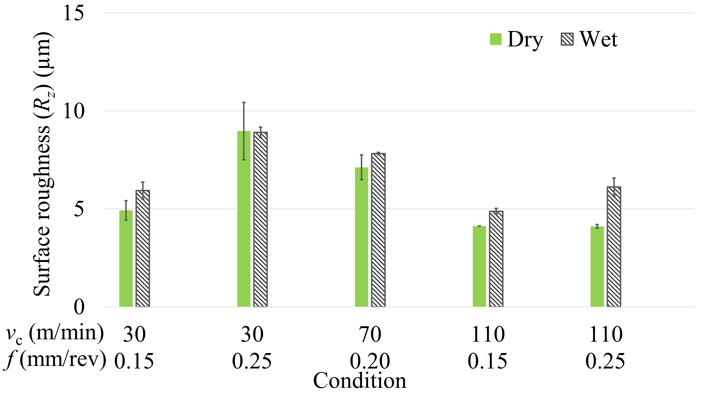 | 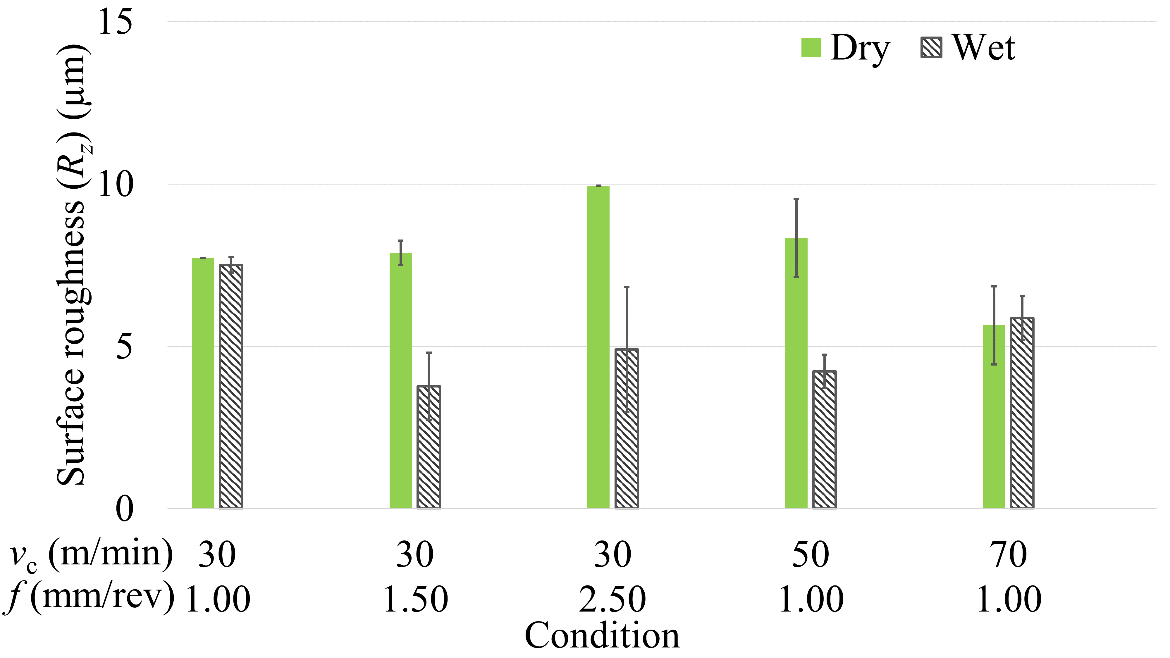
a) Conventional feed | b) High feed
Figure 6 – Values of R_{z} for conventional and high feed
In general, the use of cutting fluid increased the values of surface roughness profiles when compared to the dry condition in the conventional feed, 34.9% (R_{a}), 7.9% (R_{t}), and 19.3% (R_{z}), on average. For the high feed, the use of cutting fluid decreased the R_{a} (46.4%), R_{t} (34.2%), and R_{z} (30.2%), on average. Studying the cooling during the turning, Bruni et al. [24] observed that the use of cutting fluid did not have relevance on the tool wear. Besides, this use provided worst results of surface roughness. Simunovic et al. [25] analysed the surface roughness in milling. The authors used workpieces with small dimensions that did not cause high tool temperatures. Analysing the dry, external, and internal cooling in the drilling of Ti-6Al-4V titanium alloy, Li and Shih [26] observed that external cooling, when compared to dry condition, provided a slight increase on the tool life because the centrifugal force hampered that the fluid to achieve the cutting zone.
Shetty et al. [27], in the drilling of the Ti-6Al-4V titanium alloy, analysed the surface roughness, which was obtained the lower values employed the high level of cutting speed and feed rate. This improvement in the surface roughness can be explained because the increase of the cutting speed reduced the friction coefficient and the cutting temperature that can cause a softening of the workpiece. For high feed, although the maximum cutting speed was lower, the feed speed was higher than in the conventional feed, which reduced the cutting time, consequently, reducing the tool temperature. The high temperatures influence the tool life and the surface roughness [25].
In addition, the increase of surface roughness, in conventional feed, when using the cutting fluid can be justified due to the external flow was in the opposite direction of the exit of the chips. Thus, the micro-chips accumulated in the hole damaged the machined surface during drilling. In the high feed, due to the highest dimension of the chips and lowest cutting time, the presence of micro-chips in the was reduced from the hole during the cut, avoiding that the cutting fluid tossed the micro-chips.
In Table 3, it is shown the S/N ratio for surface roughness profiles to both feed rates classes. The conventional feed showed a similar behaviour for all surface roughness profiles, being the cutting speed the main factor. In the high feed, the rank of factor varied for each surface roughness profiles. When comparing the conventional and high feed, for example, in the R_{a} and R_{z} surface roughness, the cooling was the main factor in the high feed, however, for the conventional feed, it was the smallest significant for the conventional feed.
The optimum conditions for conventional and high feed are shown in Table 4. For the conventional feed, the combination in dry condition of v_{c} = 110 m/min and f = 0.15 mm/rev was the optimum condition for all responses. For the high feed, the optimum conditions were obtained with the wet condition. However, the feed rate varied between 1.00 and 1.50 and the cutting speed tended to converge to the high level, 70 m/min. Applying equal weight, the optimum condition was obtained employing a wet condition with v_{c} = 70 m/min and f = 1.50 mm/rev.

Table 3 – The S/N ratios for surface roughness in the conventional and high feed (Smaller is better)
 |  | R_{a} surface roughness |  |  | R_{t} surface roughness |  |  | R_{z} surface roughness
 | Level | v_{c} | f | Cooling | v_{c} | f | Cooling | v_{c} | f | Cooling
Conventional | 1 | -0.648 | 2.516 | 1.780 | -19.87 | -16.73 | -18.28 | -16.87 | -13.86 | -14.93
 | 2 | -1.428 | -1.428 | -0.755 | -20.33 | -20.33 | -18.82 | -17.47 | -17.47 | -16.37
 | 3 | 2.643 | -0.521 |  | -16.35 | -19.49 |  | -13.52 | -16.53
 | Delta | 4.072 | 3.944 | 2.535 | 3.99 | 3.61 | 0.54 | 3.95 | 3.61 | 1.44
 | Rank | 1 | 2 | 3 | 1 | 2 | 3 | 1 | 2 | 3
High | 1 | -2.052 | 0.083 | -3.244 | -21.99 | -19.44 | -22.41 | -16.49 | -16.14 | -17.85
 | 2 | 0.729 | -0.108 | 2.189 | -19.61 | -21.44 | -18.46 | -15.51 | -14.81 | -14.26
 | 3 | 2.791 | -2.779 |  | -16.58 | -22.39 |  | -15.27 | -17.04
 | Delta | 4.843 | 2.862 | 5.432 | 5.41 | 2.94 | 3.95 | 1.22 | 2.23 | 3.60
 | Rank | 2 | 3 | 1 | 1 | 3 | 2 | 3 | 2 | 1

Table 4 – Optimum conditions for conventional and high feed
 | v_{c} (m/min) | f (mm/rev) | Cooling | Value
R_{a} surface roughness (μm)
Conventional | 110 | 0.15 | Dry | 0.62
High | 70 | 1.50 | Wet | 0.43*
R_{t} surface roughness (μm)
Conventional | 110 | 0.15 | Dry | 6.28
High | 70 | 1.00 | Wet | 5.88
R_{z} surface roughness (μm)
Conventional | 110 | 0.15 | Dry | 4.13
High | 70 | 1.50 | Wet | 4.31*
Diameter (mm)
Conventional | 70 | 0.15 | Dry | 5.44*
High | 50 | 1.00 | Dry | 5.56
* Estimated values

In Figure 7, it is shown the comparison between the optimal condition for the conventional and high feed. The best surface roughness and a reduction of cutting time, about 6 times, were the advantages obtained when employing the high feed. It is important to remind that the aeronautical sector requires a range of R_{a} between 0.8 to 1.6 μm [5], and the maximum values of R_{a} for the high feed in wet condition was 1.24 μm. However, the diameter shows higher dimension deviation in the high feed. Besides, the holes drilled applying the high feed presented larger burr. According to Chang and Bone [28], the exit burr in the drilling occurs when the energy in the shear is larger than the energy of plastic deformation. Thus, the strong increase in the feed rate increased the cutting forces that ultimately increased the burr formation.

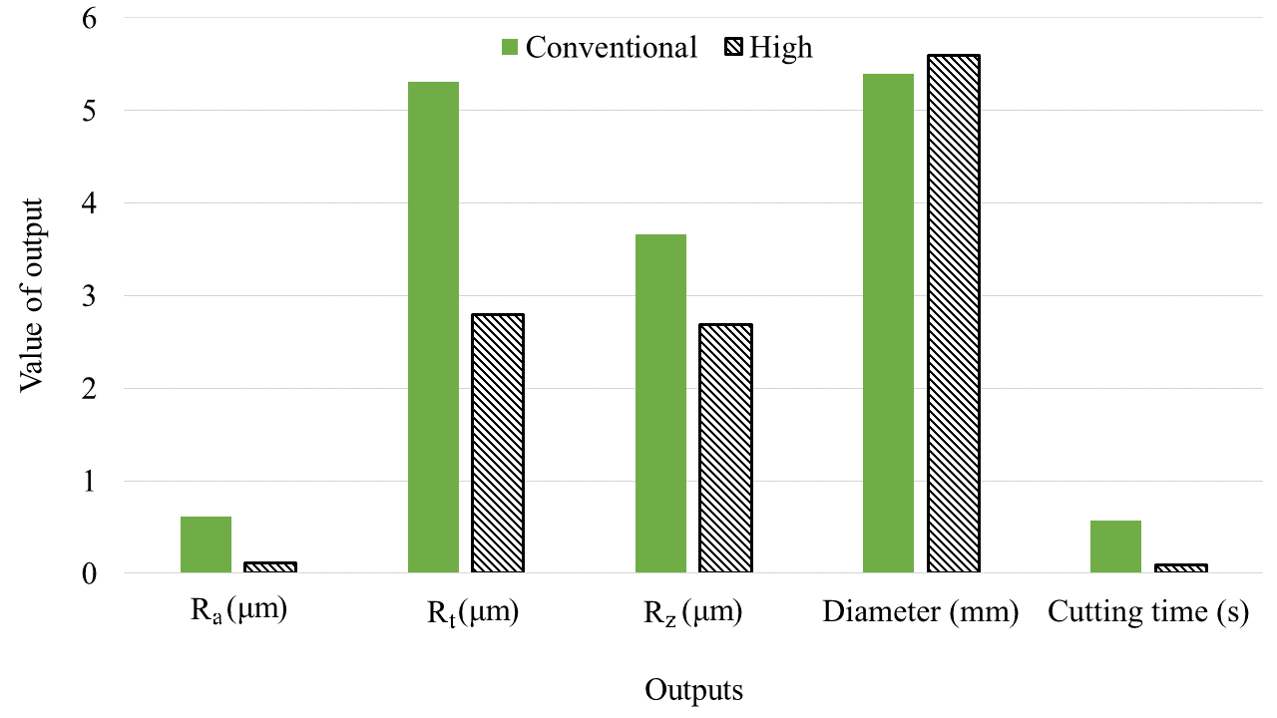
Figure 7 – Comparison between the optimum condition for conventional and high feed.

- Conclusions
Comparing the results of conventional and high feed in the drilling in Al 2011 aluminium alloy, the following conclusions can be drawn:
- The high feed provided higher values of diameter than conventional feed, which can indicate higher drill flexion for the high feed.
- For the conventional feed, the use of cutting fluid, external flow, increased the values of surface roughness; while, for the high feed, the external fluid decreased the values of surface roughness.
- In general, the use of high feed in dry condition provided higher values of surface roughness than conventional feed. However, the combination of high feed and wet condition provided similar values of surface roughness than conventional feed.
Based on the comparison of optimal conditions for both feed rate classes, the high feed can be employed in a production line in which the diameter and burr height are non-critical. However, more studies should be carried out to evaluate the deburring, metallurgic alterations, as well as the drilling of high hardness materials. Besides, more comprehensive studies on the variation in the diameter are needed because the method used to measure the diameter did not allow differentiating the geometric and dimensional deviation.

Acknowledgements
The authors would like to thank to the University of the Aveiro and Sandvik (Portugal). Additional thanks to the Ministry of Education’s Coordination for the Improvement of Higher Education Personnel (CAPES) – Brazil and Foundation for Science and Technology (FCT), Portugal (Project No. 031556-FCT/02/SAICT/2017; FAMASI – Sustainable and intelligent manufacturing by machining, financed by FCT/POCI).

References
1. Liu, H., Zhu, W., Dong, H., Ke, Y.: A helical milling and oval countersinking end-effector for aircraft assembly. Mechatronics. 46, 101–114 (2017). doi:10.1016/J.MECHATRONICS.2017.07.004
2. Carou, D., Rubio, E.M., Davim, J.P.: Machinability of Magnesium and Its Alloys: A Review. In: Davim, J.P. (ed.) Traditional Machining Processes. pp. 133–152. Springer, Berlin, Heidelberg, Heidelberg (2015)
3. Santos, M.C., Machado, A.R., Sales, W.F., Barrozo, M.A.S., Ezugwu, E.O.: Machining of aluminum alloys: a review. Int. J. Adv. Manuf. Technol. 86, 3067–3080 (2016). doi:10.1007/s00170-016-8431-9
4. Campos Rubio, J.C., Rezende, B.A., Vieira, L.M.G., Houmard, M.: Drilling of aluminium/PE sandwich material with a novel TiO2-coated HSS drill deposited by sol–gel process. Int. J. Adv. Manuf. Technol. 92, 1567–1577 (2017). doi:10.1007/s00170-017-0138-z
5. Zhu, Z., Guo, K., Sun, J., Li, J., Liu, Y., Zheng, Y., Chen, L.: Evaluation of novel tool geometries in dry drilling aluminium 2024-T351/titanium Ti6Al4V stack. J. Mater. Process. Technol. 259, 270–281 (2018). doi:10.1016/J.JMATPROTEC.2018.04.044
6. Costa, E.S., Silva, M.B. da, Machado, A.R.: Burr produced on the drilling process as a function of tool wear and lubricant-coolant conditions. J. Brazilian Soc. Mech. Sci. Eng. 31, 57–63 (2009). doi:10.1590/S1678-58782009000100009
7. Brandão, L.C., Neves, F.O., Nocelli, G.C.: Evaluation of Hole Quality in Hardened Steel with High-Speed Drilling Using Different Cooling Systems. Adv. Mech. Eng. 3, 746535 (2011). doi:10.1155/2011/746535
8. de Sousa, P.F.B., Borges, V.L., Pereira, I.C., da Silva, M.B., Guimarães, G.: Estimation of heat flux and temperature field during drilling process using dynamic observers based on Green’s function. Appl. Therm. Eng. 48, 144–154 (2012). doi:10.1016/J.APPLTHERMALENG.2012.04.061
9. Le Coz, G., Jrad, M., Laheurte, P., Dudzinski, D.: Analysis of local cutting edge geometry on temperature distribution and surface integrity when dry drilling of aeronautical alloys. Int. J. Adv. Manuf. Technol. 93, 2037–2044 (2017). doi:10.1007/s00170-017-0671-9
10. Caggiano, A., Napolitano, F., Nele, L.: Study on thrust force and torque sensor signals in drilling of Al/CFRP stacks for aeronautical applications. Procedia CIRP. 79, 337–342 (2019). doi:10.1016/J.PROCIR.2019.02.079
11. Angelone, R., Caggiano, A., Improta, I., Nele, L.: Characterization of hole quality and temperature in drilling of Al/CFRP stacks under different process condition. Procedia CIRP. 79, 319–324 (2019). doi:10.1016/J.PROCIR.2019.02.074
12. Antunes, F.V., Serrano, S., Branco, R., Prates, P.: Fatigue crack growth in the 2050-T8 aluminium alloy. Int. J. Fatigue. In press. doi:10.1016/J.IJFATIGUE.2018.03.020
13. Chang, H., Li, S., Shi, R.: Design and Manufacturing Technology of High Speed Milling Cutter for Aluminum Alloy. Procedia Eng. 174, 630–637 (2017). doi:10.1016/J.PROENG.2017.01.200
14. Montross, C.S., Florea, V., Swain, M. V.: The influence of coatings on subsurface mechanical properties of laser peened 2011-T3 aluminum. J. Mater. Sci. 36, 1801–1807 (2001). doi:10.1023/A:1017537011772
15. Jeelani, S., Reddy, P.A.: A study of cumulative fatigue damage in aluminum alloy 2011-T3. Mater. Sci. Eng. 56, 253–258 (1982). doi:10.1016/0025-5416(82)90100-8
16. Jiménez, A.-E., Bermúdez, M.-D.: Short alkyl chain imidazolium ionic liquid additives in lubrication of three aluminium alloys with synthetic ester oil. Tribol. - Mater. Surfaces Interfaces. 6, 109–115 (2012). doi:10.1179/1751584X12Y.0000000011
17. Bononi, M., Giovanardi, R.: Hard anodizing of AA2011-T3 Al-Cu-Pb-Bi free-cutting alloy: improvement of the process parameters. Corros. Sci. 141, 63–71 (2018). doi:10.1016/J.CORSCI.2018.07.004
18. Cardoso, P., Davim, J.P.: Optimization of Surface Roughness in Micromilling. Mater. Manuf. Process. 25, 1115–1119 (2010). doi:10.1080/10426914.2010.481002
19. Coelho, R.T., Souza, A.F., Roger, A.R., Rigatti, A.M.Y., Lima Ribeiro, A.A.: Mechanistic approach to predict real machining time for milling free-form geometries applying high feed rate. Int. J. Adv. Manuf. Technol. 46, 1103–1111 (2009). doi:10.1007/s00170-009-2183-8
20. Hense, R., Wels, C., Kersting, P., Vierzigmann, U., Löffler, M., Biermann, D., Merklein, M.: High-feed milling of tailored surfaces for sheet-bulk metal forming tools. Prod. Eng. 9, 215–223 (2015). doi:10.1007/s11740-014-0597-0
21. Biermann, D., Iovkov, I.: Investigations on the thermal workpiece distortion in MQL deep hole drilling of an aluminium cast alloy. CIRP Ann. - Manuf. Technol. 64, 85–88 (2015). doi:10.1016/j.cirp.2015.04.072
22. Etesami, F.: Tolerance verification through manufactured part modeling. J. Manuf. Syst. 7, 223–232 (1988). doi:10.1016/0278-6125(88)90006-4
23. Balajia, M., Venkata Rao, K., Mohan Rao, N., Murthy, B.S.N.: Optimization of drilling parameters for drilling of TI-6Al-4V based on surface roughness, flank wear and drill vibration. Measurement. 114, 332–339 (2018). doi:10.1016/J.MEASUREMENT.2017.09.051
24. Bruni, C., Forcellese, A., Gabrielli, F., Simoncini, M.: Effect of the lubrication-cooling technique, insert technology and machine bed material on the workpart surface finish and tool wear in finish turning of AISI 420B. Int. J. Mach. Tools Manuf. 46, 1547–1554 (2006). doi:10.1016/J.IJMACHTOOLS.2005.09.007
25. Simunovic, K., Simunovic, G., Saric, T.: Single and multiple goal optimization of structural steel face milling process considering different methods of cooling/lubricating. J. Clean. Prod. 94, 321–329 (2015). doi:10.1016/j.jclepro.2015.02.015
26. Li, R., Shih, A.J.-M.: High-throughput drilling of titanium alloys. Chinese J. Mech. Eng. 20, 62–66 (2007)
27. Shetty, P.K., Shetty, R., Shetty, D., Rehaman, N.F., Jose, T.K.: Machinability Study on Dry Drilling of Titanium Alloy Ti-6Al-4V using L9 Orthoganal Array. Procedia Mater. Sci. 5, 2605–2614 (2014). doi:10.1016/J.MSPRO.2014.07.521
28. Chang, S.S.F., Bone, G.M.: Burr height model for vibration assisted drilling of aluminum 6061-T6. Precis. Eng. 34, 369–375 (2010). doi:10.1016/j.precisioneng.2009.09.002

